Students can easily acquire a minor in the Spears School of Business (SSB) while still only taking 120 hours of college credit. Here is how. Know that to get a minor in the SSB you need to complete the courses required on this form. In this document I show you how this can be done.

First notice the requirements for a General Business Minor, shown here. It requires 3 hours, but notice you already have to take ACCT 2103, ACCT 2203, ECON 2203, and STAT 2023. SSB also allows us substitutions to satisfy ECON 2103, LSB 3213, and FIN 3113. This means that there are only three extra courses needed to acquire this major, and these three courses can easily be taken as part of your AGBU/AGEC degree, such that MSIS 2103, MGMT 3013, and MKTG 3213 can count for both your AGBU/AGEC major and the General Business Minor. An example is the AGBU-No option major, where these three courses can go under the “15 hours in CASNR/SSB”.

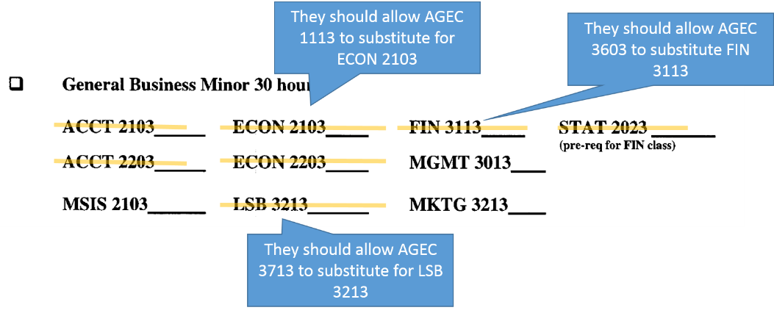

Now consider a business minor in a specific area, like finance, marketing, or economics. The first “9 hours from” block (see below) you will naturally satisfy as part of your AGBU/AGEC degree. For the second 9 hour block, they will allow us to substitute AGEC 3713 and AGEC 3603 (two courses required for the AGBU/AGEC degree) for LSB 3213 and FIN 3113. Then, you take either MGMT 3013 or MKTG 3213, in addition to 9 hours for the specific minor as shown on the second page. These 12 hours can apply to both your AGBU/AGEC degree and your minor, such that you can get one of these minors with only taking the normal 120 hours.
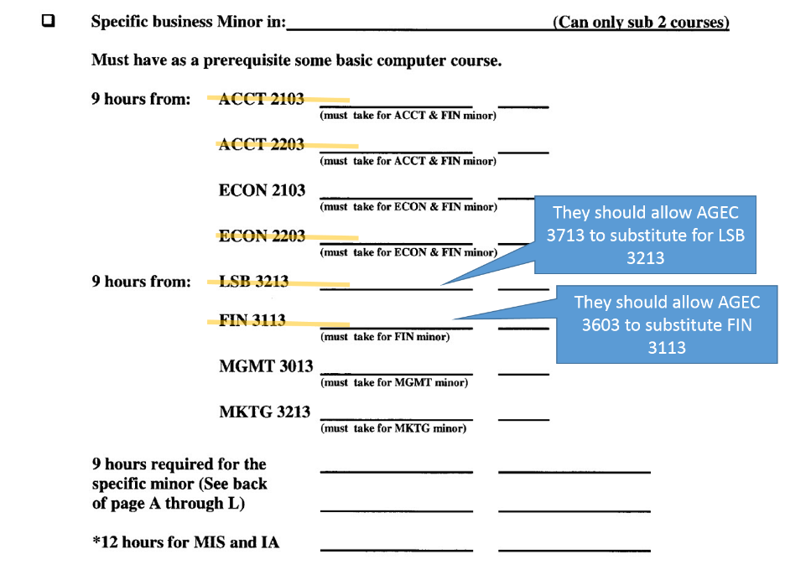

Notice that to get an economics minor you can simply take one more upper division economics course, such that it counts for both your minor and your AGBU/AGEC degrees.
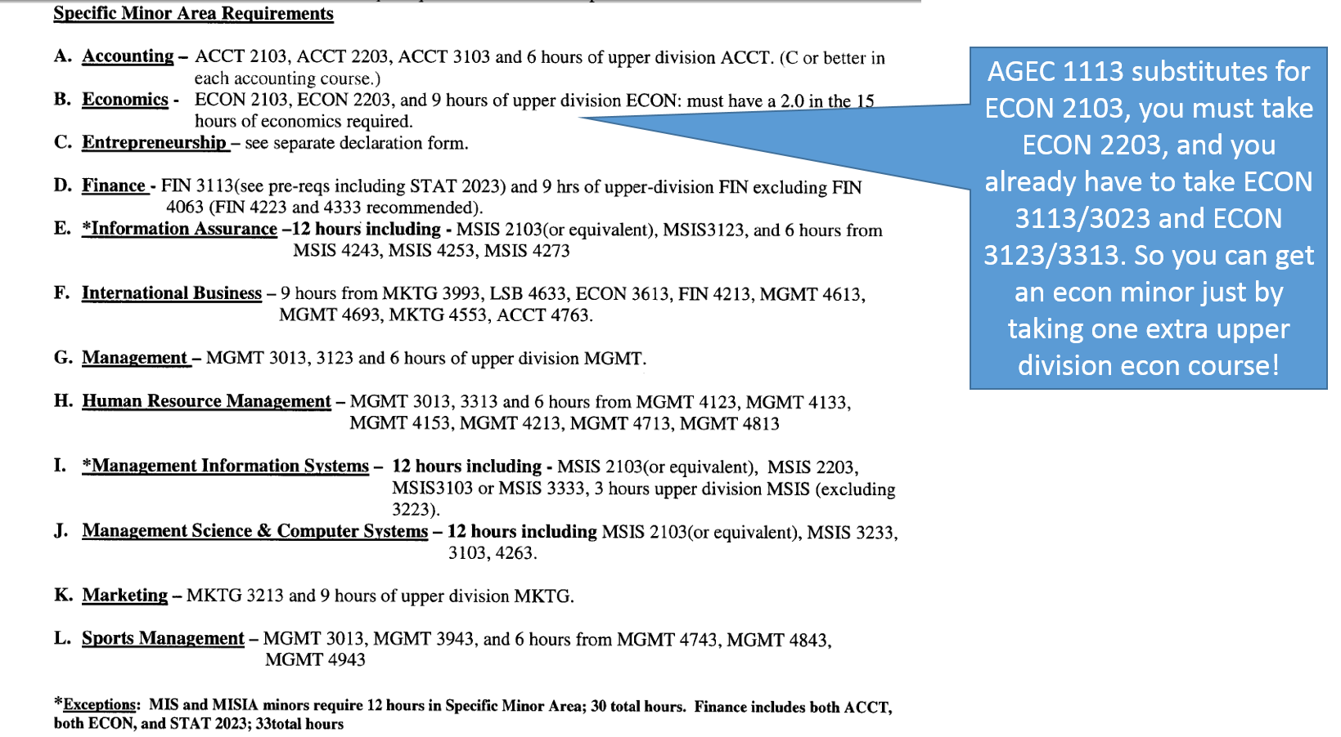

If you are interested in one of these minors, download the form at the top of the page and use it to help make your class enrollment descriptions. And see an advisor in SSB to make sure all this information is correct and that nothing has changed. Make sure you discuss this with your AGEC advisor.

