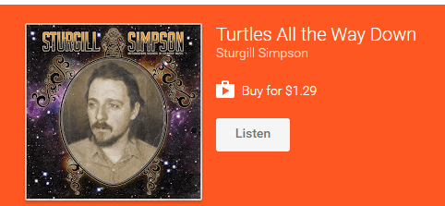

Lyrics
I've seen Jesus play with flames in a lake of fire that I was standing in
Met the devil in Seattle and spent 9 months inside the lion’s den
Met Buddha yet another time and he showed me a glowing light within
But I swear that God is there every time I glare in the eyes of my best friend
Says my son it's all been done and someday yer gonna wake up old and gray
So go and try to have some fun showing warmth to everyone
You meet and greet and cheat along the way
There's a gateway in our mind that leads somewhere out there beyond this plane
Where reptile aliens made of light cut you open and pull out all your pain
Tell me how you make illegal something that we all make in our brain
Some say you might go crazy but then again it might make you go sane
Every time I take a look inside inside that old and fabled book
I'm blinded and reminded of the pain caused by some old man in the sky
Marijuana, LSD, Psilocybin, and DMT
They all changed the way I see
But love's the only thing that ever saved my life
So don't waste your mind on nursery rhymes
Or fairy tales of blood and wine
It's turtles all the way down the line
So to each their own til' we go home
To other realms our souls must roam
To and through the myth that we all call space and time

