Hog production and the animal welfare controversy

Americans are conflicted about how they believe animals should be raised. Most grocery stores sell both cage and cage-free eggs, but only 5% - 10% of sales in California are of the cage-free variety (and that includes organic eggs).  Yet, in 2008, when Californians were asked to vote on whether it should ban cage egg production, 63% of voters approved the ban. Californians seem to hold one opinion at the ballot box and another at the grocery store. | [display]  In California  - More than 90% of sales are cage eggs  - But 63% voted to ban cage eggs in 2008  [label: Cage System]  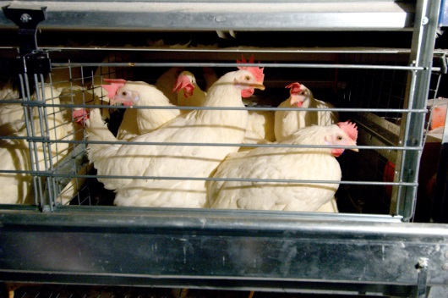  [label: Cage-Free System]  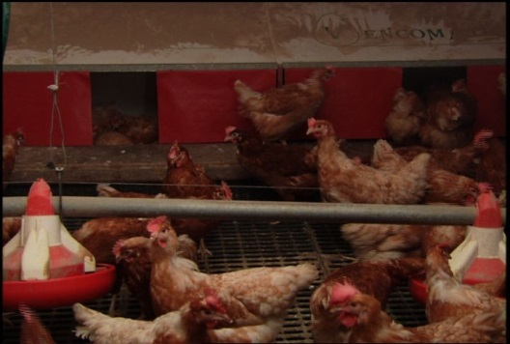
Similarly, in my research consumers tell me they don’t like the crates used to house pregnant sows, and when given the opportunity to ban the crates in a voter initiative, the ban is always approved. This happened in Florida, Arizona, and California.  Yet, it is very hard to find pork advertised as “gestation-crate-free”. Stores like Whole Foods is an exception but they constitute a very small percentage of pork sales. If consumers are really willing to pay the cost of gestation-crate-free pork then we would expect pork producers to profit from that demand. As with eggs, it seems like consumers say one thing when they vote but something else when they shop. | [display]  In Florida, Arizona, and California  - there is almost no market for gestation-crate- free pork  - A majority of voters decided to ban gestation-crates  [display, label as “sows in gestation crates”]  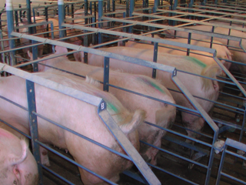
The willingness of consumers to pay higher prices in return for better animal care is difficult to judge. When people are asked whether they would pay premiums for animal-friendly products they say they will, but when asked about the importance of various social issues the well-being of farm animals is ranked slightly lower than food prices, as well as the well-being of U.S. farmers, as shown here.  These are the results of a telephone survey I conducted of over 1,000 Americans, where I asked them to compare the social issues of human poverty, health care, food safety, the environment, financial well-being of U.S. farmers, food prices, and the well-being of farm animals. They were asked to rank these issues in terms of importance, and I then compiled a “score” of importance for each issue based on these rankings.  A higher score means it was more important to most Americans, and the scores are designed such that they sum to 100. You can interpret the scores as the percent of people who believe the issue is the most important of the seven issues.  For instance, the financial well-being of U.S. farmers was deemed the most important issue for 8.16% of Americans, …  … food prices were deemed the most important to 5.06% of Americans, …  … and the well-being of farm animals was deemed most important by the fewest Americans: only 4.15%. | [diplay table]  Importance score of social issues as expressed by a representative sample of Americans (higher score indicates greater importance)  Social Issue Score  Human poverty 23.95  U.S. health care system 23.03  Food safety 21.75  The environment 13.91  Financial well-being of U.S. farmers 8.16  Food Prices 5.06  Well-being of farm animals 4.15  Importance score of social issues as expressed by a representative sample of Americans (higher score indicates greater importance)  Social Issue Score  Human poverty 23.95  U.S. health care system 23.03  Food safety 21.75  The environment 13.91  Financial well-being of U.S. farmers 8.16  Food Prices 5.06  Well-being of farm animals 4.15  Importance score of social issues as expressed by a representative sample of Americans (higher score indicates greater importance)  Social Issue Score  Human poverty 23.95  U.S. health care system 23.03  Food safety 21.75  The environment 13.91  Financial well-being of U.S. farmers 8.16  Food Prices 5.06  Well-being of farm animals 4.15  Importance score of social issues as expressed by a representative sample of Americans (higher score indicates greater importance)  Social Issue Score  Human poverty 23.95  U.S. health care system 23.03  Food safety 21.75  The environment 13.91  Financial well-being of U.S. farmers 8.16  Food Prices 5.06  Well-being of farm animals 4.15
In a previous article / video you were taken on a virtual tour of the standard hog production facility, where hogs are raised completely indoors in cramped spaces, and where pregnant sows are housed in gestation-crates. For this reason the conventional hog farm is described here as a confinement-crate system. Is this the best system in terms of animal welfare? If not, what type of farms provide hogs a better life, and if we purchased pork from these farms, how much more would we pay?  This lecture seeks to compare the confinement-crate system to two alternatives:  - a confinement-pen system: a small tweak of the conventional system, where gestation-crates are replaced with group-pens, and  - a shelter-pasture system: a completely different system, where animals are raised in pastures, lots, and shelters without cages and in an enriched environment. | [display]  A previous video took you on a tour of the confinement-crate system, how most hogs in the U.S. are raised.  This lecture will expose you to two alternatives to the confinement-crate system:  - confinement-crate system  - shelter-pasture system  and their consequences for the well-being of hogs.
[display section title]
MEASURING ANIMAL WELFARE
In Chapter 8 of Agricultural and Food Controversies we discuss the difficulty of measuring the well-being of farm animals. Neither consumers nor animal welfare researchers are sure how they should measure the happiness of an animal.
You, as an individual, might be able to easily make up your own mind about the relative welfare provided by different farm systems. In fact, I encourage you to try and do so. But I also want to assure you that some of you may find it difficult, and many animal welfare researchers feel the same way.  But to facilitate discussion, in the next article I will expose you to the most scientific animal welfare rating system thus far: the SOWEL model. You don’t have to agree with the SOWEL model, but it might help you make up your mind.  The SOWEL model was developed by four animal welfare researchers and was published in the prestigious Journal of Animal Science. It measures only the welfare of sows (adult females), not piglets, nor growing pigs in the nursery or finishing stage.  This model is particularly useful because it compares the confinement-crate system to the confinement-pen and shelter-pasture system.  It rates the welfare of sows based on 37 different attributes of the farm, relying on previous scientific studies to determine what is most or least important to a sow’s well-being. Based on those 37 farm attributes, it computes a precise number indicating the level of well-being of the sow. | [display]  The SOWEL model  Bracke, M. B. M., Metz, J. H. M., Spruijt, B. M., & Schouten, W. G. P. 2002a. “Decision support system for overall welfare assessment in pregnant sows A: Model structure and weighting procedure.” Journal of Animal Science. 80:1819–1834.  Bracke, M. B. M., Metz, J. H. M., Spruijt, B. M., & Schouten, W. G. P. 2002b. “Decision support system for overall welfare assessment in pregnant sows B: Validation by expert opinion.” Journal of Animal Science. 80:1835–1845.  The SOWEL model  - Rates well-being of sows  - in confinement-pen, confinement-crate, and shelter-pasture systems  - according to 37 farm description  - and according to scientific publications on animal welfare.
The model not only takes into account a sow’s biological needs but her desire to express natural behaviors. Meaning it assumes that even if allowing the sow to root in dirt doesn’t improve her health, allowing her to do so makes her happier. I think that is good not only because I think allowing sows to behave naturally is important, but, from a telephone survey of Americans, I have concluded that the average American does as well. | The SOWEL model  - Rates well-being of sows  - according to 37 farm description  - and according to scientific publications on animal welfare.  - Accounts for sows’ biological and behavioral needs
Researchers have compared the model to the subjective evaluations of animal welfare researchers and found it provides similar ratings, suggesting the SOWEL model is a good proxy for expert judgments. | The SOWEL model  - Rates well-being of sows  - according to 37 farm description  - and according to scientific publications on animal welfare.  - Accounts for sows’ biological and behavioral needs.  - Is consistent with expert judgment.
The one drawback of the SOWEL model is that it only takes into account the welfare of sows, but I have found that farms that the SOWEL model ranks high seems, in my opinion, to provide high welfare for growing pigs as well, though not necessarily nursing piglets. | The SOWEL model  - Rates well-being of sows  - according to 37 farm description  - and according to scientific publications on animal welfare.  - Accounts for sows’ biological and behavioral needs.  - Is consistent with expert judgment.  - Is consistent with consumer beliefs about what makes animals happy.
The SOWEL models doesn’t provide facts about animal welfare, but it can help us form our own beliefs.  I only include the SOWEL model to help facilitate a discussion about the welfare of hogs under different environments. You are welcome to disagree with the SOWEL model and form your own, educated opinion. | The SOWEL model doesn’t provide facts about animal welfare, but it can help us form our own beliefs.
Remember, I’m not trying to tell you what to think. I’m here to help you think well.
Let’s now go learn about the two alternatives to the conventional hog production system, what the SOWEL model says about them, and what kind of price we might be expected to pay for pork under these alternative systems.

References

Norwood, F. Bailey and Jayson L. Lusk. 2011. Compassion, by the Pound. Oxford University Press: NY, NY.

Prickett, R. W., F. Bailey Norwood, and Jayson L. Lusk. 2010. “Consumer preferences for farm animal welfare: results from a telephone survey of US households” Animal Welfare. 19:335-347.

