 | Stuff in this color should appear on the screen
In the fall of 1894, Alexander Magruder’s fiancée returned from a trip in a buggy, during which a heavy rain occurred, chilling her so thoroughly that she developed a type of pneumonia referred to at the time as rapid consumption. She feared that death was close, and asked Magruder to marry her in case she soon died. He did marry her, and shortly after, she did die.
A sad story, indeed. Magruder was a relatively young man at the time—only 27. I don’t know if he thought of human death much before this, but I do think the death of a field had been on his mind for some time, for in 1892 he began an experiment to determine just what it took to kill a field, making it unable to grow crops. That experiment is still being conducted, and the field still hasn’t died. It’s one of the most interesting experiments ever conducted in the field of agriculture. | Alexander Magruder (1867 – 1924)
If you harvest crops every year without returning the nutrients removed you are basically mining the soil until its nutrients are depleted, at which point your soil is infertile. Magruder wanted to measure exactly how long it took to mine a soil completely, so he designed a rather simple experiment where a field was farmed but never fertilized. The experiment wouldn’t be of much use unless it was continued for a long time—a really long time. Fortunately, the plant scientists here at Oklahoma State University (OSU) are patient people. Magruder’s experiment that began in 1892 is still continued to this day, and the field still hasn’t died.
Let’s first take a look at the history of the Magruder experiment. This video is an excerpt from an episode of Sunup, a television series produced by the agricultural college at OSU.
 | Play Magruder Milestone video
Now that we know the history of the Magruder Plots, let’s see what this century-old experiment has taught us.  First let’s look at wheat yields on the unfertilized plots. The y-axis is telling us the wheat yield in bushels per acre and the years, spanning 1893 to the present are on the x-axis.  For those of you who are unfamiliar with the concept of a “bushel”, it is a measure of volume. One bushel equals 9.3 gallons, and one bushel of wheat weighs 60 lbs.  For those unfamiliar with the concept of an acre, one acre is three-quarters of a football field (American football, that is). | Wheat Yields on Unfertilized Plots  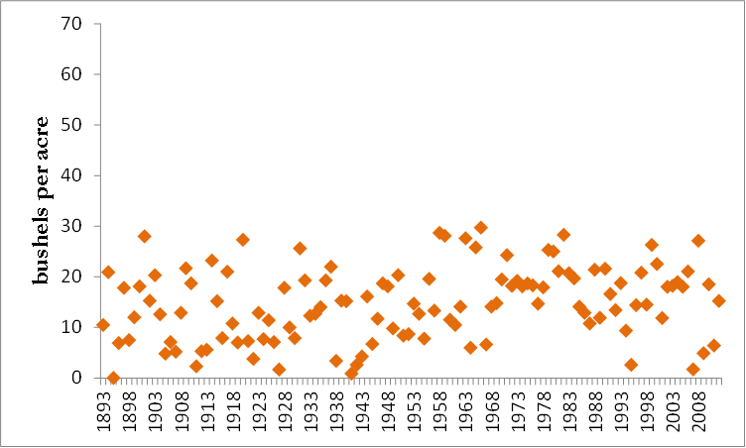  Bushels per acre?  Bushel = 9.3 gallons  Acre = 75% of an American football field
I find it remarkable that yields do not seem to be declining over time. This indicates that the soil is replenishing nitrogen each year, and already had enough of other nutrients, to last a century or more. I should also add that as time goes by, OSU is planting more productive varieties of wheat, and that may be one reason yields are level despite the absence of fertilizer. | The wheat yields are roughly constant over the last century, despite no fertilizer.  At the same time nutrients are being mined from the soil, more productive wheat varieties are being planted.
Now let’s compare the unfertilized plots to those receiving manure fertilizer, which we know to be a complete fertilizer.  Although the plots receiving no fertilizer continue to produce roughly the same amount of wheat each year, plots receiving manure fertilizer produce much more. It is clear, manure, properly applied, increases wheat yields. | Wheat yields with and without manure fertilizer  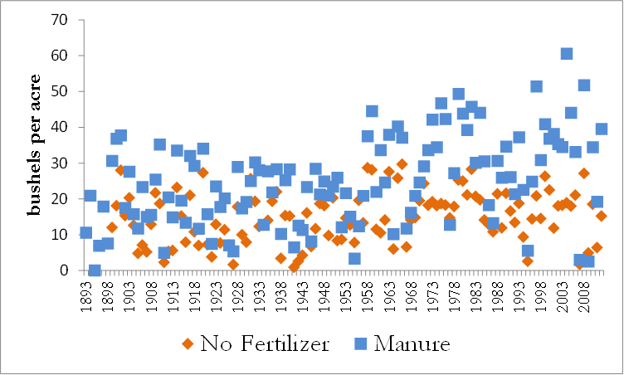  Applying livestock manure increases wheat yields.
Now we come to the most important part: the ability of chemical fertilizers to increase yield. This is important because the amount of manure in any given region may be limited, and chemical fertilizers are often cheaper than livestock manure.

Remember that when we say “chemical fertilizer” we are usually referring to fertilizer created in a large factory or mined from the earth, and when we say “chemical fertilizer” we are usually only referring to nitrogen, phosphorus, and potassium.
If you buy bags of chemical fertilizer in a store they often contain three numbers, referring to the amount of nitrogen, phosphorus, and potassium. This is so well-known that the labels often don’t indicate what the numbers mean. | 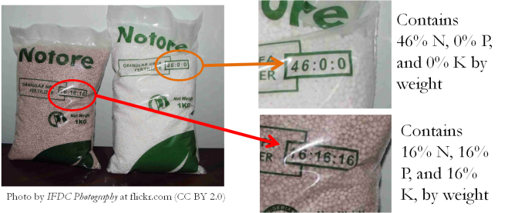
Here is a chart showing wheat yields from the plots receiving no fertilizer (in blue), manure fertilizer (in red), and chemical fertilizer (in light green).  Notice that the x-axis refers to different decades from the 1930’s until recent times, so this is over a very long time period.  It is clear that both manure and chemical fertilizer produce about the same yields, with chemical fertilizer having a slight advantage.  This is surprising, as chemical fertilizers do not have all the nutrients plants need, while manure does. Thus, the nutrients lacking in chemical fertilizers must already be abundant in the soil. | Wheat yields with no fertilizer, manure fertilizer, and chemical fertilizer  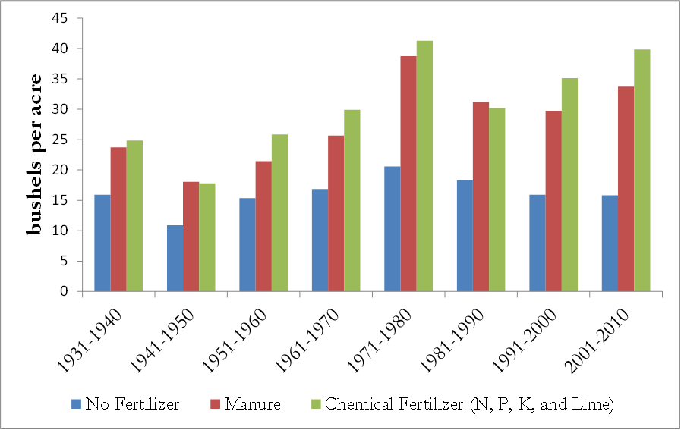  Manure and chemical fertilizers increase yields by roughly the same amount.
The implication is that chemical fertilizers seem to do a very good job of fertilizing the soil over a very long period of time, but that livestock manure does so as well.
Finally, let us look at the rate in which the soil is being depleted of micronutrients. One would think that there would be fewer micronutrients like sulfur and copper in the plots receiving chemical fertilizer, relative to the plots receiving no fertilizer.  This is because the land should have had roughly the same amount of micronutrients before it was farmed. But each year, more micronutrients are harvested from the plots receiving fertilizer, because the yields are larger, leaving fewer micronutrients in the soil.  Logically, then, there should be less micronutrients in the soil of the plots receiving fertilizers, compared to those receiving no fertilizer. | Plots receiving chemical fertilizer are removing more micronutrients without replacing them.  Logically, the more micronutrients you harvest without replacing, the less micronutrients should be present in the soil.
However, this is not necessarily the case.  This red bars in this graph show the  concentration of seven micronutrients in the soils receiving chemical fertilizer, as a percentage of the concentration for the unfertilized plots.  If the red bar is 100%, as in the case of iron, this means the iron concentration on the plots receiving chemical fertilizer is 100% greater than those receiving no fertilizer.  That seems impossible. It would be like watching a glass fill up with more and more water, the more water you drink.  In fact, there are more red bars with positive percentages than those with negative percentages, which means that for most micronutrients the plots receiving chemical fertilizer are—counterintuitively—gaining micronutrients.  We can explain the higher calcium concentrations. Notice the chemical fertilizers also include lime, which is a calcium compound.  Before 1960, sulfur was part of the phosphorus fertilizer applied, so that would explain the higher sulfur concentrations.  But what about iron, boron, and copper?  The micronutrients measured in the plots are not total micronutrients, but plant-available micronutrients. Perhaps the chemical fertilizers alter the chemistry of the soil such that more iron that was not plant available now becomes plant available.  The blue bars show the amount of micronutrients in the soils of the plots receiving manure fertilizers, relative to the unfertilized plots. There are more blue bars with positive numbers than negative numbers, and the blue bars tend to be larger overall (especially for zinc).  The reason for this is simple: manure has all of those micronutrients, so as they add manure, more micronutrients are being added to the soil.  Notice, however, that the plots receiving manure fertilizer have less sulfur and iron than plots receiving no fertilizer. Perhaps manure fertilizer reduces the rate at which total sulfur / iron is converted to a plant-available form. | 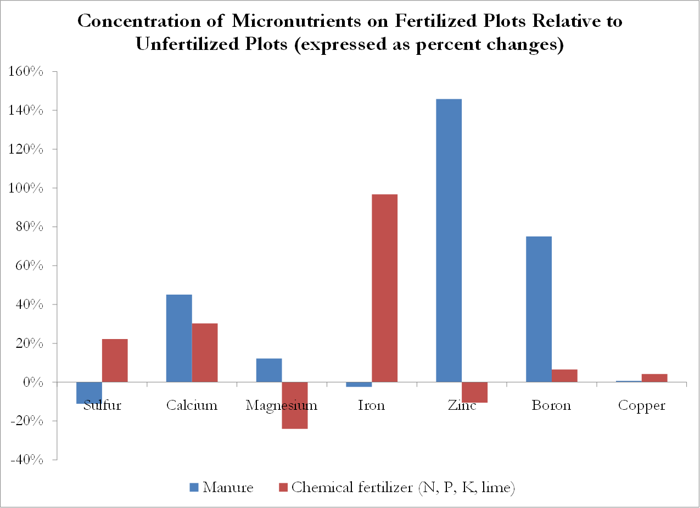  How can you have more calcium in the soil, the more calcium you harvest?  The micronutrients measured are plant-available micronutrients.  Perhaps chemical fertilizers help convert more total nutrients into plant-available micronutrients?
This century-long experiment has provided us with some key insights into fertilizer. The first is that, at least, on the soils in the Magruder Plots, chemical fertilizers consisting of nitrogen, phosphorus, and potassium (with applications of lime) can maintain the soil’s fertility for a very long time. How long? We don’t know because the fields have not yet become infertile! | Lessons from the Magruder Plots  - Chemical fertilizers work well over long periods of time.
Second, properly applied manure works about as well as chemical fertilizer. | Lessons from the Magruder Plots  - Chemical fertilizers work well over long periods of time.  - Chemical and manure fertilizers are equally effective.
Third, there seems ample amounts of micronutrients in the soil, and the complex chemistry of the soil can make more plant-available micronutrients appear even when no micronutrients are applied. | Lessons from the Magruder Plots  - Chemical fertilizers work well over long periods of time.  - Chemical and manure fertilizers are equally effective.  - Micronutrients are abundant in the soil.  - Conversion of total to plant-available micronutrients is a complex process.
For now, at least on soils resembling those of the Magruder Plots, chemical fertilizer has had a remarkable impact on agricultural productivity, and for now seems about the only fertilizer one needs.

