Unless stated otherwise, all times refer to the video at my dairy videos: http://ra.okstate.edu/STW_DASNR/Norwood/BaileyDairyScript/video.html

Segments to show | Remarks to ITLE | Notes mostly to Bailey
Talking points in this color
Audio to add in this color
Introductory video will be made in the studio. Info about this is in the transcript in the word document at the class homepage.
00:16:50;00  To  00:18:10;00 |  | Section: Birth. Lot where cows r ready to give birth.
Title: A heifer is born
Use video at right link, no audio:  00:00:01;00 to  00:00:03;00  Then  00:00:12;00 to 00:00:16;00  Then  00:00:41;00 to  00:00:45;00 | Audio to add:  I was fortunate to be on the dairy farm one day when a cow was giving birth, allowing me to film it on my iPhone for you. This is a cow who was in labor for about an hour and a half, though only in the last twenty minutes did she try hard to push her baby out. | http://ra.okstate.edu/  STW_DASNR/Norwood/  BaileyDairyScript/video.html
Use video at right link, no audio  00:01:18;00 to 00:01:21  Then  00:01:51;00 to 00;01:53  Then  00:02:18;00 to 00:02:21;00 | Immediately after giving birth the cow will begin licking her calf to clean it. It will take about 20 minutes of cleaning for the calf to be dry. During this time the cow will eat her placenta, and shortly after, the calf will try to walk.  13 | http://ra.okstate.edu/  STW_DASNR/Norwood/  BaileyDairyScript/video.html
00:02:56;00 to 00:03:04;00 | As soon as the calf is dry the farmer will remove the calf from the mother. As we will see, this is to ensure good nutrition for the calf.
Title: From birth until weaning (0 – 9 weeks of age)
00:03:56;06  To  00:06:51;15 | At some point I describe how a calf will try to nurse from your hand, but it didn’t do it at the time. There is video around 00:08:28;00 where the calf is sucking my hand. Try and incorporate that in. | At 00:05:04;00 put talking point  Colostrum—a yellowish liquid, especially rich in immune factors, secreted by the mammary gland of female mammals a few days before and after the birth of their young.
00:07:53;00  To  00:08:18;00 | Do a quick cut to other pictures of heifers, dry cows, and nursing cows and their shelter and comfortable resting places. These will have to come from my videos.  Like from (Bailey’s videos)  00:12:15;00 to 00:12:20;00  00:26:39;00 to 00:26:43;00 and 00:39:18;00 to 00:39:18;00 and from 00:47:02;00 to 00:47:13;00
Title: From weaning until first breeding (9 weeks - 15 months of age)
00:09:07;00  To  00:11:25;00 | Around 00:11:49;00 you have video of the small buds that are the beginning of horns. Show those buds around 00:09:50.
From video in right link  If it appears okay (is it too jumpy?)  00:19:30;00 to  00:19:42;00 (won’t use it all)  00:25:23;00 to 00:25:26;00  Then 00:43:09;00 to 00:43:20;00 | Audio to add:  Once they are ready, the heifers will be released into a pasture where they have shelter, pasture, hay, and nutritious feed. From about 3 months of age until 15 months they will remain in with other heifers in this pasture, rarely handled by humans.  Remember the heifer you saw being born? This is her, #752.  You can tell she is treated kindly by the farm workers because, not only is she not fearful of humans, but she wants to be petted. | From video in link http://ra.okstate.edu/STW_DASNR/  Norwood/BaileyDairyScript/video.html
Title: First breeding (15 months of age)
From video in right link, but no audio  00:54:22;00  To 00:55:02;00  00:55:23;00 to 00:56:05;00 | Narration:  Once the heifer has reached 15 months of age she will be bred for the first time. But you won’t find a bull on this farm, or on most dairy farms. Instead, she will be bred using artificial insemination, and Dr. Stein from the Department of Animal Science is going to give a demonstration.  Notice the long glove he wears. This is because he is going to stick most of his arm up the cow’s rectum, but don’t worry, I have done this before and can assure you it does not hurt the cow. Also notice the steel rod tucked under his right arm. At the tip of this rod is bull semen that he will inject inside the cow’s reproductive tract.  Once his left arm is deep within the cow’s rectum he will attempt to locate the cervix and grasp it—through the rectum wall—in his left hand.  [embed these diagrams in the video]  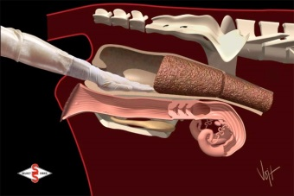  Once he has grasped the cervix with his left hand, he will insert the rod (they call them straws) into the cows vagina,  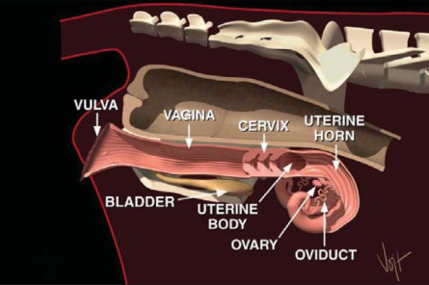  and by pushing the cervix away from his body, the vagina channel straightens and the rod can be smoothly guided up to the cervix.  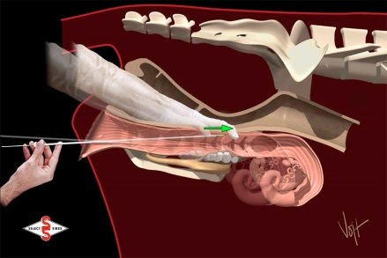  Once you do this several times you know when the rod is at the cervix because you can feel the rings. Once the rod is at the first ring he will manipulate it past all three rings, coming out the other side of the cervix. Once the rod is about ¼ of an inch past the last ring he will eject the sperm.  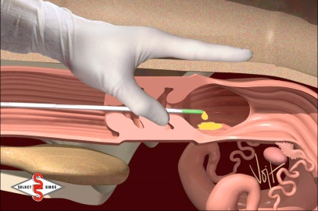  And here [round 00:56:00;00] you see him ejecting the sperm. | From video in link http://ra.okstate.edu/STW_DASNR/  Norwood/BaileyDairyScript/video.html  NOTE: The zipfile for the four images to the left about AIing are available at  http://seeds.okstate.edu/MOOC/Dairy,Issues/  dairy/virtualtour/Dairy,AI.zip
Title: First breeding until first birthing (15 months to 2 years of age)
00:39:26;00 to 00:39:40;00 | Add audio:  Once she is bred the heifer will return to the pasture, a pasture equipped with shade and shelter, where she will stay until she is ready to give birth at around two years of age. | From video in link http://ra.okstate.edu/STW_DASNR/  Norwood/BaileyDairyScript/video.html
00:31:01;00
To
00:32:05;00
00:34:17;00  To  00:34:50;00 | Incorporate some of the shots 00:35:34;00 to 00:35:53. I especially like the fact that in here I mention it only takes 8-10 minutes for a cow to be milked.
00:33:17;00 to  00:33:25;00 | No audio, just show the scene with no audio
00:34:19;00  To  00:34:19;00 | Do the shots from the other angles you have also  Show videos of cows entering and exiting
00:48:46;20
To
00:49:27;19
extra | There were a number of videos of the milkers milking the cows but it wasn’t on my video. Show some of this, being sure to show the milkers automatically removing itself from the cow udders
Title: The heifer is now a cow
00:52:42;00  To  00:54:14;00 | Incorporate scenes from my videos below:  At 00:53:00;19 of your video show brief clip starting at 00:48:15;00 to 00:48:21;00 and perhaps some of 00:49:34;00 onward of the video in the right link  At 00:53:14;00 of your video when talking about the feed, show 00:33:03;00 to 00:33:10;00 of the video in the right link  At 00:53:33;00 of your video show  00:26:36;00 to 00:26:43;00  And/or 00:26:53;00 to 00:27:00;00  And/or 00:27:33;00 to 00:29:39;00 of the video in the right link , to show that the cows in the shelter also have access to pasture | http://ra.okstate.edu/STW_DASNR/  Norwood/BaileyDairyScript/video.html
From your video:  Show brief scene (5 second) you have (wasn’t on the video you gave me) of others milking cows without me in it  From video in right link  00:55:25;00 to  00:55:29;00  00:39:59;00 to 00:40:17;00  00:00:40;22 to  00:00:43:19  00:12:54;00 to  00:13:21;00 | Add audio:  Remember that the cow is about 2 years old the first time she is milked,  and 2 months after that she will be bred for a second time.  Then when the cow is 2 years and 9 months old she will be removed from the milking heard and sent to a “dry lot” where she will have access to pasture (during the growing season), other food, shelter, and the like. After two months in the dry lot, when she is 2 years and 11 months old,  she will be ready to give birth again,  and then return to the milking herd. Once the cow has given birth about three times, and has been through the milking cycle three times, she will be “culled” from the herd and slaughtered for beef. It varies across cattle though, depending on how much milk the cow is producing and whether she conceives quickly. Cattle who have trouble conceiving and don’t produce much milk will be removed from the herd earlier than other more productive cows. | http://ra.okstate.edu/STW_DASNR/  Norwood/BaileyDairyScript/video.html
Final remarks made in studio | I hope you enjoyed the tour, but remember, there is much more to a dairy farm than what you saw in the tour. I encourage you to visit a dairy farm yourself. Most welcome visitors and will let you even milk a cow yourself.

