Virtual tour of dairy farm at OSU

 | Talking points are in this color
One of the most interesting things we will do in this class is to go on virtual tours of farms at my university. Today is our first farm tour, and it will be of the dairy farm. [Show Figure 1] Although the farm was established primarily for research and teaching, it was designed to closely resemble private, for-profit farms, so the tour will give you an inside-look at where your milk comes from. | 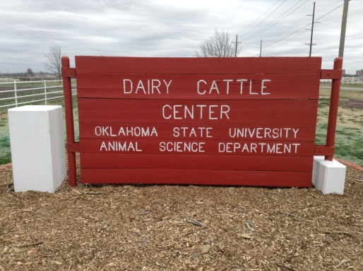  From video in link http://ra.okstate.edu/STW_DASNR/  Norwood/BaileyDairyScript/video.html  Show scene from dairy farm barns around 00:14:14
No two dairy farms are the same. They may milk different breeds of cows, use different feeds, and have different milking systems, but the basic process is the same. Although dairy farmers use different breeds of cattle than farmers who only produce beef, all dairy cattle are eventually slaughtered for beef.  For a cow to produce milk, it must first give birth to a calf. The male calves will usually be sold to another person who will raise them for meat. My sources suggest that about 70% of the male calves will be raised for beef and the other 30% raised for veal.  Most all the female calves will be raised by the farmer for milk production. | Dairy farms use different cattle breeds than beef producers.  Female calves are raised for milk production but are eventually slaughtered for beef.  Most male calves are raised for beef but some are raised for veal.
Dairy cows will be fed forage (that is, grass and hay) but will also receive a high energy feed consisting of grains, legumes, and other ingredients. The cows will be milked two to three times each day in an automatic milking parlor. It only takes about ten minutes for the machines to finish milking a single cow. | Cows eat grass, hay, grains, legumes, and other feeds.  Cows are milked 2-3 times each day.  Each milking takes about 10 minutes.
On our tour we will start with the pregnant cow, see a calf being born, and then observe what happens to the heifer (a heifer is a female calf) as she ages, is bred, and finally begins producing milk for human consumption.

If you have never seen an animal give birth, get ready for an awesome sight. Let’s go to the farm now.

