Selective breeding and carbon footprints
While our tour of the dairy farm gave us an intimate view of where milk comes from, it didn’t communicate what to me is the most interesting aspect of modern dairy farms: its productivity. In the last century dairy producers have learned to produce much more milk while using less feed, water, land, and cows.

Because of this, milk costs only half as much today as it did in 1890 (after adjusting for inflation). This means that if we were using the 1890 dairy production technologies our milk would be twice as expensive. This is a remarkable achievement and a direct consequence of farmers attempting to increase their profits by producing milk more efficiently. | [Figure 1]  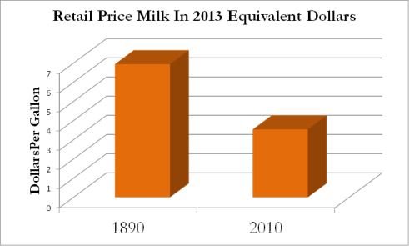
For instance, today it takes about 10 lbs of feed to produce a gallon of milk, while it took 50 lbs in 1945. So we can produce a gallon of milk using only 20% of the feed needed in 1945. That, I believe, is a triumph.  My friend and frequent coauthor Jayson Lusk conducted a survey of 1,017 people where he first told people about this productivity improvement and then asked them an open-ended question, “How do you think this change happened?”  Of the responses, 13% mentioned growth hormones, 3% referred to drugs and steroids, 6% used terms related to science and technology, 6% referred to genetics and breeding, 8% referred to the type of feed given to cows, and 3% mentioned some type of better farming technique. There were a few other types of responses. | [talking points]  Milk prices are lower today because dairy farms are more productive.  Today we can produce a gallon of milk using only 20% of the animal feed needed in 1945.  Where did these productivity improvements come from?  Of 1,017 Americans asked in an open-ended question:  13% said: growth hormones  3%: drugs and steroids  6%: science / technology  6%: genetics / breeding  8%: better animal feed  2%: farming techniques
What is interesting is that the largest category, 13%, is the wrong answer. In the next reading, you will learn it is better genetics and better nutrition that deserves most of the applause.

In our tour of the dairy farm you saw the technologies involved in artificially inseminating cows, so you already have an understanding of the science behind animal breeding.

What I would like to do now, before we start the reading, is to give you a captivating illustration of how far the science of cattle nutrition has advanced.

In a moment I will show you a cow with a hole in its side, and you are going to see me stick my arm through this hole, into the cow’s stomach.  But this story really begins in 1822, when, by accident, Alexis St. Martin was shot in the stomach. As he moaned on the ground some of the food in his stomach spilled out, falling onto the ground. A doctor with the last name of Beaumont happened to be there, and he saw this. Martin lived, with the help of Dr. Beaumont, but as his stomach healed, strangely, there remained a hole both in his skin and his stomach, and through these holes one could literally insert one’s fingers into Martin’s stomach (it’s unclear whether this odd healing happened by accident or deliberately by Beaumont).  Beaumont took advantage of this unusual patient, and began performing experiments on Martin. For instance, he would tie pieces of food to a string, drop the food into Martin’s stomach, and then pull it out to see what happened to the food. What he saw was food being digested.  And remember, this was before we knew what digestion really was.  Over years Beaumont took notes on a large variety of foods and how long it would take to digest.  The big discovery came when some of Martin’s stomach fluids were removed and placed into a jar, after which some food was added to the jar. What Beaumont then saw was astonishing. He saw the food be digested outside the stomach! Think about that. Beaumont saw that food could be digested outside the jar. He saw that digestion was a biological process separate from the human. For the first time we really began to understand what the body does with food, and how.  Today, we have cow versions of St. Martin. We call them cannulated or fistulated cows. Surgeries are performed where a cow’s stomach is stitched to the cow’s skin, and a hole is created which allows direct access to the first of the cow’s four stomachs.  This allows researchers to study in great detail how cattle digest feed. We can not only observe how milk production changes according to feed given, but pull out specimens of the cow’s stomach to determine the chemistry behind those changes. This allows us to really exploit the science of chemistry to produce ever more milk with less and less inputs, and thus a lower carbon footprint.  Think about this for a second. These are just cows. But the science of feeding cows is so advanced we don’t just look at the effects of feed on the outside of the cow and how much milk it produces, but we literally go inside the cow’s stomach to observe directly how different feeds like corn, cottonseed, and feed additives like calcium carbonate is digested.  An example is a study at NC State University where they wanted to know exactly why calcium carbonate improved the health of cattle. Was it needed by the bacteria in the cow’s stomach, the cow itself, or both? To answer that, they needed direct access to the cow’s stomach, and cannulated steers allow them to do that.  As we look to the future and we seek to identify feeds that not only increase productivity but reduce methane emissions from the cow, we will probably rely on these cannulated cows for insights. | Alexis St. Martin  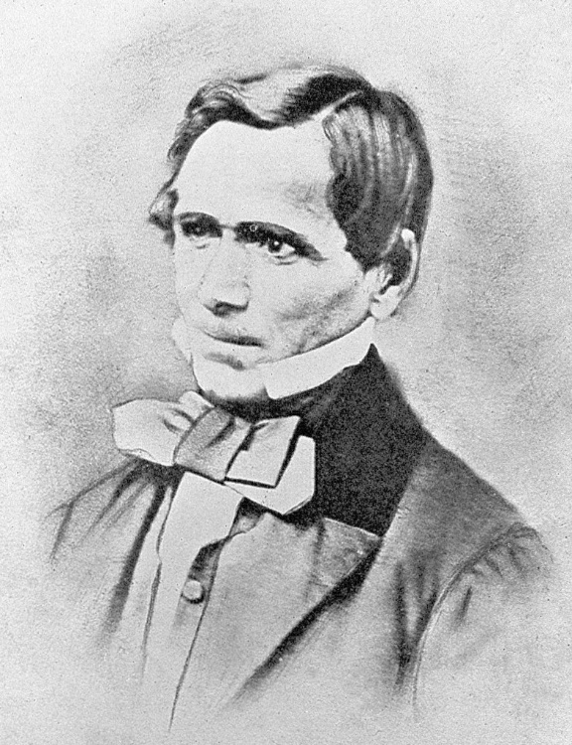  By Jesse Shire Myer [Public domain], via Wikimedia Commons  For below use the video at  https://www.dropbox.com/s/l0h3xcjfptt5ecf/  AllVideos%2C2014%2C7%2C22.mp4?dl=0  Show 13:16 to 13:24 (Bailey’s timestamp)  Then 12:02 to 12:12
As you read the article I hope that you gain an appreciation for how the science of genetics and nutrition can be applied to the ancient occupation of milking cows, and how that science has not only cut the price of milk in half since 1890, but as you will see, has reduced milk’s impact on global warming by a third since 1945.

Figures
[Figure 1] Original figure using data from http://www.infoplease.com/ipa/A0873707.html and a pricedeflator at http://www.reffonomics.com/TRB/chapter20/inflationcalculator.html.

References
Capper, J. L., R. A. Cady, and D. E. Bauman. 2009. “The environmental impact of dairy production: 1944 compared with 2007.” Journal of Animal Science. 87:2160-2167. DOI: 10.2527/jas.2009-1781.
Data acquired from OSU dairy farm. 2014. These were the data used to determine what a dairy cow consumes in 2014.
Lusk, Jayson. 2014. Personal communication. Department of Agricultural Economics. Oklahoma State University.
Radiolab. Episode 7. Season 10. Guts [podcast].
Fellner, V. and J. W. Spears. 2004-2005. North Carolina State University Animal Science Departmental Report. Accessed July 23, 2014 at http://www.ncsu.edu/project/swine_extension/swinereports/2004-2005/beefcattle/nutrition/fellner.htm.

