The finger-prints of bacteria

TP = talking points
AA = add audio
Cam 1: 00:00:22;0 to 00:00:33;0  At 00:41;00  To 41;25 | [TP]  Do the same bacteria infect both livestock and humans?  Can Staphylococcus aureus (S. aureus), which infects us, be found in dairy cattle?
Use pictures and audio  [AA]  We are particularly interested in S. aureus because it can develop a resistance to the antibiotic methicillin, making S. aureus difficult to treat. You have probably heard of the infection MRSA. That is just methicillin-resistant Staphylococcus aureus … | Figure 1  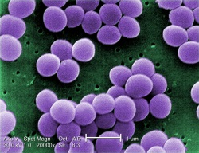  [Within or above the picture use title]  MRSA = methicillin resistant Staphylococcus aureus
which has harmed the health of both humans and livestock. So if S. aureus can infect both humans and livestock, and if S. aureus can develop a resistance to antibiotics, that is a link between the health of cattle and humans we need to be aware of. This video provides a virtual tour of how Dr. Matyi and Dr. Gustafson at Oklahoma State University answered that question. To determine if the S. aureus that infects humans can also be found in cow milk … | Show pics titled SheepInfection and HumanInfection side-by side. Title one MRSA infecting sheep and the other MRSA infecting a human  Figure 2  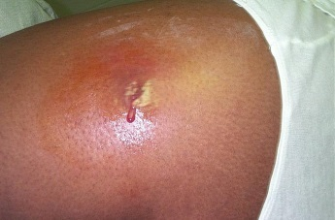  Figure 3
Beginning from Cam 1 00:53;00 where I say “they first”  To 57;00  To 1:32;00  1:45  (replace 1:46;00 with CAM 2 2:20;00 to 2:37;00  1:52  (replace video 1:58;00 to 2:32;00 with CAM 2 5:01 to 5:30  , leave audio alone)  2:35;00  (replace video 2:49;00 with CAM 2 6:20 6:26, but leave audio alone)  3:16  Better shot of the petri dish at 5:41;03 to 6:14;28 (CAM 1) so perhaps either use a picture from this portion or insert the video in place of the video around 3:15  3:52  Incorporate brief, better shot of agar at CAM 8:41;00  4:14;21  Better shot of the actual DNA code they are looking for at CAM 1 6:42;23 | Step 1: Gather 133 milk samples from 133 different dairy cattle, 33 of which were sick.  Step 2: Of the microorganisms in the milk, feed S. aureus and poison others.  (Agar: a gelantinlike product of certain seaweeds)  Mannitol salt agar—petri dish of agar with food for S. aureus and a high salt concentration  Sterilize equipment. Add milk sample to agar and place in incubator.  The agar feeds some bacteria (including S. aureus) and “poisons” other bacteria  Add animation:  With text and arrow show the yellow streaks and indicate it is S. aureus. Same for other side, indicate it is not S. aureus as it didn’t grow  If agar contains yellow streaks it may contain S. aureus, but could be some other bacteria.  To see if it is S. aureus, inspect the bacteria’s DNA and see if contains this unique sequence of 534 letters
CAM 1 14:50;00  To 15:41;00  16:03;00  16:23;00 | PCR = polymerase chain reaction  If that 534 letter sequence is in the bacteria’s DNA, PCR will make millions of copies of it  If this 534 letter sequence isn’t found, no copies will be made and the bacteria isn’t S. aureus | Note: the scene starting here at CAM 1 14:50;00 is also shot at CAM 2 16:30;00, so switch between the two cameras to add dynamism to video
Starting at CAM 1 16:25;07  16:32;00 to 16:40;00 audio  09:47;00 to 09:55;00  CAM 2 10:48;00 10:56;00 video | Step 3: Use PCR to detect and copy that 534 letter sequence  Ingredients of PCR  —Extract DNA from bacteria  —Add primers (tells PCR the 534 letter sequence to look for)
16:40;00 to 16:48;00 audio  09:24;00 to 09:32;00 video | —Add nucleotides (building blocks of DNA for making copies)
16:48;00 to 16:54;00 audio  10:27;00 to 10:33;00  CAM2 11:48;00 to 11:55;00 video | —Add polymerase (makes the copies)
16:54;00 to 16:59;00 audio (roughly)  17:36;00 to 17:39;00 and then 19:35;00 to 19:39;00 video | Let PCR work for a day and you will have millions of copies
16:59;00 video onward | Examine the copies to see if the DNA segment sequence is 534 letters long. If so, the bacteria in the milk is indeed S. aureus
Animation of PCR: using video at http://ra.okstate.edu/STW_DASNR/Norwood/PCRAnimation/video.html (though it needs correcting in two places … should not say lopesided and at end # lopsided should be 50, not 25.
 | This brief animation will demonstrate how PCR works.
 | You start with a whole DNA and heat it to 203⁰ F, (Begin playing animation)which causes the two sides to separate. We now have two entire strands of the DNA.
 | Specially designed primers then locate a specific part of the DNA. The Taq polymerase then attaches to the primers and begins rebuilding the other strand of that DNA from the primer until the end of the strand.
 | (pause when rebuilding is complete) After the first cycle we still have two complete strands of the DNA, but two lopsided strands as well.
 | Heating the DNA and separating them again, our primers (resume) and Taq polymerase then set about rebuilding the other side of four DNA strands.
 | After this second cycle we have (pause when rebuilding is complete) our original two whole DNA strands, four lop-sided strands, and two small segments of DNA we call the “target”. These two segments are the DNA segments we want PCR to replicate. The primers were designed such that, if this was the S. aureus bacterium, the polymerase would build these target DNA segments. (resume)
 | The process then repeats, and now, after the third cycle we have our two complete DNA strands, (pause when rebuilding is complete) 6 lopsided strands, and 8 target strands. If this continues until the 25 cycle, we have our two original (resume, but pause after cycle 25) complete DNA strands, 50 lopsided strands, and over 67 million target strands.
 | The target strands soon dominate because each (resume and let play out) cycle adds no full strands, only two lopsided strands, but the number of target strands more than doubles. It doesn’t take many cycles before any DNA pulled from the solution is virtually guaranteed to be one of the target strands.
Begin rolling at CAM 2 00:20:31;00
At 20:51;26;00  End at 00:21:04;00 | Gel electrophoresis—a method to measure the length (# letters) in a DNA segment
CAM 1 00:25:02;00 to 00:25:26;00 | Measures length of DNA by how far an electric current can push it inside a gel
CAM 1 00:25:25;00 to 00:25;32;00 | Here you see me hand the PCR results to the actual scientist who performed this research: Dr. Stephanie Matyi. | No audio
CAM 2 00:22:33;00 to 00:22:41;07 | She is now going to take a DNA segment from the output of the PCR …
CAM 1 00:26:52;00 to 00:27:02;00 | … and place it in a gel substance. Then she closes the lid and tells the computer to begin supplying the electric current for a specific amount of time.
CAM 1 00:18:57;00 to 00:19:07;00 | Once that time is finished they will remove the gel and can then analyze it in one of two ways. One way is to visualize inspect it in a special machine, like this one.
CAM 1 00:22:12;00 to 00:22:30;00 | Or you can have a computer take a picture of gel. The five horizontal lines in the first and last columns are like measuring sticks. They tell you how far a DNA segment of a certain length will travel. For instance, one of the bars might denote the distance a segment consisting of 534 letters might travel. The horizontal lines in the middle are the DNA segments.
Show pic GelE  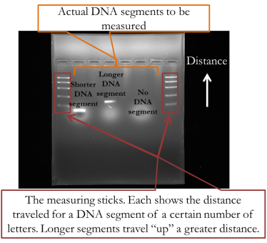 | Here is a clearer picture. In the second and third columns are horizontal bars indicating the length that two DNA segments traveled. The further “up” the segment goes, the smaller the segment it is. When they analyzed the segment they acquired from the PCR, and compared it to the measuring sticks on the sides, they concluded that the DNA segment was indeed 534 letters long.  That was proof that the bacteria in the milk sample was indeed S. aureus.
Show pic AntiResist  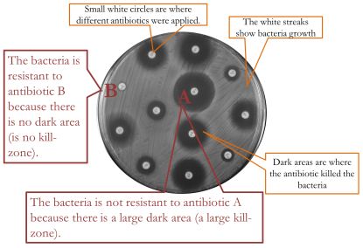 | Concluding remarks made in the lab:  Finally, we may want to ask whether this S. aureus is resistant to certain antibiotics. The method for testing this is simple. Put antibiotics on the bacteria and see if it kills it. What you see here is a picture of a petri dish that had a bacteria colony grown all over it. The solid, small circles are where researchers added antibiotics. Some, like the one labeled A, has a large kill zone around it—a large dark circle, where the lack of streaks indicates that bacteria are no longer growing on it. This means that antibiotic killed a lot of bacteria, and so the bacteria is not resistant to that antibiotic.  However, look at B, with almost no kill-zone around the circle. That means the antibiotic was ineffective, and thus the bacteria was resistant to that antibiotic.
The field of biochemistry and molecular biology changes fast, and in just a few years researchers will use different tools than those described here. For instance, instead of using PCR and gel electrophoresis they will just sequence the whole DNA, thereby acquiring not just one segment of the DNA, but the whole thing.

Still, what we learned today is helpful in understanding those new technologies. The Sanger Method of sequencing the entire DNA uses PCR, for instance. Although the Ion Torrent technology for DNA sequencing does not use PCR, it does use polymerase.

 | Moreover, understanding PCR is useful for understanding all DNA studies, whatever methods are employed. PCR played a part of beef production when they discovered the gene causing birth defects in one particular Red Angus bull,^{(A1)} and PCR was one of the tools used to identify the gene for tender beef in cattle.^{(I1)} Rice farmers in developing countries now have access to rice seed that will patiently remain dormant during prolonged floods, sprouting when the waters have receded. After identifying the gene sequence that makes some plants possess this trait, they inserted this sequence into more popular rice plants. It took only four years between the time this gene sequence was identified before it was available to farmers, and PCR deserves some of the praise.

A special thanks is given to Stephanie Matyi, Nathanial Torres, and John Gustafson of the Biochemistry and Molecular Biology department at Oklahoma State University.

Figures

(1) In public domain. Acquired on May 28, 2014 from Wikimedia Commons at http://en.wikipedia.org/
wiki/File:Staphylococcus_aureus_VISA_2.jpg.

(2) By Jóna Þórunn (Own work) [GFDL (http://www.gnu.org/copyleft/fdl.html) or CC-BY-3.0 (http://creativecommons.org/licenses/by/3.0)], via Wikimedia Commons

(3) HumanInfection: By CDC/Bruno Coignard, M.D.; Jeff Hageman, M.H.S. [Public domain], via Wikimedia Commons

