The finger-prints of bacteria
(http://fbaileynorwood.blogspot.com/p/the-finger-prints-of-bacteria.html)

To understand modern agriculture we must understand genetics. Scientists are developing new varieties of rice that will benefit small farmers in developing countries. Some, like Golden Rice, are created through genetic modification, where genes from organisms other than rice were added to the rice DNA. Other times scientists use information on rice DNA to decide which rice plants to breed.

Understanding DNA is important to the beef industry as well. Ranchers breeding Red Angus bulls once had problems with birth defects in their calves, but scientists helped remedy this problem when they detected the gene causing this birth defect. Now, there is a genetic test available for ranchers to determine whether a cow or bull has this gene.

The health of humans and their livestock are interdependent. Most all human epidemics (like smallpox) were caused by bacteria or viruses that originated in livestock and then evolved to infect humans. Even today, the same strains of bacteria can affect both humans and livestock—and some of them are becoming resistant to antibiotics. Scientists today study the DNA of bacteria in humans and livestock to see if the same bacteria can infect both.

To understand much of modern agriculture, we must understand the structure of DNA and the biological process of reproduction.

The twisting, double-helix structure of DNA is one of the most recognized images in the modern world, but not everyone understands exactly what the DNA components are, so first we will briefly discuss the structure of DNA. Then we will go to the laboratories at the Department of Biochemistry and Molecular Biology here at OSU to see how scientists determined that the same bacteria, S. aureus, were infecting both cattle and humans. | FIGURE 1  (Bailey holds up the DNA-prop, horizontally, twisting it)
Let’s untwist our simple depiction of DNA, so that it looks like a ladder, and perform an autopsy of it. Before we identify its components, remember that all organisms are built according to the information contained in the DNA, and the structure of every organisms’ DNA is made from the same things.  Just as a big or small ladder can be made from the same material, this model DNA could be a segment of a human, worm, flower, or bacteria DNA. | Talking points:  The Structure of DNA  (Bailey holds up the DNA-prop, rotates it vertically, untwisting it)
The sides of the DNA, usually called its “backbone” are phosphate and Deoxyribose (sugar) molecules. This backbone only provides structure to the DNA. It doesn’t have any genetic information. | (Animation: point to yellow balls and say “phosphate molecule” and point to green balls and say “Deoxyribose (sugar) molecules).
The genetic information is contained in the steps of the ladder. You’ll notice the steps are made of different colors, and there are only four colors: (1) light blue (2) dark blue (3) pink and (4) red. These are four nucleotides, and they go by the name of:  - Guanine (G)  - Cytosine (C)  - Adenine (A)  - Thymine (T)  All organisms’ DNA have only these same four nucleotides. What makes us different from the worm, plant, or bacteria, is the length of our DNA and the sequence of the nucleotides. The length of our DNA could theoretically be the same as that of a plant, but so long as the sequence of the nucleotides is different, we will be built differently than the plant.  Rather than repeating the names of the nucleotides over and over, let’s just identify them by their first letter: G, C, A, and T. | - Animation: point to dark blue and label Guanine (G)  - Animation: point to light blue and label Cytosine (C)  - Animation: point to pink and label Adenine (A)  - Animation: point to red and label Thymine (T)  Animation:  - Replace Guanine (G) with just G  - Replace Cytosine (C) with just C  - Replace Adenine (A) with just A  - Replace Thymine (T) with just T
Now I’m going to rotate the DNA horizontally and point-out a pattern in the DNA. Notice that each step of the ladder contains two colors, which means each step is made up of two nucleotides that are bound together by hydrogen bonds. Notice the pattern though. Light blue is always connected with dark blue, meaning G is always matched with C, and pink is always matched with red, meaning A is always matched with T. | Animation: point this out on the DNA.  (Bailey now puts down the model, and DNA will now be represented with animation)  Animation: show this model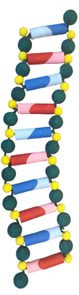
What this means is that if we know one side of the DNA, we know the other side, allowing us to just concentrate on one side of the DNA. | Animation: show the top and bottom splitting, like that below, and then remove the bottom part.  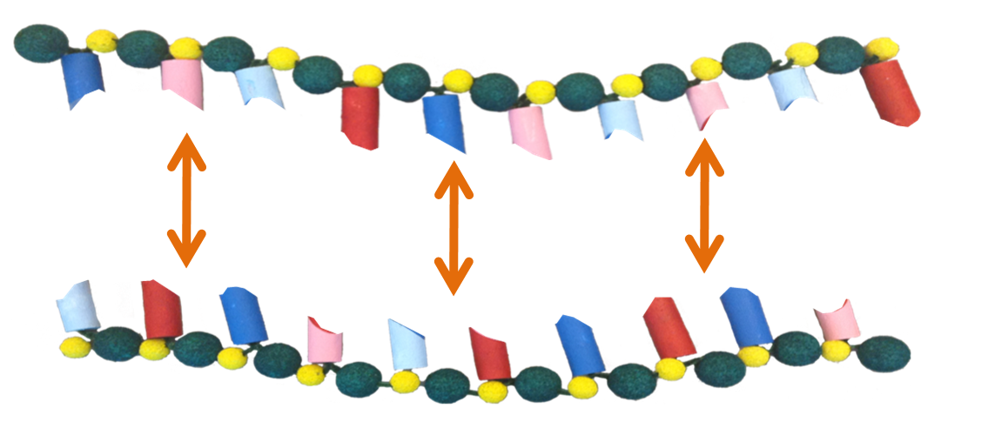
Finally, since we are concentrating on only one side of the DNA, and all the information is contained in the sequence of the four nucleotides, we can represent DNA as a simple sequence of four letters:  GACTGACACT | Animation: Point to each color and label it with the appropriate letter. Then make the picture go away, except for the letters, and then bring the letters together to make a simple sequence of the letters:  GACTGACACT
When discussing DNA, we can simply talk about it as a sequence of four letters, where the length of that sequence differs across organisms.

Using this simple model of the DNA can be deceiving because it is so small. How many letters are contained in the actual DNA of, say, a S. aureus bacterium?

NOW THE VIDEO MOVES FROM THE LAB ONTO THE FOOTBALL FIELD
Now using video at http://ra.okstate.edu/STW_DASNR/Norwood/FootballScript/video.html
01:47:55;00 to … messed up cause I said you only see three letters when there are actually four

01:44:00;00 to 01:46:46;00 good but didn’t walk down the whole 45 yards
Use 01:51:51;00 to 01:53:54;00
there is some video of the camera zooming in more on the DNA as the cameraman walks … incorporate some of that if you think it improves the lecture. There is also video around 01:27:46 showing me walking and being filmed from up high in the stands. Incorporate that where you see appropriate also.

Later in the video we have Gary’s camera, from the stands, behind and to the side of the goal posts. Incorporate this video as you see fit. They are at 01:14:00:00 to 01:14:11;00 and 01:16:12;00 to 01:16:24;00 (I can’t tell if he made these two goals)
Beginning of video to 01:39:32

01:41:19;00 to 01:41:41;00

Then use 01:42:49;00 to 01:43:12;00
Then use 01:58:25;00 to 01:59:11

