Conducting Consumer Research
(under 10 minutes)
Most of my kin rely almost exclusively on low-carb diets to lose weight, and when they go on a low-carb diet they replace some of their carb-calories with beef and yogurt. For my family, this means that meat and yogurt played an important role in maintaining a healthy weight. This means that two foods produced from dairy cattle: beef and yogurt, are essential to them for a slim figure.
But are they representative of all Americans? What percent of Americans who use low-carb diets increase their meat and yogurt consumption when losing weight? That is a question worth asking, and I answered it using a survey.
This lecture is about how to conduct consumer research using a survey or consumer experiment. We are focusing on beef and yogurt, but the general survey methods can be applied to any food or product.
The first step in administering this survey was to recruit a group of survey respondents who were representative of all Americans. This was the easy part, as I could simply pay a marketing firm to administer the survey online, and they would ensure a representative sample.  A sample is representative if its demographics match those of the population you are studying. In my case, I was studying Americans in general.  In many ways my sample was representative. For example, 13% of the American population is 65 years of age or older, and 13% of my survey respondents were also 65 or older.  This survey was not perfectly representative though, because it didn’t account for people who don’t use the internet and don’t like taking surveys, but it is a good sample nevertheless. | Step 1 to surveys: Recruit a representative sample of subjects  A sample is representative if its demographics match those of the population you are studying.

Allow me to give a rather humorous description of a “representative sample”.  This American Life is one of the most popular podcasts, and in their episode titled A Little Bit of Knowledge, NPR journalist Alex Blumberg told a story about what he thought the Nielson Ratings were.  For those of you who do not know, the Nielson Ratings are how we measure the popularity of television shows. They are statistics compiled by the Nielson Company. They select a group of representative Americans and ask them to record all the programs they watch over a period of time. These Americans are selected so that all demographics of Americans (meaning all ages, genders, geographic locations, etc) are captured. And they are captured in a way that allows us to infer the viewing behaviors of all Americans.  Well, Blumberg thought the company was only acquiring viewing information on families with the last name of Nielson. He thought that was why it was called the Nielson ratings.  Blumberg just assumed there was one explanation for this, and in this explanation he reveals his intuitive grasp of a representative sample. He remarks:  “I think I figured they had done some research and found that the name Nielsen-- because it was a common name maybe, and it seemed to cut across class and economic lines-- actually came pretty close to a representative sample.” | “I think I figured they had done some research and found that the name Nielsen—because it was a common name maybe, and it seemed to cut across class and economic lines—actually came pretty close to a representative sample.”  —Blumberg, Alex [guest]. July 22, 2005. “A Little Bit of Knowledge.” This American Life. Episode 293. Host: Ira Glass.
Now back to my survey on low-carb diets.  After acquiring a representative sample, the next step was to “control as much as you can,” which means with surveys that since you are in charge of writing the questions, you control the language used and the ordering of questions such that subjects are really answering the questions you want them to address.  I did this by first asking a series of questions that filtered out all the individuals who have not and do not rely upon low-carb diets for weight loss. Thus, I “controlled” for the fact that some people have never been on a low-carb diet.  [Insert Figure 1]  Then, I asked this very simple question: When you are own a low-carb diet, how does your consumption of the following foods change? I then listed  - beef  - pork  - chicken/turkey (as a single group)  - milk  - yogurt  - cheese  - eggs  - vegetables  - sugar (excluding those found naturally in fruits)  - fruits  And I then asked whether they  - consume less of,  - consume the same amount of, or  - consume more of  each food.  I “controlled” for the fact that some people can be wishy-washy in their answers. I wanted them to have to choose between eating more, less, or the same amount. There was no “I don’t know,” category for them to choose from. Now, sometimes researchers do want consumers to have the option of responding with “I don’t know”, but since I could only afford a sample of less than 400 subjects, I needed those subjects to state a position clearly. Had I allowed for “I don’t know answers” I might have had only a few dozen of responses to my main question of interest. | Step 2: Control as much as you can  [Figure 1]  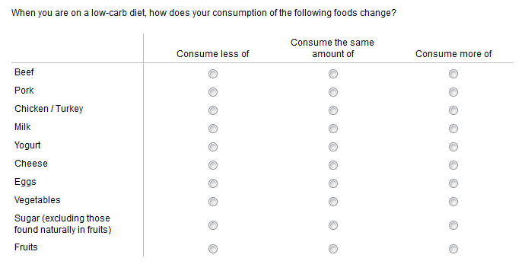
As you might expect, people’s responses will be influenced by the order of the foods listed. People might be more inclined to choose some of the first four options, simply because they do not want to read all the options. Perhaps they might say they eat more beef on low-carb diets simply because it was the first item to choose from. This would bias the survey, and whenever there is a factor embedded in the survey that biases subjects’ answers, the solution is to randomize it. Randomize what you cannot control.  In this case, we randomly varied the order of the foods listed. Beef appeared first on the survey the same amount times as pork, chicken/turkey, milk, or any other food. The precise ordering of the food items for any one survey was randomly determined by a computer.  So if people do tend to select the first items on the list, this randomization will not allow this tendency to bias responses in favor of one food or another. | Step 3: Randomize what you cannot control  As I’m saying this, show on the screen different random orderings of the answers.  Random ordering #1  - beef  - pork  - chicken/turkey  - milk  - yogurt  - cheese  - eggs  - vegetables  - sugar (excluding those found naturally in fruits)  - fruits  Random ordering #2  - cheese  - eggs  - vegetables  - sugar (excluding those found naturally in fruits)  - fruits  - beef  - pork  - chicken/turkey  - milk  - yogurt  Random ordering #3  - eggs  - vegetables  - cheese  - pork  - chicken/turkey  - milk  - yogurt  - sugar (excluding those found naturally in fruits)  - fruits  - beef
[Insert Figure 2]  What did I learn from the survey?  Of the 388 individuals who took the survey 197 had gone on a low-carb diet and could tell us how their food patterns changed. The graph here shows, of the 197 individuals, how many consume more, less, or the same amount of each food item while on the diet.  More people decreased pork and beef consumption than those who increased it, but the reverse was true for chicken/turkey. Some people reduced chicken consumption on a low-carb diet, but many more increase consumption.  What about yogurt? More people ate more yogurt when they went on a low-carb diet than those who ate less.  This suggests that yogurt but not beef is an important complement to low-carb diets.  The most interesting result is that the majority (68%) increased their vegetable consumption and only 6% consumed less. That has to make nutritionists happy!  Surprisingly, more people increased their consumption of fruits than those who either decreased or consumed the same amount of fruit. This is surprising because fruit contains many sugars, which are certainly carbs! | [Figure 2]  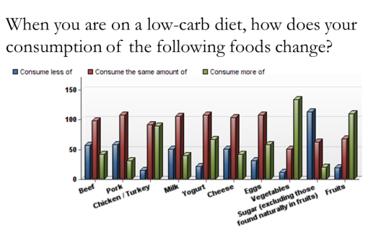  Low-carb dieters ate less beef and pork  Low-carb dieters ate more chicken/turkey and yogurt  Low-carb dieters increased vegetable consumption the most
Why am I telling you about this survey?  Because in our effort to “understand modern agriculture” we want to do more than learn how farmers raise crops and animals. We want to understand the interactions between farmers and consumers, and thus we want to know how consumers think about food. | To understand modern agriculture we must understand consumer preferences for food.
Between 2007 and 2013, sales of Greek yogurt—a yogurt higher in protein than regular yogurt—went from 1% of the yogurt market to 36%!

Was it just the taste? Probably not. My study showed that sales of Greek yogurt tend to increase when people go on a low-carb diet, and enthusiasm for low-carb diet has not waned in the last 10 years. One of the hardest parts of a low-carb diet is finding a variety of foods to eat, since bread is now out of the picture. Greek yogurt offers a new alternative, and consumers adopted it eagerly.

I think this an important insight about consumer preferences for dairy foods.

To understand modern agriculture we must understand modern consumers. | To understand modern agriculture we must understand modern consumers.
Consider another example. I once conducted a telephone survey of more than 1,000 Americans to gauge their attitudes about the well-being of farm animals. Two of the questions I asked are:  - Do you agree or disagree? Low meat prices are more important than the well-being of farm animals.  - Do you agree or disagree? The average American believes that low meat prices are more important than the well-being of farm animals.  This also is a dairy issue, as just like every other livestock industry, the dairy industry is under the watch of animal welfare advocates, and periodically scrutinized for how calves and dairy cattle are raised (especially since some dairy calves are raised for veal).  Here is what we found. When we asked if they believe that low prices are more important than the well-being of farm animals, only 16% agreed. That is, most people told us that preventing animal suffering is more important to them, than low meat prices.  But when we asked them to speculate about what the average American believes, the percent agreeing went from 16% to 68%!  Think about that! Most people were basically saying, “I personally care more about the well-being of farm animals, but the average American doesn’t.” That is like saying most people are above average in height. Mathematically, it just can’t be true.  It is impossible for both of these percentages to be true, so subjects are telling lies to at least one of the questions. I believe they were probably overstating the degree to which they really take the well-being of farm animals into account when purchasing food.  Though the student may find this surprising, psychologists would not, as they have consistently found that most people rate themselves above average on almost everything, which mathematically is impossible (note: for those who know statistics this assumes most people interpret the average to be the median).  This is referred to as the Lake Wobegon Effect, from NPR’s A Prairie Home Companion where a fictitious town of Lake Wobegon is described as, “all the women are strong, all the men are good looking, and all the children are above average.”  What we believe these questions tell us is that you cannot measure how much people really care about the well-being of farm animals by directly asking them. One must infer it indirectly, say, by their purchasing behavior. That is, you can’t simply ask consumers whether they would pay 10% higher prices for cage-free eggs. Too many would incorrectly answer “yes”. You must observe whether they actually do so.  The same goes for other issues, like milk produced using rBST and sustainable beef.  For this reason researchers often use consumer experiments instead of surveys, where they place subjects in a scenario where they must make real purchasing decisions with real money.  This and the following two lectures are all about how to conduct consumer experiments, using as an example recent research on consumer preferences for milk.  Much about designing experiments is similar to a survey. You must choose a representative sample, control your questions intelligently, and randomize what you can’t control.  However, experiments require more than that. They require auctions, and not the type of auction you are used to. | - Do you agree or disagree? Low meat prices are more important than the well-being of farm animals.  - Do you agree or disagree? The average American believes that low meat prices are more important than the well-being of farm animals.  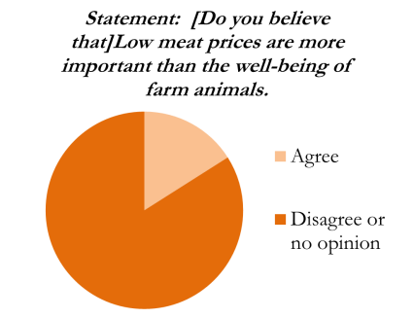  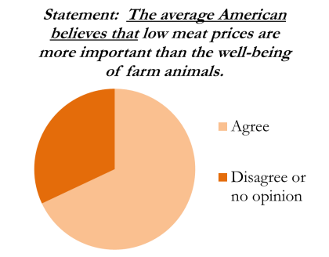  Mathematically, a majority of people cannot care more about livestock than the average American.  Lake Wobegon Effect—where a majority of people believe they are above average.

References
Domnick, Brianna. 2014. The Low-Carbohydrate Diet Movement. M.S. Thesis. Oklahoma State University. Stillwater, Oklahoma.
Polis, Carey. March 5, 2013. “Greek Yogurt Invasion Continues As Product Is Added To Cream Cheese, Hummus And More.” Huffington Post. Accessed July 8, 2014 at http://www.huffingtonpost.com/2013/03/05/greek-yogurt-food-product_n_2807818.html.
Prickett, Rob, F. Bailey Norwood, and Jayson L. Lusk. 2010. “Consumer Preferences for Farm Animal Welfare: Results From a Telephone Survey of U.S. Households.” Animal Welfare. 19:335-347.
This American Life [podcast]. July 22, 2005. “A Little Bit of Knowledge.” Episode 293. Host: Ira Glass.

