Experimental auctions for milk
When German author Johann Wolfgang von Goethe [gur-tuh] wanted to sell an epic poem to a publisher he employed a rather odd way of negotiating the royalties (royalties are the percent of the sales that go to the author).  [insert figure 1] | [Figure 1]  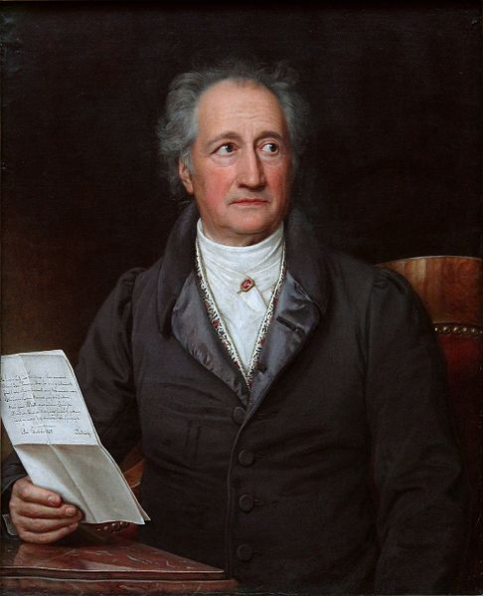  Joseph Karl Stieler [Public domain], via Wikimedia Commons
Goethe said both he and his publisher should submit offers to a third-party. Goethe’s letter would contain the royalty he demands, and the publisher would submit their offered royalty. This third-party would then open the letters and determine the outcome of the negotiation using the following two rules.

If the publisher offered less than Goethe demanded, there would be no deal and Goethe would seek another publisher.
However, if the publisher offered more than Goethe demanded, then Goethe would not charge more than his original offer.
To illustrate, let’s suppose that Goethe demands 13% royalties from all the book sales. He would then write 13% on his letter to the third-party. Suppose also that the publisher offers 10%. They would then write 10% in a letter to that same third-party. Because the publisher offered less than what Goethe demands, there would be no deal. Goethe would seek another publisher. | Goethe demands 13%  Publisher offers 10%  Result: no deal. Goethe seeks another publisher.
Suppose instead that the publisher offers 15%. Now a deal is made, but the publisher doesn’t pay 15%, but 13%--the original amount Goethe demanded. | Goethe demands 13%  Publisher offers 15%  Result: Deal is made. Publisher pays Goethe 13% royalties, less than the publisher’s offer.
It appears that regardless of the outcome Goethe would know what the publisher offered, but the publisher would only know Goethe’s demand if the deal was made.
His motivation for this strange offer can be found in a letter where he says, “Let me … name the main evil. It is this: the publisher always knows the profit to himself and his family, whereas the author is totally in the dark.” | “Let me … name the main evil. It is this: the publisher always knows the profit to himself and his family, whereas the author is totally in the dark.”
What Goethe was attempting to do was to find out exactly how much his work was worth to the publisher—that is, the maximum amount the publisher were willing to pay. Knowing he could not just ask the publisher the maximum price they would pay, he instead made this wacky offer that, as we shall see, encourages the publisher to reveal this maximum price.
It turns out that economists also like to make these wacky deals. Often we want to know the maximum amount a consumer will pay for something, like, milk produced without using rBST.

Because consumers don’t want always tell the truth in surveys, we often prefer to use experiments where people are actually given the option of purchasing the good.

Like Goethe though, it is not easy getting this maximum price because no one wants to pay it! So what economists do is to employ weird auctions like a second-price auction where the participant enters an auction to buy milk, but they if they win they don’t pay their auction bid, but the second-highest bid.
Why the second-highest price? Well, Goethe’s publisher would submit their maximum willingness to pay because they knew, if the deal was made, they would always pay less than that price. Likewise, in a second-price auction you have the incentive to bid your true maximum willingness-to-pay because if you win you always pay a price lower than that maximum.
This article discusses how to administer such a auction and why it works. It does so in the context of a study attempting to measure the value of milk produced without using the rBST synthetic growth hormone, relative to milk that did use it. The authors found that a label on milk saying it was produced without using rBST stigmatizes milk produced using rBST. This is good evidence for why most of the milk you purchase has the no-rBST label.

Figures
(1) Joseph Karl Stieler [Public domain], via Wikimedia Commons.
References
Moldovanu, Benny, and Manfred Tietzel. 1998. “Goethe’s Second-Price Auction.” Journal of Political Economy. 106(4).

