The carbon footprint of beef and other foods
In 2008 the EPA began coming up with concrete solutions for reducing greenhouse gas emissions, and one of these solutions involved a tax on emissions. When applied to beef producers, it meant they might have to pay an annual tax of $88 for each cow they owned. Not surprisingly, beef producers were outraged, but environmentalists saw it as a reasonable action, given the carbon footprint of beef production. The tax wasn’t meant to penalize people for owning cows, but for the greenhouse gas emissions those cattle are responsible for emitting.  A tax would also be applied to hogs, but would only be $22 per hog, because in any year a hog emits less greenhouse gas emissions than a beef cow. | [talking points]  —EPA can tax carbon emissions to fight global warming  —Might tax ranchers $88 for each beef cow they own  —EPA can tax carbon emissions to fight global warming  —Might tax ranchers $88 for each beef cow they own  —Because hogs emit less greenhouse gases, the hog tax would only be $22 per hog.
By the way, if you are confused as to why I say “greenhouse gas” in one breath but the word “carbon” in another, it is because when we measure and report emissions of greenhouse gases we usually state them in terms of their carbon dioxide equivalent. For example, methane has about 21 times the global warming effect as carbon dioxide, so when we report 1 ton of methane we often refer to it as 21 tons of carbon dioxide.  Most of the time when we measure the “carbon emissions” of something we are referring to the equivalent tons of carbon dioxide.  This is why we say “carbon footprint” when we refer to an impact on global warming. | Warming effect of methane (CH₄) is 21 times that of carbon dioxide (CO₂)  All greenhouse gas emissions tend to be reported in equivalent units of CO₂.  So one ton of CH₄ is reported as 21 tons of CO₂.  “Carbon emissions” usually means tons of [equivalent] CO₂  This is why we use the term “carbon footprint” to denote the impact on global warming.
The idea of a carbon tax applied to agriculture is relatively simple. If beef production resulted in a certain amount of greenhouse gas emissions, and those emissions imposed a cost on the population today as well as future generations, beef producers should compensate society by paying a tax equal to those costs. If you are for a carbon tax, that is the justification you might use.  This way, the animal would only be raised if society valued the food it produced more than the pollution it caused—that’s how markets work; they only sell things to consumers when the consumers are willing to pay more than what it costs to produce. | A carbon tax equal to the costs caused by the carbon ensures the food is only produced if consumers value the food more than the global warming it causes.
Of course, estimating the appropriate tax rate is difficult. It requires knowing (1) the amount of greenhouse gases emitted from each animal and (2) the damages those emissions impose on society.  Estimating (2) is more guess-work than science, but it is impossible to construct a rational solution to global warming without coming up with some number for the cost of carbon emissions. The EPA has proposed a tax of $44 per ton of emissions.  But measuring (1) can be done with more scientific rigor. Scientists can measure greenhouse gas emissions from cattle by enclosing them in a container that traps all emissions from the cow while also bringing in fresh air for the cow to breathe. An example of such a contraption is shown here. [show picture] | [talking points]  A carbon tax requires  - Knowing greenhouse gases emitted by each animal  - The damages those emissions impose on society  Example: one ton of carbon dioxide may impose $44 of costs to society  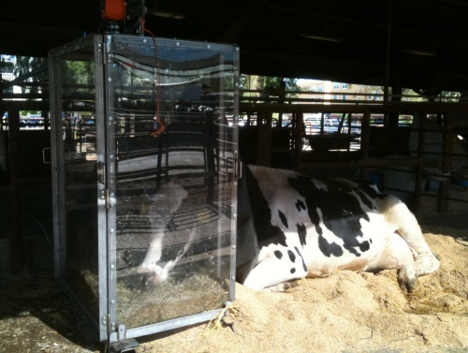
This is a cow whose head was kept inside of a chamber for a period of time. The cow could still stand up if she wanted, and she wasn’t kept in the chamber for very long. It didn’t hurt her and she could still find a comfortable resting position.  This chamber was designed to deliver fresh air for the cow and to capture all the air leaving the chamber, thereby enabling researchers to measure all the greenhouse gases emitted from the cow’s head.  It turns out that cattle emit a good deal of methane, a greenhouse gas, so you may be wondering why her head, not her rear is in a chamber. It turns out that it is the head, not the rear of the cow, where most greenhouse gas emissions emanate from. It is the burps, not the farts of the cow that emit the most methane, and cows burp about once a minute. | Cows emit methane, a potent greenhouse gas, when they burp … and they burp about once a minute.
Because researchers have developed such scientific tools for measuring the carbon footprint of food we have a decent though imperfect picture of what the carbon footprint of different foods looks like.
The reason “beef” is separated from “other foods” in this lecture’s title is because beef is often associated with a high carbon footprint relative to other foods, and there is considerable controversy right now over whether conventional beef has a lower or higher carbon footprint than grass-fed beef.

The article assigned to you is about more than beef and carbon, however. It asks whether organic food has a lower carbon footprint, it reports the relative footprint of chicken, pork, and other foods, and it also provides some practical advice on reducing your carbon footprint by changes in your diet and spending habits.
I’m hoping that the reading will give you a better idea of the relationship between your diet and your carbon footprint, some of the controversies regarding the carbon footprint of food, and how to think about reducing one’s carbon footprint, if you choose to do so.

(F2) FactCheck.org. December 29, 2008. EPA Tax on Cows and Pigs? [website]. Accessed April 292, 2014 at http://www.factcheck.org/2008/12/epa-tax-on-cows-and-pigs/.
(F3) Farm Bureau. Green House Gas Regulation, The Clean Air Act and Potential Implications For Production Livestock. Accessed April 29, 2014 at http://www.fb.org/newsroom/nr/nr2008/11-20-08/ANPR_Title_V_Justification_Final.pdf.
(P3) Place, Sara E., Yuee Pan, Yongjing, and Frank M. Mitloehner. 2011. “Construction and Operation of a Ventilated Hood System for Measuring Greenhouse Gas and Volatile Organic Compound Emissions from Cattle.” Animals. 1:433-446. doi: 10.3390/ani1040433.

