Science of soil testing
Unless noted otherwise, all times refer to the main video at http://ra.okstate.edu/STW_DASNR/Norwood/SoilScript/video.html

 | Talking points are in this color
 | Animation requests are in this color
00:00:16;00 begin
00:00;34;00 | Feeding plants  - Measure nutrients in the soil  - Determine the plant’s nutrient needs  - Add fertilizer to make up for any soil nutrient deficiency
00:00:50;00 | Feeding plants  - Measure nutrients in the soil  - Determine the plant’s nutrient needs  - Add fertilizer to make up for any soil nutrient deficiency
00:01:09;00 | We want optimal fertilizer applications  —Too little and plants are unhealthy
00:01:23;00  At 00:01:27;00 show this pic [pic 1 = Wpollution.png] for 3 seconds  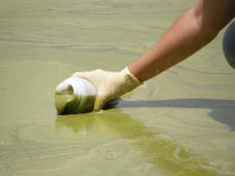 | We want optimal fertilizer applications  —Too little and plants are unhealthy  —Too much and fertilizer runoff pollutes waters
1:44;00 | Optimal fertilizer use requires information on nutrient content of the soil
Title: Plant nutrients
02:25;00 | PLANT NUTRIENTS  Non-mineral nutrients  hydrogen, oxygen, and carbon
00:03:20;00 | PLANT NUTRIENTS  Non-mineral nutrients  hydrogen, oxygen, and carbon  Mineral nutrients  Primary macronutrients—nitrogen, phosphorus, and potassium
00:03:33;00 | PLANT NUTRIENTS  Non-mineral nutrients  hydrogen, oxygen, and carbon  Mineral nutrients  Primary macronutrients—nitrogen, phosphorus, and potassium  Note: the term “fertilizer” often means just nitrogen, phosphorus, and potassium
00:04:30;00 | PLANT NUTRIENTS  Non-mineral nutrients  hydrogen, oxygen, and carbon  Mineral nutrients  Primary macronutrients—nitrogen, phosphorus, and potassium  Secondary macronutrients—calcium, magnesium, and sulfur  Micronutrients—boron, copper, iron, chloride, manganese, molybdenum, and zinc
PLANT NUTRIENTS
Non-mineral nutrients
hydrogen, oxygen, and carbon

Mineral nutrients
Primary macronutrients—nitrogen, phosphorus, and potassium

Secondary macronutrients—calcium, magnesium, and sulfur

Micronutrients—boron, copper, iron, chloride, manganese, molybdenum, and zinc
4:47;00 | When we say “nutrients” on this tour we are referring to plant-available nutrients. Not all nutrients are in a chemical form plants can consume
End at 6:09;00
Title: Overview of soil test process
06:31;00 to 06:35;00
06:35;00 to 06:45;00 (audio only)  From link at right show video (no audio) from 00:01:53;00 to 00:02:03;00 | The farmer …  - Takes many (> 20) soil samples from different parts of the field | http://ra.okstate.edu/STW_DASNR/Norwood/SoilTestMagruderScript/video.html
06:44;00 to 06:48;00 (audio only)  From link at right show video (no audio) 00:04;13 to 00:04:17;00 | The farmer …  - Takes many (> 20) soil samples from different parts of the field  - Mixes the samples thoroughly and fills the soil test bag | http://ra.okstate.edu/STW_DASNR/Norwood/SoilTestMagruderScript/video.html
06:48;00 to 06:51;00 (audio only)  From link at right show video (no audio) 00:04:47;32 to 00:04:50;00 | The farmer …  - Takes many (> 20) soil samples from different parts of the field  - Mixes the samples thoroughly and fills the soil test bag | http://ra.okstate.edu/STW_DASNR/Norwood/SoilTestMagruderScript/video.html
06:51;00 to 07:06;00 (audio only)  In addition to the 3rd talking point show a picture of the bag at pic 11 = SoilTestBag.jpg  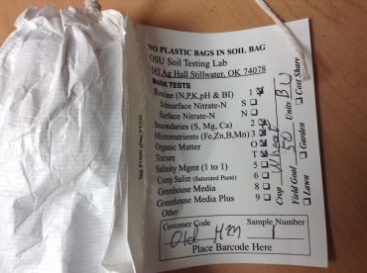 | The farmer …  - Takes many (> 20) soil samples from different parts of the field  - Mixes the samples thoroughly and fills the soil test bag  - Indicates on bag what type of tests she desires
07:06;00 to 07:15;00  As before, in addition to the 3rd talking point show a picture of the bag at pic 11 = SoilTestBag.jpg | The farmer …  - Takes many (> 20) soil samples from different parts of the field  - Mixes the samples thoroughly and fills the soil test bag  - Indicates on bag what type of tests she desires (most popular tests are nitrogen, phosphorus, potassium, and pH)
07:15;00 to 07:20;25

07:20;00 to 07:25;00  Note: stop at “soil test laboratory here—“ | The farmer …  - Takes many (> 20) soil samples from different parts of the field  - Mixes the samples thoroughly and fills the soil test bag  - Indicates on bag what type of tests she desires (most popular tests are nitrogen, phosphorus, potassium, and pH)  - Mails it to the soil test laboratory
From video at right link play 00:02:21;00 to 00:02:32;00 |  | http://ra.okstate.edu/STW_DASNR/Norwood/SoilOvenGrinderScript/video.html
From video at right link play 00:02:32;00 to 00:02:44;00 (audio only)  From video at right link play  00:00:13;00 to 00:00:24;00 (video only) | The lab …  - Bakes bag overnight at 150 degrees Fahrenheit (to remove all moisture) | http://ra.okstate.edu/STW_DASNR/Norwood/SoilOvenGrinderScript/video.html
From video at right link play  00:02:44;00 to 00:02:51;00 (audio only)  From video at right link play  00:04:48;00 to 00:04:52;00 (video only) | The lab …  - Bakes bag overnight at 151 degrees Fahrenheit (to remove all moisture)  - Grind sample until it resembles a powder | Putting sample in oven  http://ra.okstate.edu/STW_DASNR/Norwood/SoilOvenGrinderScript/video.html
then  00:10:07;00 to 00:10:18;00 (video only) |  | http://ra.okstate.edu/STW_DASNR/Norwood/SoilOvenGrinderScript/video.html
07:52;00 to 08:15;00

Title: Measuring nitrogen (I’ll leave it to your judgment if you can make attractive transitions from one section to another. So long as you don’t alter the content, feel free to edit the video however you think best.)
21:13;00 | This Flow Injection Analysis (FIA) machine measure one plant accessible form of nitrogen: nitrate (NO₃⁻)
21:53;00 | dry soil + liquid solution = liquid containing all plant-available nitrogen, converted to nitrate
23:00;00 | - FIA machine sends a specific wavelength of light through the nitrate liquid, towards a receiver.
23:18;00 | - FIA machine sends a specific wavelength of light through the nitrate liquid, towards a receiver.  - Some light is absorbed by the nitrate.
23:22;00 to 23:33;00 | - FIA machine sends a specific wavelength of light through the nitrate liquid, towards a receiver.  - Some light is absorbed by the nitrate.  - The less light the receiver detects the more nitrate is in the solution, and thus the more nitrogen that was in the soil.
Title: Measuring phosphorus, potassium, and other nutrients
Start at 09:03;00 | The Inductively Coupled Plasma Machine
00:09:30;00 | Dry soil + liquid solution = liquid containing all plant-available nutrients
00:10:03;00 | Spray plant-available nutrients into chamber hotter than the surface of the sun
11:27;00 | Animation request: show an atom with nucleus and electron, like this one. Just a nucleus and one electron. Have the electron orbiting the nucleus. Have the orbit of that electron follow my hand movements depicting an orbit.  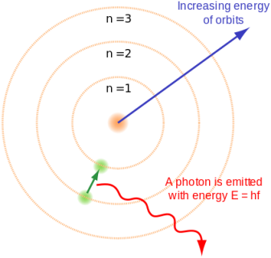
11:55;02 | Show electron moving away from nucleus, still orbiting, but orbiting at a greater distance. Have it follow my hands as I depict a larger orbit.
12:09;00 | Show electron collapsing to its prior orbit, the same distance from the nucleus as it began, and show a wave leaving the atom, labeling the wave as “photon = electromagnetic radiation”
12:45;00 to 12:58;25  Insert pic 3 [pic 3 = wavelength]  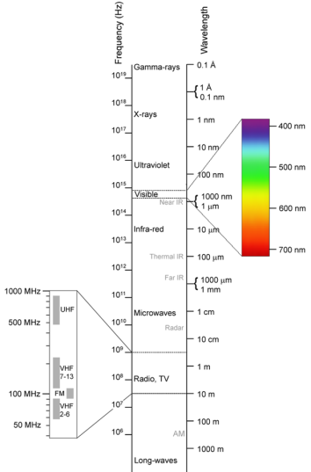 | Label the pic as “Electromagnetic radiation” and when I say that light is just electromagnetic radiation that we can see indicate that on the picture
13:05;00 | Go back to pic 3 and circle the wavelength giving the color orange
13:12;00 | Go back to Bailey
13:35;00 to 13:40;00 audio only | Show video at right link 00:05:05;00 to 00:05:10;00 | http://ra.okstate.edu/STW_DASNR  /Norwood/FireColorsScript/video.html  [blue]
13:40;00 to 13:47;00
13:45;00 to 13:50;00 audio only | Show video at right link 00:05:33;00 to 00:05:38;00 | http://ra.okstate.edu/STW_DASNR  /Norwood/FireColorsScript/video.html  [red]
13:50;00 to 13:55;00, audio only | Include video only from the link to the right: 00:00:57;09 to 00:01:02;09 | http://ra.okstate.edu/STW_DASNR  /Norwood/FireColorsScript/video.html  [green]
13:55
04:18;00 | This Inductively Coupled Plasma (ICP) machine can see many different wavelengths of electromagnetic radiation
14:30;00 to 14:51;00 | The ICP detects these wavelengths to determine nutrients are present in the soil, and at what quantities
Title: Measuring the pH of a soil sample
24:00;00
24:10;00 | The soil needs to have a proper pH for plants to consume nutrients
24:47;00 | pH measures concentration of hydrogen ions (H⁺) in the soil
25:13;00  Show pic 4 = HydrogenAndHIon  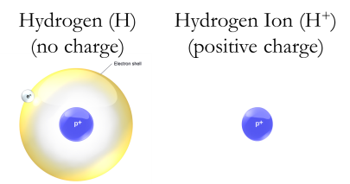 | A hydrogen ion is just a hydrogen atom with no electron.  H⁺ = one proton, no neutron, no electron.  H⁺ thus has a positive charge (it wants to acquire an electron to be made a complete hydrogen atom)
26:00;00 | Incorporate animation showing an electric current by showing free electrons moving to positively charged objects, trying to make it consistent with my hand movements. Use labels to show free electrons are negatively charged.
26:20;00 | pH in the soil is measured by the strength of the electric current the H⁺’s in the soil can facilitate. | Rick, show the video that shows the pH machine working. I didn’t see it on the video you provided me.
26:36;00 | Few H⁺’s means a weak current  Many H⁺’s means a strong current
27:10 | Show this formula on the screen  pH = -log₁₀(concentration H⁺)
27:28;00 | pH of “pure” water is  pH = -log₁₀(0.0000001) = 7  pH of 7 is said to be neutral
27:48;00 | An acidic soil  X > 0.0000001  pH = -log₁₀(X) = < 7  pH less than 7 is said to be acidic
28:00;00 | Heavily farmed fields tend to become more acidic over time
28:25;00 | If too acidic then crops may suffer  Farmers then raise the pH by applying lime to the soil
An alkaline soil

X < 0.0000001
pH = -log₁₀(X) = > 7
pH greater than 7 is said to be alkaline

Less of a problem than acidic soils
Then need to record interviews with Rodney Jones about the results of his soil test

pic 1 = Photo by Nara Souza at flickr.com (CC BY 2.0)
pic 3 = By Victor Blacus (SVG version of File:Electromagnetic-Spectrum.png) [CC-BY-SA-3.0 (http://creativecommons.org/licenses/by-sa/3.0)], via Wikimedia Commons
pic 4 = Picture adapted from BruceBlaus at Wikimedia Commons. Accessed June 11, 2014 at http://commons.wikimedia.org/wiki/Category:Hydrogen#mediaviewer/File:Blausen_0527_Hydrogen-2_Deuterium.png.
Bailey: put acknowledgements for the youtube video I got permission to use about different color lights from fire

