Local Foods and Panoramic Blurriness
Modern agriculture’s greatest achievement has been to increase the efficiency of farms, allowing them to produce more and more food using fewer inputs. [Show Figure 1] The result has been a world where the price of farm outputs like wheat and beef have fallen at the same time world population has more than tripled. Think about that. We have three times more people than in 1900, yet the price of agricultural products is 60% lower, making food more affordable. | [Figure 1]  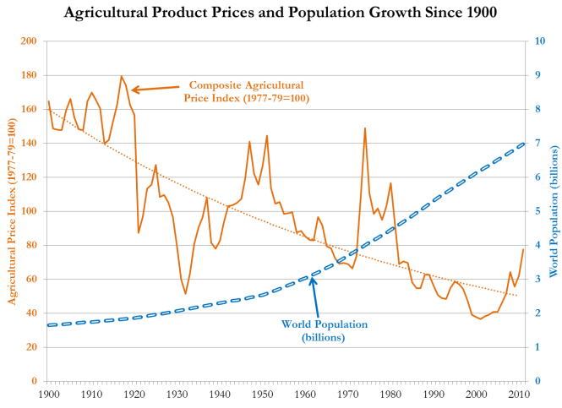
Farms are more efficient today for many reasons. The most influential factor I believe is the fact that more efficient technologies have been developed and successfully adopted by large, specialized farms.  A farmer today is unlikely to spend her day milking cows, then feeding pigs, then planting wheat, then harvesting corn, and then weeding her patch of acorn squash. Instead, she will be more specialized. She will use advanced technologies like driverless tractors or automatic milking machines. And she will focus solely on producing one or a few products. One farmer may only raise cattle and wheat, another may only operate a dairy farm, and another may produce solely cotton. | Talking points:  Food prices are lower due to better technologies, bigger farms, and more specialized farms.
In a sense, farmers have become more efficient because they employ what economist Paul Seabright refers to as “tunnel-vision”. Farmers have focused on reducing their costs of production while maintaining or improving food quality. Likewise, consumers have focused on minimizing their food costs while still seeking more pleasurable eating experience. | Taking points:  Farmers and consumers have “tunnel-vision”. They concentrate on reducing farmers’ input costs and increasing the pleasure of eating.
Both producers and consumers are essentially focused on reducing the cost of inputs the farmers must purchase to produce food of the same quality or better. When a farmer reduces her per bushel cost of corn production by applying more nitrogen fertilizer, she is rewarded with larger profits. Consumers are also rewarded, as lower farm costs leads to lower grocery store prices. | Talking points:  Farmers and consumers are rewarded when farmers’ costs fall.
Both consumers and producers are keenly focused on the farmers’ costs of production and the quality of the food as perceived by the consumer. This tunnel-vision has led to tastier foods at a lower price.  Now, you can argue that we eat too much, or that consumers eat less healthy now, but one can’t deny that it is the consumer who is making these choices for herself.  This tunnel-vision allows us to feed more people, and deliver more smiles around the dinner table. | Talking points:  Farmers and consumers are rewarded when farmers produce a tastier food.
At the same time, we know that there are other things in agriculture that matter, which are not part of this tunnel-vision. If a farmer can lower her pork production costs by reducing the well-being of the pigs, she can do so even if the consumer would disapprove, as one cannot tell how a pig was treated by the taste of a pork chop. | Talking points:  This tunnel-vision can ignore some things we care about.  Like the welfare of farm animals.
Beef has a higher carbon footprint than chicken, but this higher footprint is not fully reflected in the price of beef, and the consumer may be unaware of this fact. This means that consumers very concerned about global warming may not give carbon footprints much consideration when making their meat purchasing decisions. | Talking points:  This tunnel-vision can ignore some things we care about.  Like the welfare of farm animals.  Like greenhouse gas emissions.
Most of the agricultural and food controversies today are an attempt to force us out of this tunnel-vision and to think more about ethics when purchasing food and forming government policies.  The organic food movement asks us to think about the pesticides applied on most farms and its effect on people and the environment.  Environmentalists want us to know the water pollution that can result from an irresponsible use of chemical and manure fertilizers.  We are asked to step outside of our tunnel-vision and “think globally” where we consider how farm practices impact the world. We are asked to account for things that aren’t reflected in farmers’ cost of production, and thus not reflected in the grocery store price. We are asked to take a panoramic view of agriculture, and to do our best to make sure the food we eat is indeed ethical food. | Talking points:  A panoramic view of agriculture seeks to understand how farming practices impact society, animals, the environment—all the things ignored under tunnel-vision.
To comply with this request is admirable, and almost everyone from the farmer to the urban shopper is doing so in some regard.  To comply with this request is admirable, but it is also very difficult. Just think about how hard it is to know how the production of your cheeseburger impacts  - soil erosion  - pollution of ponds, streams, rivers, lakes, and estuaries  - welfare of beef cattle  - welfare of dairy cattle  - pesticide residues in food  - global warming  - social justice  - and the like. | Talking points:  soil erosion  pollution of ponds, streams, rivers, lakes, and estuaries  welfare of beef cattle  welfare of dairy cattle  pesticide residues in food  global warming  social justice  and the like
It is an intimidating task, to be sure. Because knowing the precise relationship between our diet, society, animals, and the environment is such a daunting endeavor, I say that this panoramic view of agriculture is also a blurry view. | Talking points:  A panoramic view can be a blurry view.
Think about it like this. [Figure 2] With tunnel-vision: Close-up, you can’t see the forest for the tree. | [Figure 2]  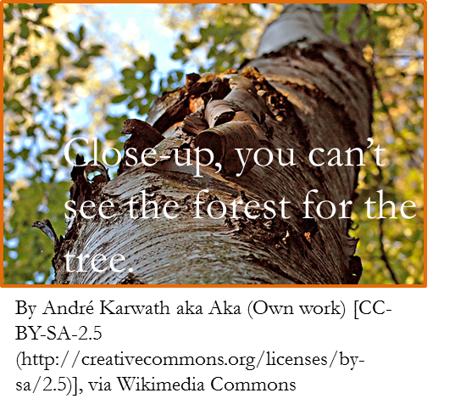
[Figure 3] With panoramic blurriness: From a distance, you can’t see the tree for the forest. | [Figure 3]  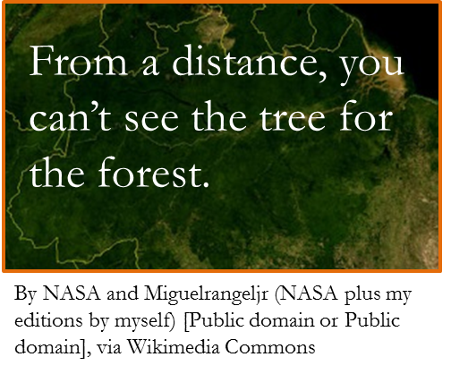
This should not discourage us from pursuing ethical food. Behaving ethically is never easy, and it is a rarity to know with complete certainty if any act is truly ethical. If we ban pesticides, it will reduce direct exposure to carcinogens, but we must ask whether that will increase cancer rates by increasing the cost of fruits and vegetables.  If we buy free-range eggs, we never know for sure whether chickens raised outside, where mortality rates can be 25%, are happier than when raised in a crowded barn where mortality rates are more like 5%.  If we adopt no-till farming practices to reduce soil erosion we must then deal with the fact that this will increase our reliance on pesticides. | Talking points:  Hard Question  Ban pesticides?  Less pesticides = less direct exposure to carcinogens  Less pesticides = less fruit and vegetable consumption, which increases cancer rates  Hard Question  Are free-range layers happier?  They are outside, living naturally.  Living naturally means higher mortality rates.  Hard Question  Should we adopt no-till farming to reduce soil erosion if it increases pesticide use?
Most of the time, we rely on our intuition for these decisions, as well as the claims of certain activists and businesses. Is organic food more environmentally-friendly? Many people intuitively say yes. Many people have heard environmentalists say it is. But agricultural scientists are not so sure. Are chickens happier in a cage-free than a cage setting? Many people intuitively say yes. Many have also heard animal advocates say it is. But many agricultural scientists are not so sure.  There is a tendency to believe that any attempt to break out of tunnel-vision—to instead take a panoramic view of agriculture—will lead to better food. We falsely equate good intentions with good outcomes. What we fail to recognize is that the blurriness of a panoramic view means we have to look beyond good intentions, and make sure our actions translate into good results. | Talking points:  good intentions ≠ good results  good intentions + research = good results
For us to truly make ethical decisions we must sharpen our intuition by thinking very deeply about subjects, incorporating the findings of scientists and the logic of economics, and widen the diversity of our information sources. | Talking point:  Panoramic-blurriness can be brought into focus by  diversifying our reading  incorporating scientific research and economic logic.
To support this idea, this lecture will consider the issue how local foods affect global warming and the local economy. We will take two notions many locavores intuitively believe.  - Buying local food always benefits the local economy  - Local food is associated with a smaller carbon footprint. | Talking point:  Our reading will illustrate panoramic-blurriness with two topics in local food.  Local foods and the local economy  Local foods and carbon footprints
In a previous lecture we went on a tour of the Stillwater farmers market, where we interviewed people on why they like buying food from a farmers market. There was one part of an interview I didn’t show you, because I was saving it until now, where someone specifically referred to helping the local economy. Let me show that clip to you now so that you see this is a topic of concern to some people.
01:03:52;00 to 01:04:09;00  And  01:01:32;00 To 01:01:49;00  And | From video at http://ra.okstate.edu/STW_DASNR/  Norwood/FarmersMarketScript/video.html
Our readings will show that although the statements that
- Buying local food always benefits the local economy
- Local food is associated with a smaller carbon footprint
could be correct in some settings, they are incorrect in other settings. Again, the objective is not to discourage you from taking a panoramic view of agriculture. The objective is to arm your intellect with the results of scientific studies and economic logic. A panoramic view of agriculture will always be blurry, but this panoramic-blurriness can be brought into greater focus by diversifying your sources of information—something I hope this lecture accomplishes.

References
Seabright, Paul. 2004. In the Company of Strangers: A Modern History of Economic Life. Princeton University Press: Princeton, NJ.

