The appeal of farmers markets
Unless stated otherwise, the times refer to the video in http://ra.okstate.edu/STW_DASNR/Norwood/FarmersMarketScript/video.html

 | Talking points in this color
Title: The appeal of farmers markets
Start at 01:20:48;00
At 01:21:16;00
Show pic 1 = farmersmarketsmap.jpg
Make title = Each red dot marks a farmers market in 2011
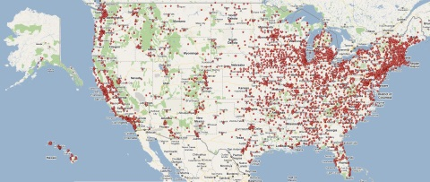
At 01:21:19;00 show
Pic 2 = NumberFarmersMarkets.jpg
Title = Growth of farmers markets in U.S.
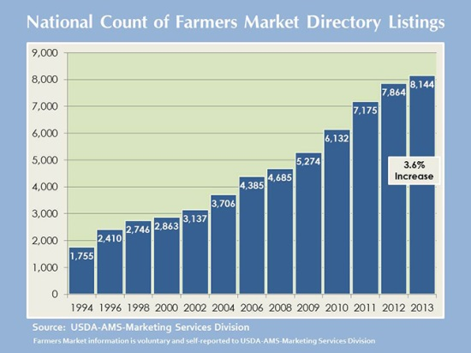

End at ??????????????/
Start at 01:22:23;00 to 01:22:45;00  We need to do something to make the transition to the next scene smoother | Locavore—one who makes an effort to eat food that is grown, raised, or produced locally, usually within 100 miles of home (Dictionary.com)
01:23:14;00 to 01:23:25;00

Start at 01:23::41;00 or 01:24:25;00
At 01:23:55;00 or 01:24:33;00 | Imports = Exports  ↓ Imports = ↓Exports  = less trade with the world
01:24:03 or 01:24:50;00 | Is the local foods movement like a ban on trade?  Yes and no  Local foods is a complex topic
01:33:00;00 to 01:33:14 | Sources of local foods  - farmers markets  - community supported agriculture  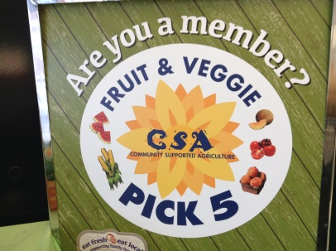  - food cooperatives
Title: Good reasons to be a locavore
01:29:23;00 or 01:30:00;00 to 01:29:53;00 or 01:30:20;00 | Reasons to buy local food  - Can be tastier
Start 01:31:08;00 | Reasons to buy local food  - Can be tastier  - Can be cheaper  - Fewer, more “natural” ingredients
At 01:31:23;00 show
Pic = StoreBread.jpg
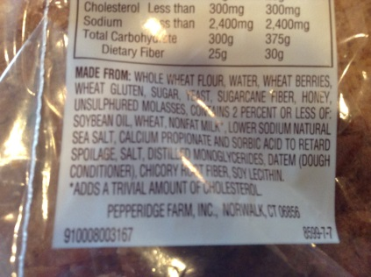
At 01:31:43;00 | Ingredients in this bread:  - wheat flour  - salt  - yeast
End 01:31:49;00
01:26:18;00 to 01:27:33;00 | Interview with Steve  Talks about additives / preservatives; natural foods; talks about god
01:32:26;00 to 01:32:49;00 | Reasons to buy local food  - Can be tastier  - Can be cheaper  - Fewer, more “natural” ingredients  - Can be more nutritious
00:59:27;00 to 00:59:00 | Interview: they said tasty, fresh, nutritious  Shopper at Stillwater farmers market
01:01:01;00 to 01:01:30 | Fresh and inexpensive  Shopper at Stillwater farmers market
01:06:42;00 to 01:06:55;00 | Say who this is:  Connie Whitmore from Whitmore Farms in Payne County, OK, on why people purchase her beef at the farmers market
01:10:28;00 to 01:11:09;00 | Interview Mary Rader: Fresh, straight from farms, organic, homemade, the people, why organic  Shopper at Stillwater farmers market
01:12:01;00 to 01:12:25;00  And 01:12:35;00 to 01:12:48;00 | Ethan Wall: local producer of free-range eggs and lamb
Title: The joy of local foods
01:33:58;00 to 01:35:15
Start 01:35:35;00
At 01:35:55;00 start showing slide show of pics  Hay1, hay2, … hay10 | 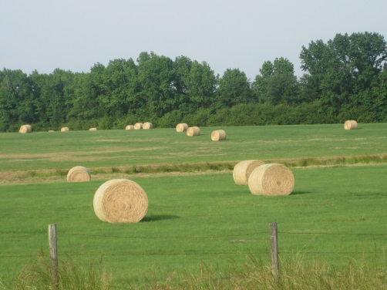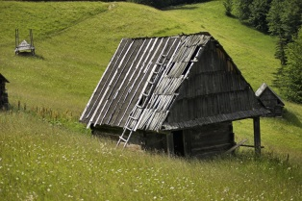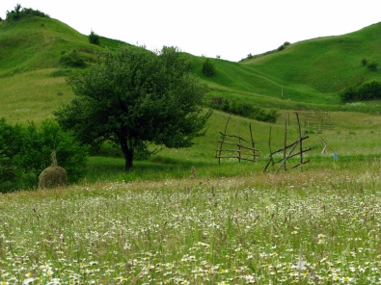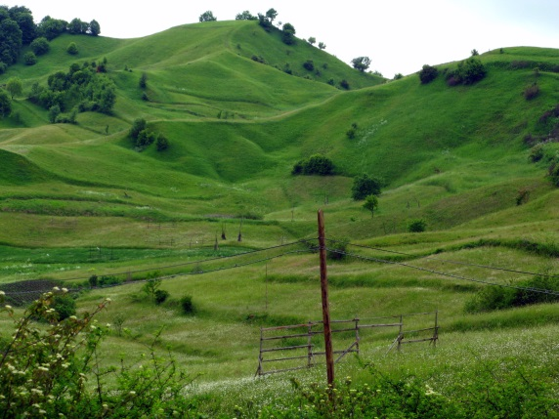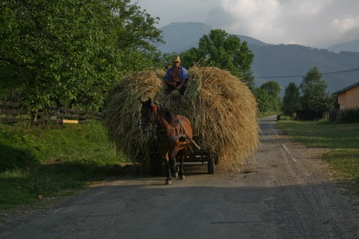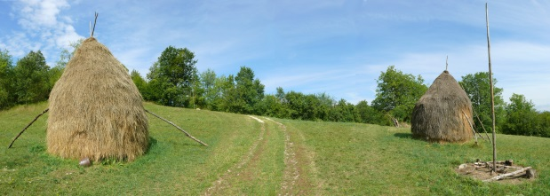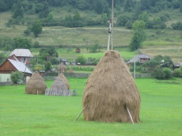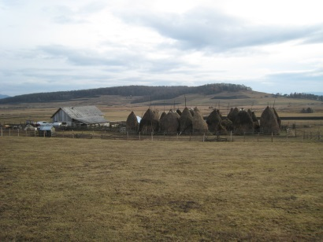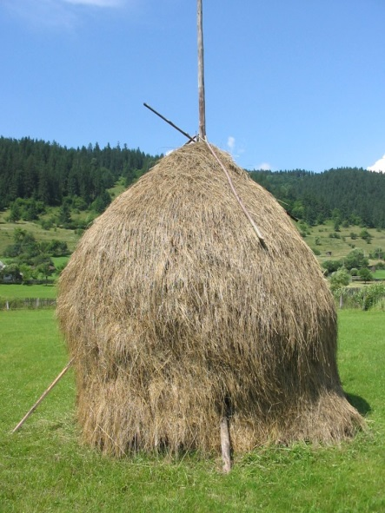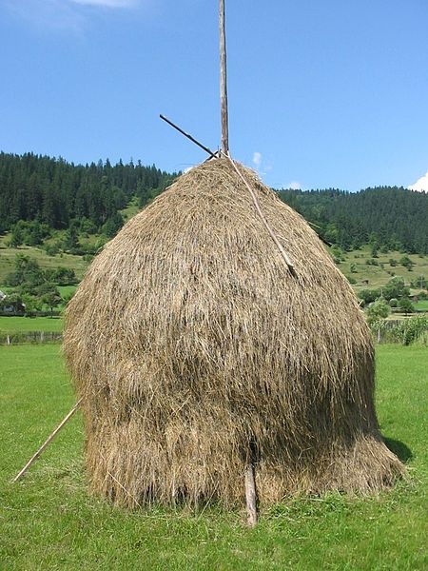
At 01:36:40;00 | Because it is real whole milk ... a piece of the past which their city life has left behind.  —A Transylvanian’s answer as to why cities were paying higher prices for local milk. Nicolson, Adam. July 2013. “Hay. Beautiful.” National Geographic. Page 124.
Start 01:14:23;00 01:15:08;00 | Buying local lets you meet the farmer and learn how the animals are raised
01:14:50;00 01:15:30;00 | Show pics EthanWallEggFarm1.jpg and EthanWallEggFarm2.jpg  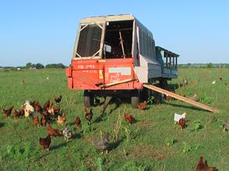  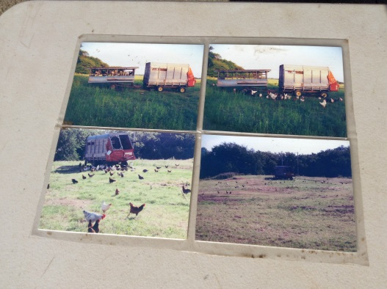
End 01:14:53;00 01:15:34;00
Start 01:37:35;00
1:37:46;00 | 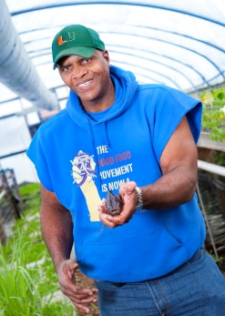  By Will Allen (Will holding fish in Green house #7) [CC-BY-2.0 (http://creativecommons.org/licenses/by/2.0)], via Wikimedia Commons
1:37:52;00 | Food desserts—locations (usually lower-income, urban areas) where calories are easily affordable but health foods like fruits and vegetables are difficult to acquire
1:38:05;00 | People in food desserts may not be familiar with healthy vegetables.
Stop at 01:38:48;00
01:39:55;00 to 01:40:20;00 | “... children whose parents reported more time on food preparation tended to make healthier food choices in the lab than children whose parents spent less time at home on food preparation, even without parental supervision.”  —Society for the Study of Ingestive Behavior. July 29, 2014. “Children whose parents spend more time cooking choose healthier foods later.” ScienceDaily.
Start 01:41:05;00 (or 01:41:46;00)
01:41:16;00 (or 01:41:54;00) | Public goods—goods that belong to society, not just the individual (non-technical definition)  Possible examples  Improved environment  Better animal treatment  Soil conservation  Social justice
Stop 01:41:25;00 (or 1:42:04;00)
Start 01:45:35;00
01:45:49;00 | WIC = program that helps women, infants, and children acquire nutritious foods. WIC vouchers allow people to buy from farmers markets in OK.  Note: at some point show the Whitmore Farms sign saying they accept WIC vouchers.  Around 01:46;10 show the sign regarding the Cherokee Nation
Stop 01:46:14;00
Start 01:48:19;00 01:49:11;00
End 01:48:46;00 01:49:00;00
IGNORE ALL THIS BELOW
01:32:12;00
01:03:52;00 | Econ multiplier,
01:01:36;00 | Support local people
01:05:17;00 to | Whitmore introduces herself
01:05:27;00 to 01:05:41;00 | Whitmore, locally grown, very very local, (not very useful)
01:05:41;00 to 01:06:03;00 | Sellers are growers, knows how fresh veggies are
01:06:05;00 to 01:06:22;00 | Explains what consumers are looking for, they want to know the farmer,
01:06:24;00 | Do many people ask questions?
01:05:32;00 | How cows are treated on whitmore farms
01:10:28;00 to 01:11:09;00 | Mary Rader: Fresh, straight from farms, organic, homemade, the people, why organic
01:12:00;00 to 01:12:25;00 | Interview with Ethan Wall, bout eggs
01:12:25;00 to 01:12:35;00 | Lamb and local
01:12:35;00 to 01:12:52;00 | Why people like local
01:12:52;00 to 01:13:19;00 | Questions people ask about the eggs and lamb

pic 1: Accessed from USDA on April 8, 2014 at http://search.ams.usda.gov/farmersmarkets/farmersmarketsmap.jpg. The map is a snapshot of the U.S. in 2011.
pic 2: Accessed from USDA on April 8, 2014 at http://www.ams.usda.gov/AMSv1.0/ams.fetchTemplateData.do?template=TemplateS&leftNav=WholesaleandFarmersMarkets&page=WFMFarmersMarketGrowth&description=Farmers%20Market%20Growth.

pics hay 1 to hay 10 all come from search of “Romanian Hay” at Wikimedia Commons.

