Industrialization of agriculture: Part 3—Getting Big
In 2012 the Library of Congress opened an exhibit titled Books That Shaped America, where they displayed the 88 books that most influenced American culture.
John Steinbeck’s 1939 novel The Grapes of Wrath were among the 88. Many students have read the book in high school, or seen the play, or seen the movie. | Bailey holds up the book
Chapter 5 of the book is particularly relevant to our discussion of the industrialization of agriculture. It portrays vividly the negative side of technological advancement, particularly in regards to mechanization, but if you are willing to peer deeper, you can find the positive side of mechanization also.
In Chapter 5, the Joad’s, a poor farming family in Oklahoma, are being evicted from the land they had farmed for generations. They had once owned the land, but a bad crop year came and they had to borrow money to get by, using the land as collateral. Unable to repay the loan, the land became the property of the bank.
And now, in Chapter 5, the bank is kicking the Joads off of the land. Why didn’t the bank just let them continue farming the land, renting it to them?  The owner explained, “One man on a tractor can take the place of twelve or fourteen families.” | “One man on a tractor can take the place of twelve or fourteen families.”  —Steinbeck, John. 1939. The Grapes of Wrath. Chapter 5.
What this means is that, although a tractor certainly costs money, it costs less than human labor. Cotton, the crop being raised on the land, could be raised at less expense, thereby reducing the price of cotton and the price of clothes.
This, of course, is not how the tractor was portrayed in The Grapes of Wrath. Instead, it was depicted as a soulless machine that displaces families who were already in dire poverty.
A little later in Chapter 5, a worker on a tractor comes to the farm and begins plowing the land. Steinbeck describes the tractor as,

“The tractors came over the roads and into the fields, great crawlers moving like insects, having the incredible strength of insects. They crawled over the ground, laying the track and rolling on it and picking it up. Diesel tractors, puttering while they stood idle; they thundered when they moved, and then settled down to a droning roar. Snub-nosed monsters, raising the dust and sticking their snouts into it ...” | “The tractors came over the roads and into the fields, great crawlers moving like insects, having the incredible strength of insects. They crawled over the ground, laying the track and rolling on it and picking it up. Diesel tractors, puttering while they stood idle; they thundered when they moved, and then settled down to a droning roar. Snub-nosed monsters, raising the dust and sticking their snouts into it …”  —Steinbeck, John. 1939. The Grapes of Wrath. Chapter 5.
Notice all the unpleasant metaphors: insects, thunder, roars, monsters, snouts—Steinbeck can’t decide whether the tractor is more like a bug, the Norse god Thor, or a hog!
A little later the man on the tractor stops for lunch, and some children come to talk to him. When the children are asking him why he is helping others take land away from honest people, he responds:
“Can’t think of that. Got to think of my own kids. Three dollars a day, and it comes every day. Times are changing, mister, don’t you know? Can’t make a living on the land unless you’ve got two, five, ten thousand acres and a tractor. Crop land isn’t for little guys like us any more.” | “Can’t think of that. Got to think of my own kids. Three dollars a day, and it comes every day. Times are changing, mister, don’t you know? Can’t make a living on the land unless you’ve got two, five, ten thousand acres and a tractor. Crop land isn’t for little guys like us any more.”  —Steinbeck, John. 1939. The Grapes of Wrath. Chapter 5.
Steinbeck’s novel indeed describes the plight of many families in the wake of efficiency improvements in agriculture. But aren’t efficiency improvements a noble ambition? Who could argue against making food more affordable?
Yet, the natural implication is, if it takes less people to produce food, we need less farmers. In a market economy, this means that some farmers must leave farming due to an inability to make profits. What do these farmers do, then? The Joad family traveled to California looking for jobs, and in real life, it seems many did the same. Technological advancements often means the displacement of labor, and the workers, along with their families, pay the cost of this displacement.
As we will see, many of the technological innovations like tractors only lower production costs if they are used on large farms, covering many acres. As The Grapes of Wrath depicts, as smaller farmers are pushed out of agriculture they are replaced with machines, and those small farms are combined into fewer, larger farms.
What happened to the Joad family is a tragedy, and many real families suffered it. On the road leading to agricultural industrialization, there were many tears.
But consider an alternative plot for the Joad family. Suppose they were told they had to quit farming, but that there were other more pleasant jobs they could take. The mother could work shorter hours in an air conditioned factory, making motorboat engines. The father could learn about computers and take a well-paying job as an IT specialist. The family would make more money, work less hours in a more pleasant environment, and food (along with everything else) would be cheaper. They would even have television, YouTube, video games, and could fly to Florida to take their children to Disneyworld.
What I’m describing, of course, is taking the Joads out of 1939 agriculture and placing them in our age. That couldn’t really happen, of course, but that is what happened to the Joad’s descendants. The same efficiency-improving tractors that kicked families off their land and made farmers fewer but farm size greater, made food cheaper. Tractors released many people from agricultural work to take other jobs, and lower food prices gave people more money to spend on other things.
What are these “other things”? They became cars, planes, videogames, television, amusement parks, chocolate stores, bowling alleys, football fields, medicine, MRI machines, cholesterol-lowering drugs, artificial knees, and so on.
There is a name for this in economics: creative destruction, a term coined by the economist Joseph Schumpeter. This is how he describes it in 1942.  “The opening up of new markets, foreign or domestic, and the organizational development from the craft shop to such concerns as U.S. Steel illustrate the same process of industrial mutation—if I may use that biological term—that incessantly revolutionizes the economic structure from within, incessantly destroying the old one, incessantly creating a new one. This process of Creative Destruction is the essential fact about capitalism.“  —Schumpeter, Joseph. 1942. Capitalism, Socialism, and Democracy. Page 83. | Joseph Schumpeter (1883-1950)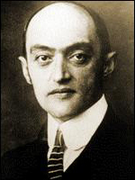  Insert this pic JosephSchumpeter.jpg  The opening up of new markets, foreign or domestic, and the organizational development from the craft shop to such concerns as U.S. Steel illustrate the same process of industrial mutation—if I may use that biological term—that incessantly revolutionizes the economic structure from within, incessantly destroying the old one, incessantly creating a new one. This process of Creative Destruction is the essential fact about capitalism.  —Schumpeter, Joseph. 1942. Capitalism, Socialism, and Democracy. Page 83.
When Schumpeter says, “organizational development from the craft shop to such concerns as U.S. Steel,” that is analogous to the industrialization of agriculture.

The jobs destroyed by agricultural mechanization were offset with jobs created in other sectors.
This is why, despite all the jobs that have been destroyed by new technologies in the past century (wagon makers, seamstresses, candle makers, mule trainers) the unemployment rate in the U.S. remains low roughly the same, excluding the Great Depression, of course. Though a market economy does destroy jobs, it also creates jobs, and after all the destruction and creation are finished, we can usually say that we have it better than our parents, and our grandparents. | 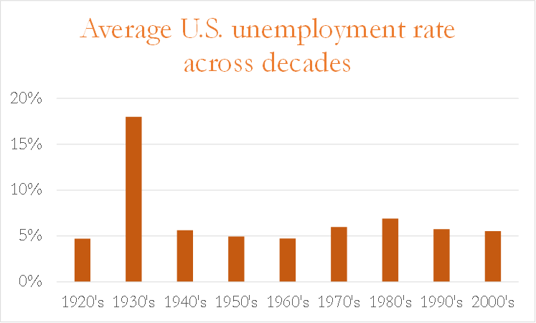  Show pic UR.png  Source: U.S. Department of Labor. Bureau of Labor Statistics. Numbers were compiled at infoplease.com. Accessed September 19, 2014 at http://www.infoplease.com/ipa/A0104719.html.
The same tractor that cruelly pushed the Joads off their land helped Americans cut in half the percent of money they spent on food. In 1939—the year The Grapes of Wrath was written—Americans spent 21% of their disposable income on food. Today, that number is 10%. Now, it may be true that food is so cheap we eat too much, but I’d be willing to bet the Joads would trade places with us any day. | Show pic EngelCurve.png  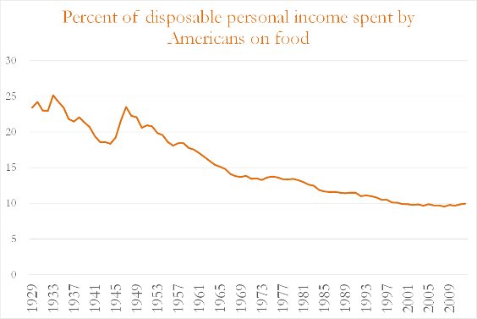  Source: Economic Research Service. 2014. Food Expenditures [website]. United States Department of Agriculture. Accessed September 16, 2014 at http://www.ers.usda.gov/data-products/food-expenditures.aspx#26636
We should never forget that new technologies impose burdens on some people, but we should also not forget that our modern prosperity is impossible without these efficiency-improving technologies. So as we study the industrialization of agriculture, let us thank the Joads for their sacrifice, and remember the real people they represent, as we struggle to stay slim, amidst food aplenty.

http://www.mhpbooks.com/library-of-congress-picks-its-88-most-influential-books/
http://www.loc.gov/exhibits/books-that-shaped-america/

