Selective breeding, induced mutations, and genetically modified plants

Narrative | Figures to be used in animation and animation directions  Talking points in this color
Part of raising crops is improving the genetics of the crops we plant.  Although this section of the course is largely about genetically modified organisms (what we commonly refer to as the acronym, GMOs), one cannot understand genetic modification without understanding other breeding techniques, including induced-mutations and traditional selective breeding.  The purpose of this video is to make sure we understand how the genes of crops are altered using these tools. | Ways to improve crops  genetically modified organisms (GMOs)  induced-genetic mutations  selective breeding
We will start at the level of the crop’s DNA, and the genes it contains, and articulate how an organism’s genes are passed down to their offspring in traditional sexual reproduction.
We have already learned about DNA, including the nucleotides it is comprised of, and the massive amount of information the DNA contains.

Here, I am going to use a very simplified version of inheritance. Remember that the DNA contains information—instructions—on how the organism should be built, so I am going to represent a very small strand of DNA as containing only three sets of information.

Let’s suppose the DNA contains information on only three attributes of a plant: the size of the seeds it produces, its vulnerability to drought, and its resistance to a pesticide. I call it the “mother” of the subsequent offspring, even though a plant may have both male and female parts. Each symbol refers to a different gene. | 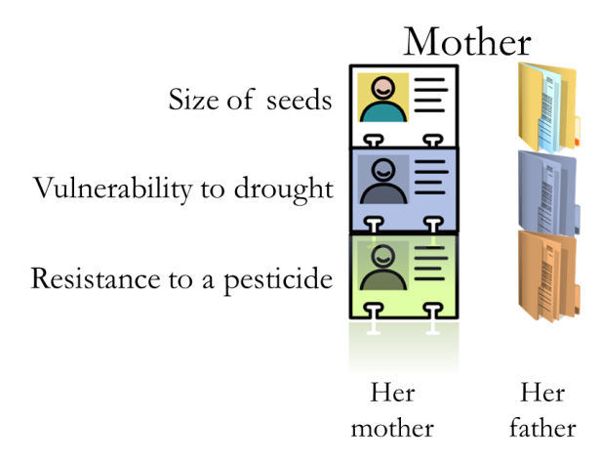
Remember that the mother’s DNA comes from her parents’. She gets one strand of DNA from her mother … | 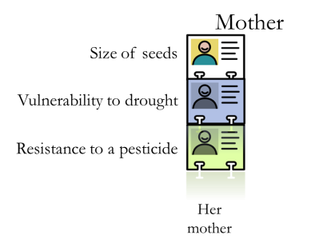
… and one strand from her father. | 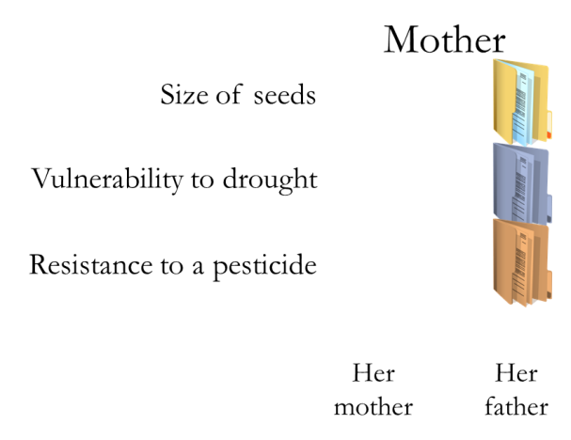
The attributes of the plants are then determined by the DNA from her mother and from her father. Sometimes one gene is dominant over another and it solely determines the plant’s attribute.  For example, in this scenario her father’s gene for seed size is dominant over her mother’s, so only her father’s gene determines the size of her own seeds. If this gene codes for large seeds, she will have large seeds regardless of her mother’s gene for seed size. | 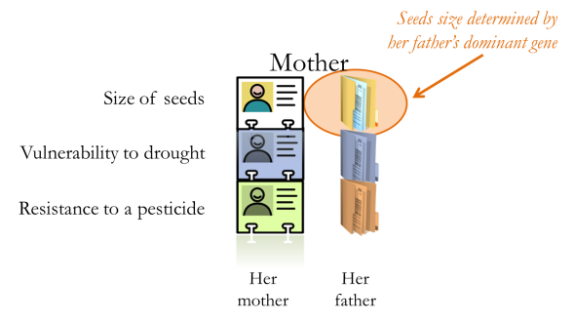
In regards to vulnerability to cold, her mother’s gene is dominant, and so her ability to withstand the cold is determined solely by her mother’s gene. | 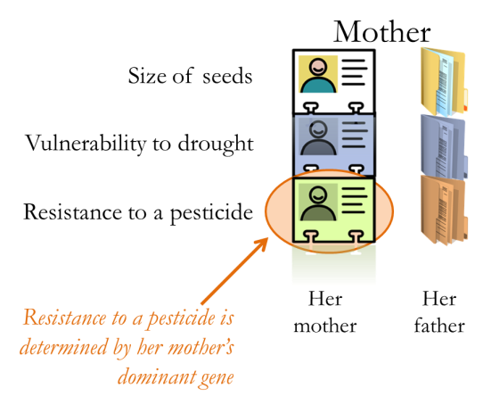
Other times there is no single dominant gene, and both genes simultaneously determine a plant’s attribute. Here, the plants ability to resist a pesticide (that is, not be harmed by the pesticide) is determined by the genes passed down to her from her mother and her father. | 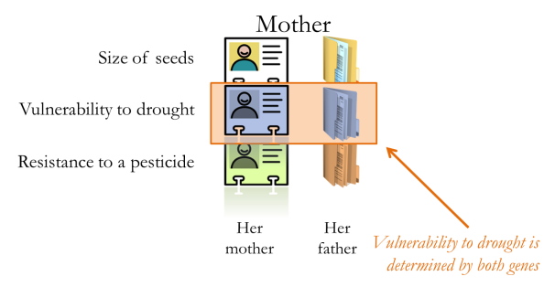
And so, our simplified DNA has instructions for only three different attributes, and there are two genes for each attribute: one given to her from her father, and one from her mother. | 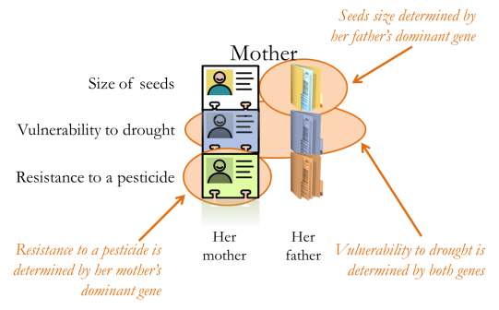
Now let’s suppose this mother is bred with a male to produce an offspring. The father also has two genes for each attribute: one given to him by his father, one given to him by his mother.  What I want us to do is to think about how the genes from the mother and father are passed onto their offspring. | 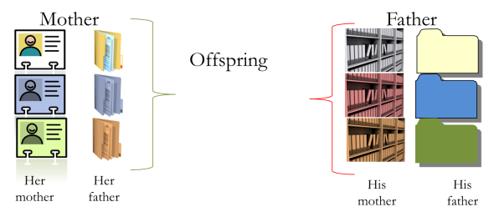
Although the mother has two genes for seed size, she can only pass down one of them. It could be that the mother passes down the entire strand of DNA given to her by her mother … | 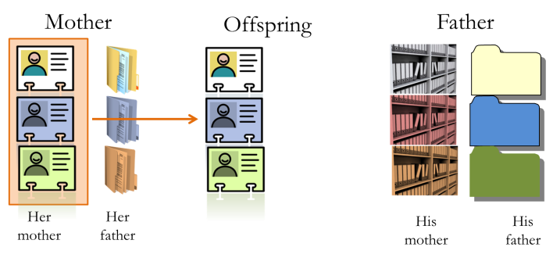
… or the entire strand given to her by her father | 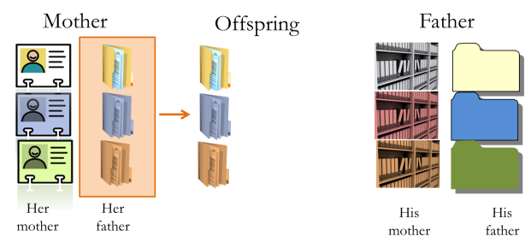
If it were true that each parent could only donate one of her two complete strands, then because each parent has two complete strands of DNA, two parents could give birth to only one of four types of individuals. That is, if they had more than four children, at least two of those children would have to be identical twins. | 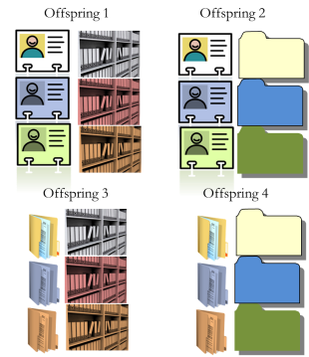
But of course, we know this is not the case. Organisms, including humans, can have much more than four children, all of whose DNA are not identical.
What really happens when a parent donates one-half of its DNA to its child is that it “shuffles” its two strands of DNA before it passes a strand of DNA to its child. They give to its child a hybrid DNA strand, made of elements of DNA from both the mother’s mother and the mother’s father.
To illustrate, when it comes to determining which of her two genes corresponding to seed size will be passed down to her child, the reproductive process randomly pics one of the two genes. The same goes for the genes for vulnerability to drought and to resist a pesticide  This means that the offspring has a 50% chance between acquiring its grandmother’s gene for seed size and its grandfather’s gene for seed size.  Notice that although the two strands of DNA are shuffled before bestowing them to an offspring, each gene always stays in its proper location in the DNA. That is, the top part of the DNA corresponding to seed size is never moved down to the middle or lower genes referring to drought or pesticide tolerance. | 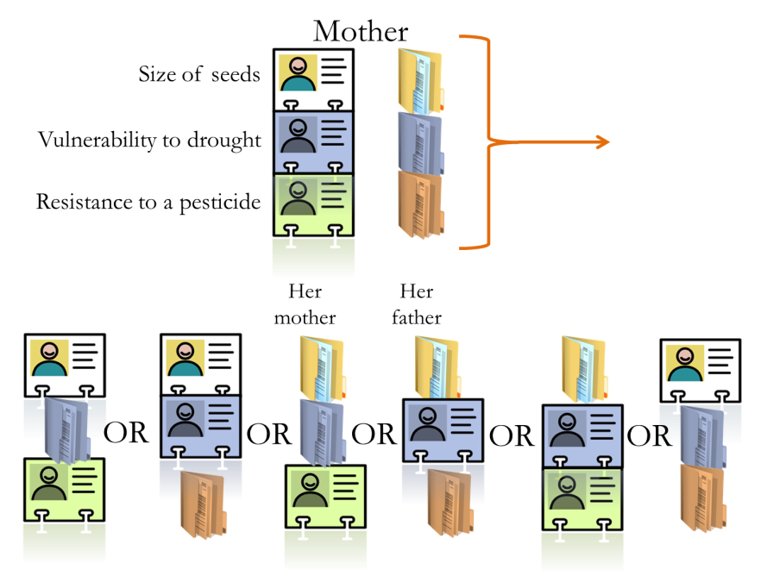
Because of this randomization in determining which genes to pass onto offspring, and because the DNA is so large (much, much larger than the 3-gene DNA model we are using), there are almost an infinite number of genetically unique offspring two parents can create.
Suppose we now wanted to have an organism with the following DNA. This organism has a green gene that looks like a file cabinet, in the space corresponding to the gene vulnerability for drought. Perhaps we believe a plant with this unique gene would better handle droughts than other plants of this species.  Let’s call a plant with this green gene in the middle space a drought tolerant crop. | 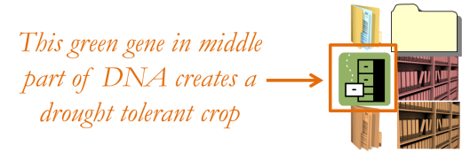
Notice that this gene is not present in the middle portion of the DNA for either the mother or the father, so if the mother and father bred and biology proceeded as usual, it would be impossible for them to create a drought tolerant crop.  So if we really want this drought tolerant crop we must introduce this gene somehow. | 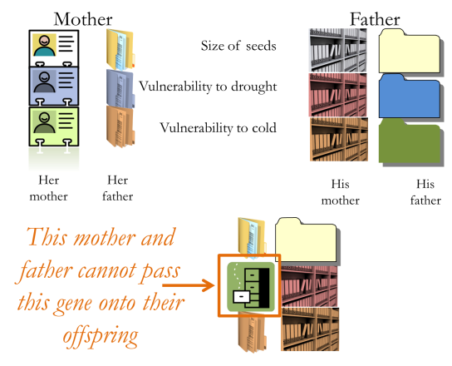
One way is to find a new mother and father who do have this green gene.  This is an ancient method of creating new plants (and animals), but today we are doing this in very scientific manner.  We first identify the gene that bestows a plant with drought tolerance, then we sequence the DNA of various plants to determine which one of those have this drought tolerant gene (this is called molecular marking). Then, we deliberately breed those plants known to have that gene.  So traditional plant breeding today uses the most advanced technologies in genetics. | 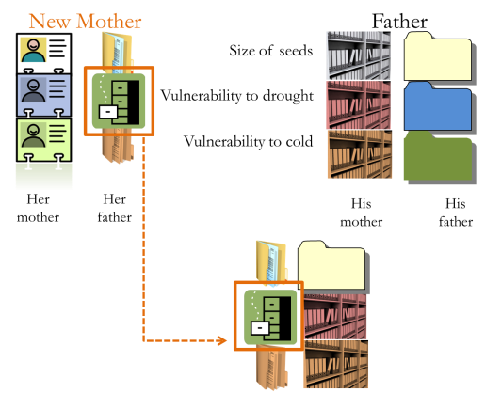
Another option is to rely on the fact that genetic mutations will happen, and given enough time, when passing along their genes, some of the genes will randomly mutate into the green gene that gives us a drought tolerant plant.
The problem is that genetic mutations happen only rarely, and we are not willing to wait thousands of years for the right mutation to occur—especially when we can speed up the rate of genetic mutations using chemicals and radiation.
Consider the Clearfield varieties of wheat in Oklahoma, one of the varieties shown here. These varieties were created by using chemicals to speed up the rate genetic of mutations in wheat, and some of these mutations bestowed the plant with a gene that makes the plant resistant to certain herbicides. This allows the farmer to spray herbicides right on top of the wheat, and though the herbicide will kill most of the weeds in the wheat field it will not harm the wheat itself. | Clearfield wheat varieties are resistant to certain herbicides  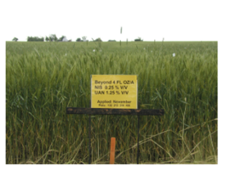
To see how valuable this mutation is, compare the Clearfield variety on the left with another wheat variety on the right. The other wheat obviously has much more weeds, which reduces the amount of wheat the farmer can harvest. | 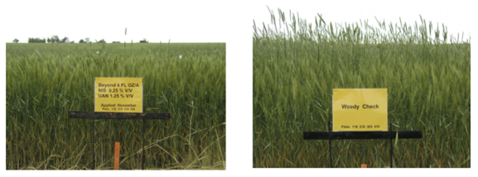
These Clearfield wheat varieties could also have been made using radiation to speed up the rate of genetic mutations.
Just as OSU created a new variety of wheat by encouraging genetic mutations, one could do the same thing to acquire that drought resistant plant with the green gene.
Now, remember this Clearfield variety of wheat was created by using chemicals to encourage genetic mutations in the wheat. This is not an example of genetic modification, though. That is, the Clearfield variety is not a GMO.
You might ask: why? To answer that, let us now discuss what genetic modification is.
One way to get that green gene in the middle portion of DNA is to simply cut the green gene out of a different part of the plant’s DNA (perhaps the lower portion, if the green gene is there) and then insert it into the middle portion.  Or, cut the green gene out of a similar plant and insert it into the middle part of the DNA.  Or, cut the green gene out of a completely different organism, perhaps a bacterium, and insert it into the middle part of the DNA.  Any and all of these methods are examples of genetic modification, and the resulting plant would be considered a genetically modified organism (GMO).  If the gene was cut out of the same plant species or a similar species the resulting plant would be referred to as a cisgenic GMO.  If the gene was cut out of a different organism the resulting plant would be called a transgenic GMO.  Most GMOs in agriculture are plants, and most are transgenic plants. | 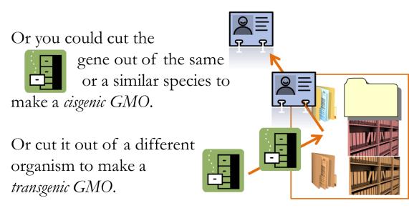  Genetically modified organism: genetically modified organism: an organism or microorganism whose genetic material has been altered by means of genetic engineering (dictionary.reference.com)  Cisgenic plant: implanted gene came from same or similar plant  Transgenic plant: implanted gene came from different organism
Consider an example of how genetic modification can improve and protect our food.  The vast majority of the bananas we eat are of the Cavendish variety, and they are not bred naturally but are propagated by cloning. This means that any disease that threatens one banana plant threatens all banana plants because they have virtually identical DNA.  One disease is called the Black Sigatoka fungus. However, scientists are trying to develop bananas resistant to Black Sigatoka by using radiation to encourage genetic mutations in bananas.  The Tropical Race Four disease is also a fungus, and it is being confronted using genetic modification. | 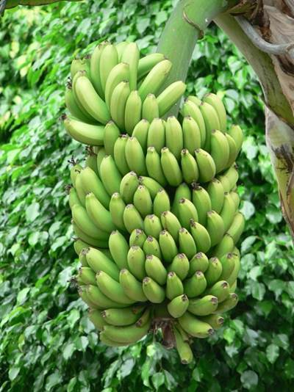  By Rosendahl [Public domain], via Wikimedia Commons
Defenders of GMOs will often remark that genetic modification is nothing new. We have been genetically modifying plants since the beginning of agriculture. Simply by deliberately choosing to plant seeds from crops that produce the most food, we are modifying the genes of the plants that we cultivate. Because we prefer corn plants that yield more rather than less food, we have transformed an ancient grass called Teosinte (on your far left) to a plant that yields more and bigger seeds, ultimately resulting in our modern corn plant (on your far right). | 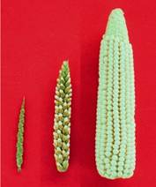  By John Doebley (http://teosinte.wisc.edu/images.html) [Attribution or CC-BY-3.0 (http://creativecommons.org/licenses/by/3.0)], via Wikimedia Commons
So, no, genetic modification is nothing new, and is the normal part of agriculture.
It should also be added that genetic modification is a much more precise and reliable tool for acquiring better crops.
I have never understood why the public dislikes genetic modification but raises no protest against inducing genetic mutations in plants through radiation and chemicals.
However, we should also add that genetic modification allows us to alter genes at a much faster pace, and in more diverse ways, than traditional plant breeding or radiation and chemical induced mutations.

For those who do not trust the corporations doing the genetic modifications, the last thing they want is for the corporations to have more flexibility and more speed in creating new plant varieties. Therein lies the modern debate about GMOs.

(E1) The Economist. March 1, 2014. “Yes, we have no bananas.” Pages 62-63.

