AGEC 1113-001
Final Examination
Spring 2015

There are 43 questions worth one point each. Answer all questions on an orange scantron, and make sure to enter your CWID correctly.

From Exam 1

For questions 1-2 use the graph below
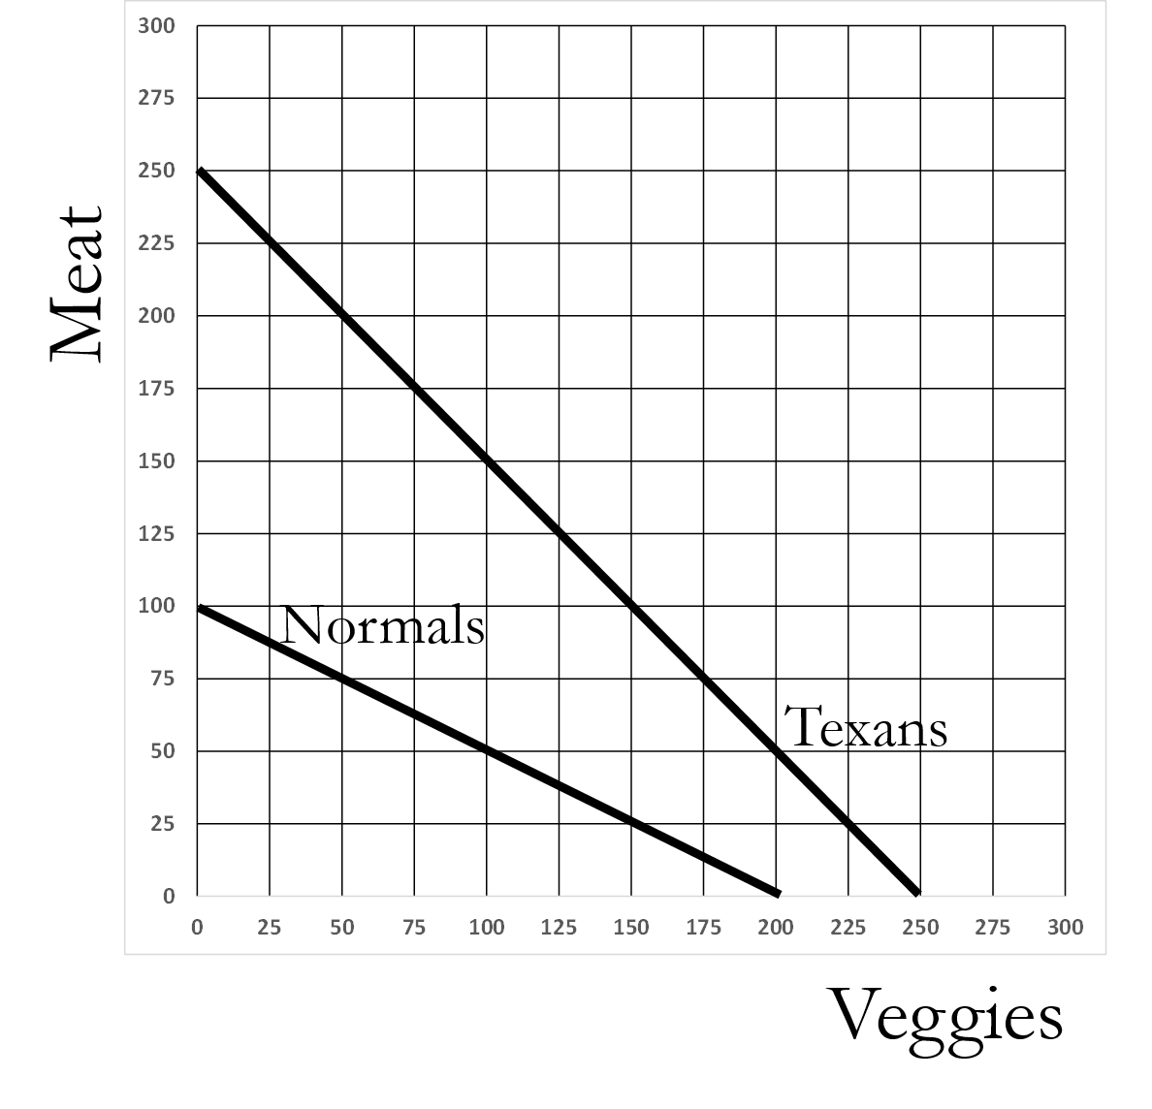
- [Chapter 3.2] In the graph above, the formula for the Normals is...?
- Normals: Meat = 100 – (1)(Veggies)
- Normals: Meat = 100 – (0.5)(Veggies)
- Normals: Meat = 200 – (1)(Veggies)
- Normals: Meat = 200 – (0.5)(Veggies)
- [Chapter 3.2] In the graph above, the formula for the Texans is...?
- Texans: Meat = 250 – (1/2)(Veggies)
- Texans: Meat = 250 – (1)(Veggies)
- Texans: Meat = 250 + (2)(Veggies)
- Texans: Veggies = 250 – (2)(Meat)

- [Chapter 3.2] Under what conditions do we say that two countries gain from trade? Assume that they can produce and consume only two goods.
- If the gains to one country are larger than the losses to the other country
- If both countries can consume more of at least one good
- If, for each country, they gain more of at least one good without decreasing consumption of either good
- If each country gains more of both goods
- If at least one good for each country does not increase or decrease
- [Chapter 3.2] What does the acronym “PPF” stands for?
- Production Possibilities Frontier
- Potential Production Frontier
- Production Potential Function
- Points of Production Function
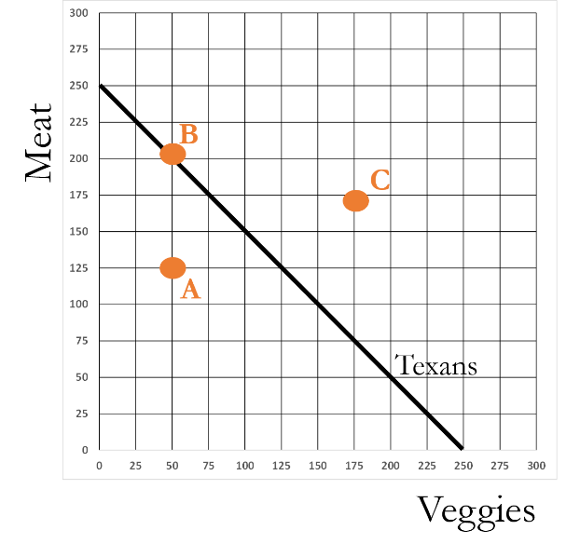
- [Chapter 3.2] In the figure above, Point A is referred to as an
- Inefficient point
- Efficient point
- Infeasible point
- Feasible point
- Ceteris paribus
- [Chapter 3.2] When two regions engage in trade, what will each region produce?
- The good for which they have an absolute advantage
- The good for which they do not have an absolute disadvantage
- The good for which they have a comparative advantage
- The good for which they can produce the most of
- The good they have been producing most often in the past

- [Chapter 3.3] Being able to trade allows regions to produce large amounts of a crop, and that allows them to increase their productivity by … ?
- Specializing and honing their skills
- Afford new technologies
- Paying higher wages to workers
- a and b only
- a, b, and c
- [Chapter 3.3] The U.S. had to wait until 1968 before any patent was granted for a technology related to agriculture.
- True
- False
- [Chapter 3.3] If the PPF for a clan is: grain = 100 - (5)(salmon), what is the opportunity cost of salmon?
- 5 grain
- 1/5 grain
- 5 salmon
- 1/5 salmon
- 100/5 = 20 salmon
- [Chapter 3.3] If the PPF for a clan is: grain = 100 - (10)(salmon), what is the opportunity cost of grain?
- 10 grain
- 1/10 grain
- 10 salmon
- 1/10 salmon
- 100/10 = 10 grain

From Exam 2

- [(5.2) The three stages of production] In Stage 2 of production, the marginal product of fertilizer is …
  - Positive and rising
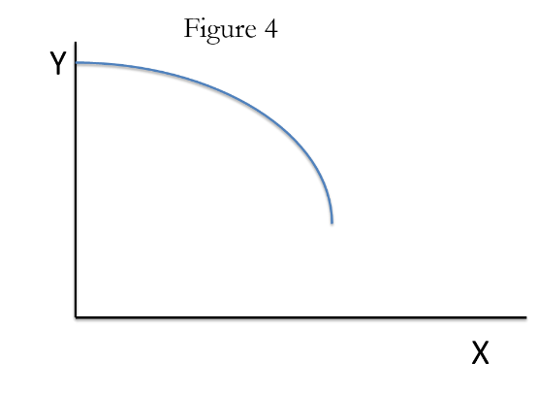
  - Positive and falling
  - Negative and rising
  - Negative and falling
  - Exactly zero
- [(5.2) The three stages of production] In Figure 4, the marginal product of X is …
- Positive and rising
- Positive and falling
- Negative and rising
- Negative and falling
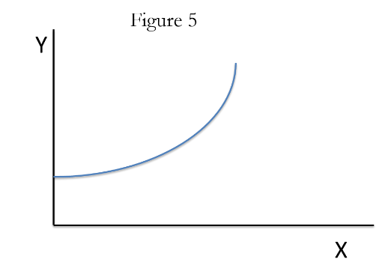
- Exactly zero
- [(5.2) The three stages of production] Figure 5 depicts which stage(s) of production?
- Stage 1 only
- Stage 2 only
- Stages 1 and 2
- Stages 2 and 3
- Stages 1, 2, and 3
- [(5.2) The three stages of production] Consider a feedlot, whose input is Days on Food (DOF) and whose output is Live-weight (LW). Suppose that a steer gained 3 pounds yesterday and 2.8 pounds today. What stage of production is this?
- Stage 1
- Stage 2
- Stage 3
- [(5.3) Marginal product] In the 1950's China, the leaders of the Communist Party often gave the farmers instructions on how they should raise crops. In one instance, the party leaders believed that by doubling the amount of fertilizer added to each acre, yields would also double. This belief assumes that ...
- The marginal product of fertilizer turns negative the more you use
- The marginal product of fertilizer always declines the more you use
- The marginal product of fertilizer never declines the more you use
- The marginal product of fertilizer never becomes positive the more you use
- [(5.3) Marginal product] Consider a feedlot, whose input is Days on Food (DOF) and whose output is Live-weight (LW). Suppose that when you increase DOF from 60 to 100, LW increases from 800 to 900. Within this interval, what is the marginal product of DOF?
- 2.5 lbs
- 1 lbs
- 0.4 lbs
- 0.8 lbs
- 0.2 lbs

- [(5.4) Costs, revenues, and profits] In Oklahoma wheat production, which of the following are not variable inputs / costs?
- Seed used to plant soybeans and corn
- Fertilizer used to keep fields fertile
- Pesticides used to combat weeds, insects, and fungal infections
- Loan payment, for loan used to build a shed
- All of the above are variable inputs / costs
(18) [(5.3) Marginal product] In Table 1 below, what is the marginal product when nitrogen use rises from 20 to 30 lbs per acre?
- 0.5
- 5
- 0.3
- 3
- 1
TABLE 1
Produce wheat? | Change in nitrogen use  (lbs N per acre) | Change in wheat yield  (bushels per acre) | Marginal Product of Nitrogen (bushels per acre)
NO | ------ | ------ | ------
YES | 0 ➔10 | 20 ➔25
YES | 10 ➔20 | 25 ➔35
YES | 20 ➔30 | 35 ➔38

(19) [(5.3) Marginal product] Where is Stage 3 in Table 1 above?
- 0 ➔10 to 10 ➔20 lbs N
- 0 ➔10 to 20 ➔30 lbs N
- 10 ➔20 to 20 ➔30 lbs N
- There is no Stage 3
(20) [(5.3) Marginal product] Which of the following terms best describes Stage 2 of production for nitrogen?
- Nitrogen is productive and becoming increasingly productive the more it is used
- Nitrogen is productive but becoming less productive the more it is used
- More nitrogen reduces yield, but if you keep adding nitrogen and it will eventually increase yield
- More nitrogen reduces yield
- Nitrogen is unproductive but becoming increasingly productive the more it is used

Use this information for questions 21-23.
Consider a feedlot whose input is days-on-feed (DOF) and whose output is the live-weight (LW) of cattle. The units of live-weight are total weight of an animal in lbs, and the units of DOF are the number of days in a feedlot. Suppose the marginal product (MP) of DOF goes by the following formula:
MP = 3 – 0.02(DOF)
(21) [(5.3) Marginal product] What is the marginal product at 75 days in the feedlot?
- 3.21
- 2.43
- 1.90
- 1.50
- 0.82
(22) [(5.3) Marginal product] Suppose that the price of cattle is $1 per lb and the cost of one DOF is $0.9. What is the profit-maximizing DOF?
- 105
- 110
- 111
- 140
- 142
(23) [(5.3) Marginal product] Suppose that the price of cattle is $0.9 per lb and the cost of one DOF is $1. What is the profit-maximizing DOF?
- 55.32
- 84.90
- 94.44
- 102.38
- 104.33
Use the table on the next page to answer questions 24-26.
(24) [(5.4) Costs, revenues, and profits] In the table below, what is the answer for the cell labeled “ #24 answer = _______ ”.
- 1
- 2
- 3
- 4
- 5
(25) [(5.4) Costs, revenues, and profits] In the table below, what is the answer for the cell labeled “ #25 answer = _______ ”.
- 100
- 122
- 42
- 160
- 162
(26) [(5.4) Costs, revenues, and profits] In the table below, what is the answer for the cell labeled “ #26 answer = _______ ”.
- (84)
- (62)
- 2
- 4
- 22
In the table below, you may assume that the wheat price is $4 per bushel, the nitrogen price is $0.20 per lb, fixed costs are $120, and variable costs other than nitrogen are $40. Use this table to answer the questions below.
Produce wheat? | Nitrogen (lbs / acre) | Wheat yield (bushels / acre) | Cost of nitrogen application ($ / acre) | Total fixed costs ($ / acre) | Total variable costs ($ / acre) | Total costs ($ / acre) | Revenues ($ / acre) | Profits ($ / acre)
NO | 0 | 0.00
Yes | 0 | 20.00
Yes | 10 | 25.00 | #24 answer = _______ |  |  | #25 answer = _______ |  | #26 answer = _______
Yes | 20 | 35.00
Yes | 30 | 40.00
Yes | 40 | 42.00
Yes | 50 | 41.00

From Exam 3

- [7.1.c. Compound Interest] Suppose you invest $1,000,000 for one year at a 14% interest rate. How much money will you have at the end of that year?
  - $999,999
  - $1,000,014
  - $1,014,000
  - $1,140,000
  - None of the above
- [7.1.d. Net present value] Suppose that you have the opportunity to spend $10,000 today to buy a bottle of wine that will be worth 12,000 in five years. Assume an interest rate of 10%. Also assume that you do not want to drink the wine, and would only buy it if it was profitable. Should you purchase the wine? Why?
  - No, because the present value of the investment is $9,314.77, which is less than its cost of $10,000.
  - No, because the present value of the investment is $7,451.06, which is less than its cost of $10,000.
  - Yes, because its present value is $19,326.15, considerably more than its cost of $10,000
  - Yes, because its present value is $12,008.27, considerably more than its cost of $10,000
- [8.1 The Supply Curve] The supply curve is also a _________ _________ curve and a demand curve is also a _________ ________ curve.
  - Added cost; added value
  - Marginal cost; marginal value
  - Cost value; value cost
  - Accounting cost; opportunity cost
  - Accounting value; opportunity value
- [8.3 The equilibrium price] Consider the diagram below. If the price is $50 then there is an excess ______ of ______ units.
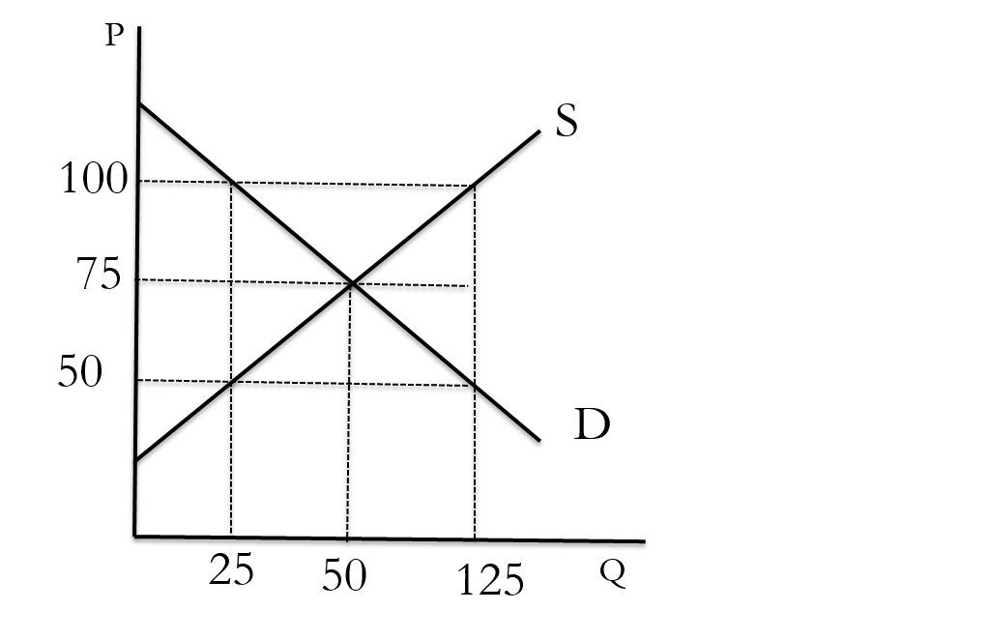
  - Demand; 25
  - Supply; 125
  - Demand; 100
  - Supply; 100

- [8.4 The supply curve shifts] Consider the diagram below. Suppose it refers to the market for lettuce. Suppose the initial supply curve for lettuce is S. Due to higher pest infestations it is now more costly to produce lettuce. This will shift the supply curve from S to _____
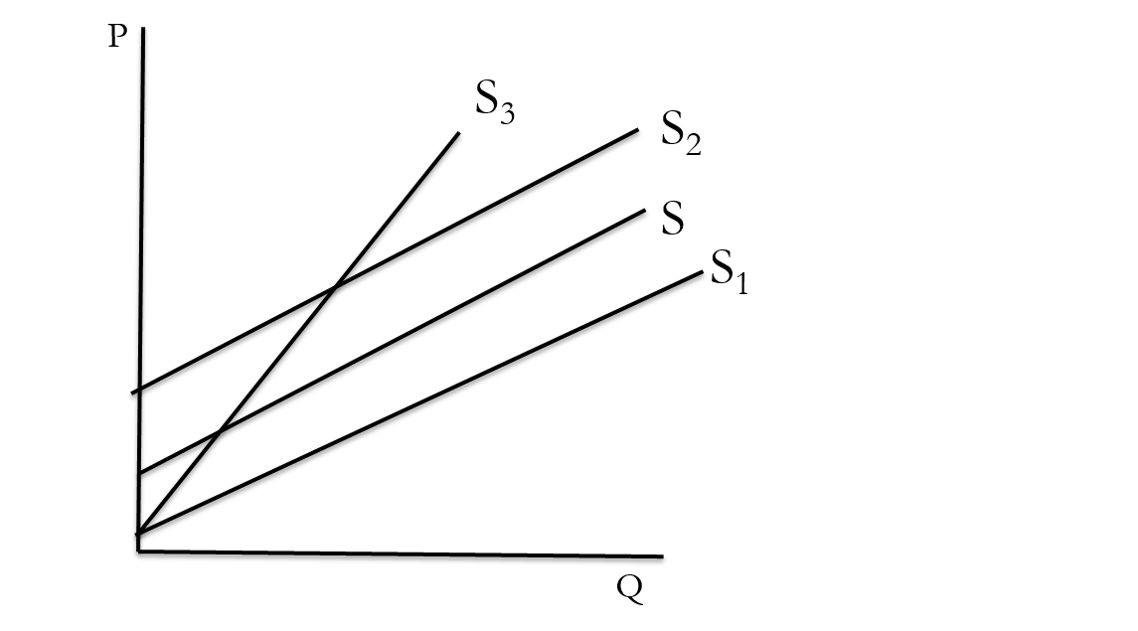
  - S₁
  - S₂
  - S₃
  - None of the above
- [8.5 The demand curve shifts] Consider the diagram below. Suppose it refers to the market for beef. Suppose that the price of hamburger buns rises. This will shift the demand for beef from the original demand curve D to _____.
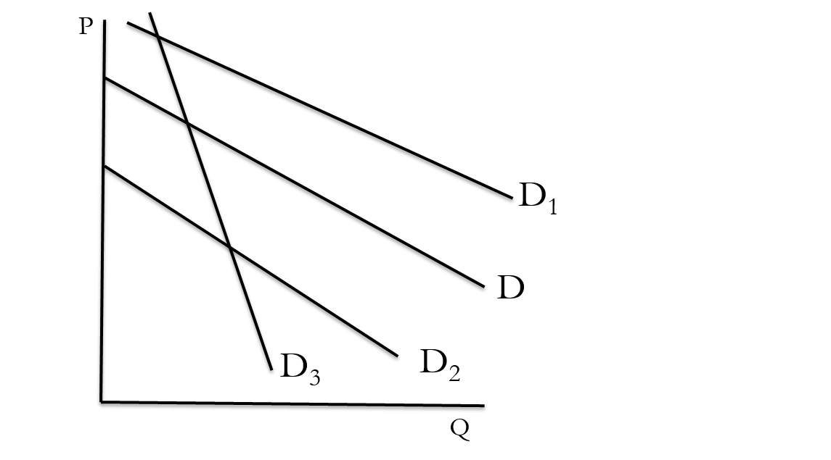
  - D₁
  - D₂
  - D₃
  - None of the above

- [8. Supply and Demand] Consider the graph below. What is happening to supply as the demand curve shifts to the left or shifts to the right?
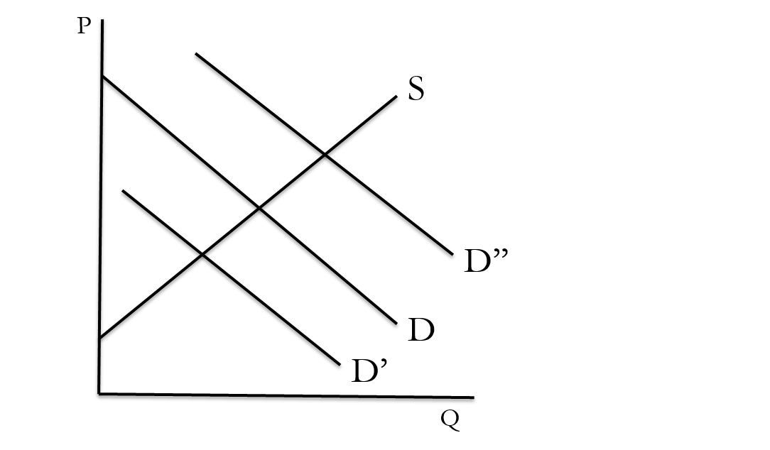
  - When demand decreases, supply decreases, and when demand increases, supply increases
  - When demand decreases, supply increases, and when demand increases, supply decreases
  - When demand increases, quantity supplied increases, and when demand decreases, quantity supplied decreases
  - When demand increases, quantity supplied decreases, and when demand decreases, quantity supplied increases
- [8. Supply and Demand] Assume that rice and beans are complements. If this is the case, then a rise in the price of rice will cause the demand for beans to ________, causing bean prices to _______.
  - Rise; rise
  - Fall; fall
  - Rise; fall
  - Fall; rise
- [8. Supply and Demand] If the supply of a good falls, and simultaneously, the demand for a good falls, what do we know about the price change?
  - Price will definitely rise
  - The price change is ambiguous (depends on the size of the curve shifts)
  - Price will definitely fall
- [8. Supply and Demand] If the supply curve shifts down, or to the right, this is referred to as a(n)
  - Increase in supply
  - Increase in quantity supplied
  - Decrease in supply
  - Decrease in quantity supplied
- [8. Supply and Demand] If the intercept of a demand curve decreases, this refers to a(n)
  - Increase in demand
  - Increase in quantity demanded
  - Decrease in demand
  - Decrease in quantity demanded
- [8. Supply and Demand] If the slope of a supply curve increases, this refers to a(n)
  - Increase in supply
  - Increase in quantity supplied
  - Decrease in supply
  - Decrease in quantity supplied
- [8. Supply and Demand] In the supply and demand curves given below, what are the correct supply and demand curve formulas?
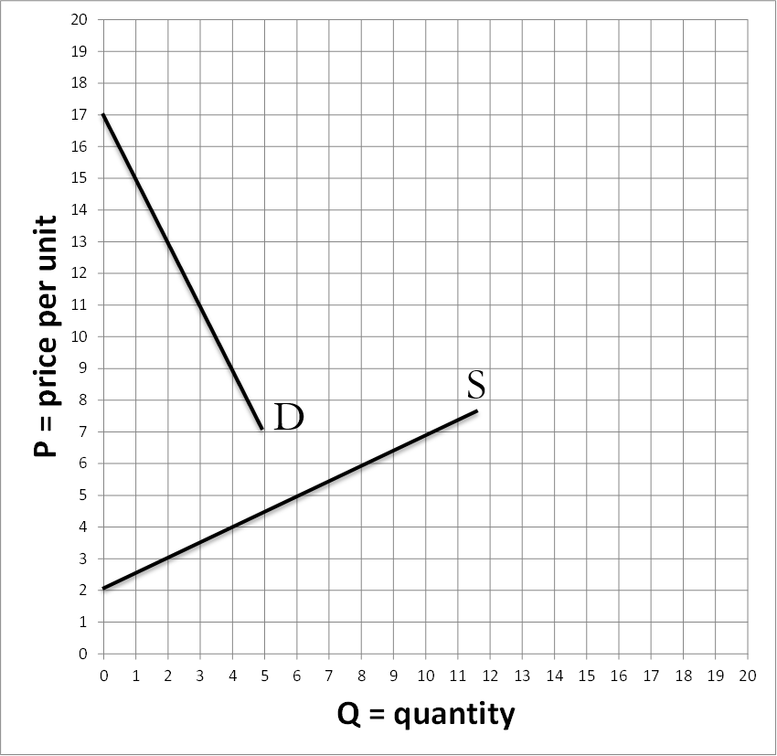
  - Supply: P = 2 + (0.5)(Q); Demand: P = 17 – (0.5)(Q)
  - Supply: P = 2 + (2)(Q); Demand: P = 17 – (2)(Q)
  - Supply: P = 2 + (2)(Q); Demand: P = 17 – (0.5)(Q)
  - Supply: P = 2 + (0.5)(Q); Demand: P = 17 – (2)(Q)
  - Supply: P = 2 + (0.5)(Q); Demand: P = 18 – (2)(Q)
- [8.3 The equilibrium price] Suppose the following supply and demand curves: Demand: 200 – (0.4)(Q); Supply: 20+(2)(Q). What is the equilibrium price and quantity?
  - Q^{E} = 122.2; P^{E} = $62.8
  - Q^{E} = 184.5; P^{E} = $55.5
  - Q^{E} = 130; P^{E} = $36.51
  - Q^{E} = 68; P^{E} = $80
  - Q^{E} = 75; P^{E} = $170
- [Fear the Boom and Bust] In Fear the Boom and Bust, __________ is the guy who loves to party but suffers from the hangover. He is adored by liberals because he advocates government action to prevent booms and limit the damage caused by busts. ______ is the opposite, as he is reserved and controlled, and believes government will only make the booms wilder and the busts more harmful.
  - Milton Friedman; Paul Krugman
  - Friedrich Hayek; John Maynard Keynes
  - Paul Krugman; Milton Friedman
  - John Maynard Keynes; Friederich Hayek
  - Joseph Stiglitz; Francis Epplin

- [Personal Finance] Which of the following describes Bailey’s recommendations for investing in stocks.
  - Never try and pick stocks. Instead, purchase tiny pieces of many stocks using mutual funds and index accounts.
  - Never try and pick stocks. Instead, just buy the stocks with the highest share price.
  - You should take an active role in picking stocks. Never leave it up to your investment manager. Read newspapers and magazines for information on the most profitable stocks.
- [Happiness] Of all the things that determines a person’s happiness, what percent is the result of the individual’s personal decisions (as opposed to genetics or the environment)?
  - 0%
  - 20%
  - 40%
  - 60%
  - 80%

