Name _______________________________

There are 34 questions, each worth one point. Mark all answers on your orange scantron. At the top of the scantron sheet please indicate whether you are taking the exam on Monday or Wednesday.

You may use your smartphone as a calculator, but if it looks like you are reading off your smartphone I will ask you to sit in the front row where I can observe you better.

You may use a cheat sheet that is 15 square inches, one side only, handwritten. You must submit this cheat sheet with your test, so write your name on the back of it.

- [Merritt Taylor] In agricultural economist Merritt Taylor’s adventures to developing countries, what is the one biggest problem that no one knows about?
  - Poor roads
  - Monarchy still exists in many places
  - Lack of trust between people
  - They care very little about climate change
- [7.1.a. Opportunity Cost] Opportunity cost is defined as
  - The utility, not the value, of the good
  - The value of the next best alternative
  - The utility of a reasonable alternative
  - The hedonic, not the utility, of the good
- [7.1.a. Opportunity Cost] You win a free ticket to see Mumford & Sons in concert, which you value at $20. However, because you are super-lame, you instead pay $30 to attend a One Direction concert. If it were not for the One Direction concert you would have attended the Mumford & Sons concert. What is the opportunity cost of attending the One Direction concert?
  - $20
  - The value of attending One Direction minus the $30 ticket price
  - The value of attending One Direction minus $20
  - $10
  - Zero
- [7.1.a. Opportunity Cost] A farmer can make $300, $280, and $260 dollars in profits for each acre of soybeans, cotton, and peanuts produced, respectively. If the profits from growing peanuts rises to $285, how does the opportunity cost of growing soybeans change?
  - It does not change the opportunity cost of growing soybeans.
  - It rises $25
  - It rises $15
  - It falls $25
  - It rises $5
- [7.1.a. Opportunity Cost] It costs about $40,000 to train a guide dog for one blind person. Donating to charities that provide such guide dogs is thus an altruistic act. However, Peter Singer wants us to observe that …
  - Blind people can earn money by working whereas many in developing countries cannot even find a job
  - For the same amount of money you could cure between 400 and 2,000 people of blindness in developing countries.
  - Spending the same amount of money to subsidize chemical fertilizers in developing countries could save perhaps 30,000 lives over ten years.
  - Spending the same amount of money to cure radon poisoning can prevent 1,000 people in the U.S. from going blind each year.

Complete the table below and use it to answer questions 6-8. Round to two decimal places throughout.
Column A | Column B | Column C | Column D
Age of Stand In Years | Tons Per Acre Harvested From Stand | Accounting profits per acre if harvested in that year (profits = $0.18 per ton) | Accounting profits per acre if harvested last year (profits = $0.18 per ton) and profits invested at a real, risk-free rate of return 14%
28 | 12,000 |  | ----------
29 | 14,800 | Question 6 ___________
30 | 16,000
31 | 16,800 |  | Question 7 ___________
32 | 17,000

- [7.1.b. Harvesting Trees] The answer to the cell Question 6 ___________ in the table above is
  - $2,664.00
  - $1,908.11
  - $2,491.39
  - $1,999.00
  - None of the above
- [7.1.b. Harvesting Trees] The answer to the cell Question 7 ___________ in the table above is
  - $3,099.29
  - $2,836.83
  - $3,451.98
  - $3,283.20
  - None of the above
- [7.1.b. Harvesting Trees] To maximize wealth, you should harvest the stand when it is ______ years old.
  - 28
  - 29
  - 30
  - 31
  - 32
- [7.1.c. Compound Interest] Suppose you invest $100,000 for one year at a 10% interest rate. How much money will you have at the end of that year?
  - $105,000
  - $108,000
  - $110,000
  - $118,000
  - None of the above
- [7.1.c. Compound Interest] Suppose you invest $100,000 for five years at a 10% interest rate. How much money will you have at the end of five years?
  - $123,884
  - $132,365
  - $138,928
  - $161,051
  - None of the above
- [7.1.d. Net present value] Suppose that you have the opportunity to spend $10,000 today on an investment that will give you profits of $15,000 in five years. Assume an interest rate of 10%. Should you purchase the investment? Why?
  - No, because the present value of the investment is $9,314, which is less than its cost of $10,000.
  - No, because the present value of the investment is $9,981, which is less than its cost of $10,000.
  - Yes, because its present value is $15,000, considerably more than its cost of $10,000
  - Yes, because its present value is $24,158, considerably more than its cost of $10,000
- [7.1.d. Net present value] Suppose that you have the opportunity to spend $100,000 today on an investment that will give you profits of $110,000 in ten years. Assume an interest rate of 2%. Should you purchase the investment? Why?
  - No, because its present value is $90,238, which is less than its cost of $100,000
  - No, because its present value is $98,368, which is less than its cost of $100,000
  - Yes, because its present value is $134,089, considerably more than its cost of $100,000
  - Yes, because its present value is $144,044, considerably more than its cost of $100,000
- [7.2. Value] The _______ value of water is low compared to that of diamonds, but the ______ value of water is much larger than that of diamonds.
  - incend; excend
  - excend; incend
  - total; marginal
  - marginal; total
- [7.2. Value] To an economist, the “value” of a good to a person refers to
  - The utility of a good the person receives
  - The person’s maximum willingness-to-pay for the good, if they had an income equal to or greater than the average income
  - The person’s maximum willingness-to-pay for the good
  - The utility of the person having the next highest utility for the good

- [7.2. Value] When the government is considering a project that will save lives, it measures the value of lives saved using what concept?
  - An actuarial life
  - And incendiary life
  - Value of the average person
  - Value of a statistical life
- [7.2. Value] Why is wheat sold for a higher price in eastern OK compared to western OK?
  - More rainfall in eastern OK gives the wheat more protein, increasing form utility
  - Higher selenium concentrations in eastern OK soils gives the wheat more protein, increasing form utility
  - Wheat is harvested sooner in eastern OK, giving it greater time utility
  - Wheat in eastern OK is located closer to ports, increasing its place utility
- [7.2. Value] _________ value refers to the value of one more unit.
  - Creational
  - Abational
  - Livational
  - Plus
  - Marginal
- [7.3 General Theory of Prices] How was the price of figs determined in ancient Athens?
  - Markets set the prices
  - Determined through a negotiation with Persia
  - Democratic vote
  - Consulted the oracle (prophets)
- [7.3 General Theory of Prices] The minimum price is determined by ________ while the maximum price is determined by ______.
  - Seller’s opportunity cost; buyer’s value
  - Seller’s accounting cost; buyer’s utility
  - Buyer’s accounting costs; seller’s utility
  - Buyer’s opportunity cost; seller’s value
- [7.3 General Theory of Prices] What pricing strategy did Quakers invent around the 18th century?
  - Fair, fixed prices for everyone
  - Letting buyers name their own price, as Concert Window now does
  - Negotiating through communication by touching fingers underneath a cloth so no one can see the resulting price
  - Auctions
- [8.1 The Supply Curve] The supply curve is also a _________ _________ curve and a demand curve is also a _________ ________ curve.
  - Added cost; added value
  - Marginal cost; marginal value
  - Cost value; value cost
  - Accounting cost; opportunity cost
  - Accounting value; opportunity value

- [8.3 The equilibrium price] Consider the diagram below. If the price is $100 then there is an excess ______ of ______ units.
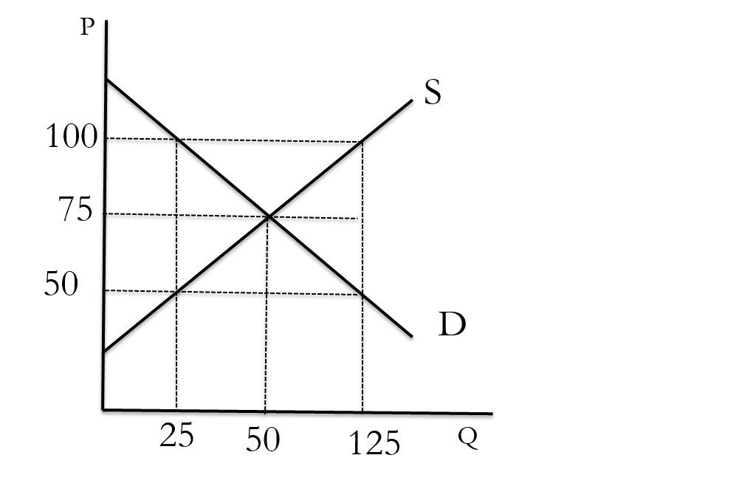
  - Demand; 25
  - Supply; 125
  - Demand; 100
  - Supply; 100
- [8.3 The equilibrium price] Suppose the government determines wages instead of supply and demand, and at those wages there was more demand for labor than supply. This tells us that the government-set wage is ______ the equilibrium wage.
  - Below
  - The same as
  - Above
- [8.4 The supply curve shifts] Consider the diagram below. Suppose it refers to the market for lettuce. Suppose the initial supply curve for lettuce is S. Due to lower pesticide prices, it is now cheaper to combat pests than before. This will shift the supply curve from S to _____
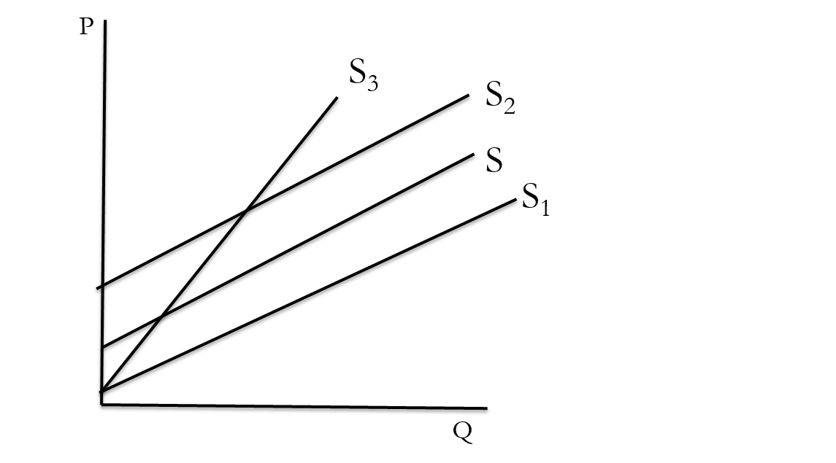
  - S₁
  - S₂
  - S₃

- [8.5 The demand curve shifts] Consider the diagram below. Suppose it refers to the market for beef. Then suppose that the price of pork falls. This will shift the demand for beef from the original demand curve D to _____.
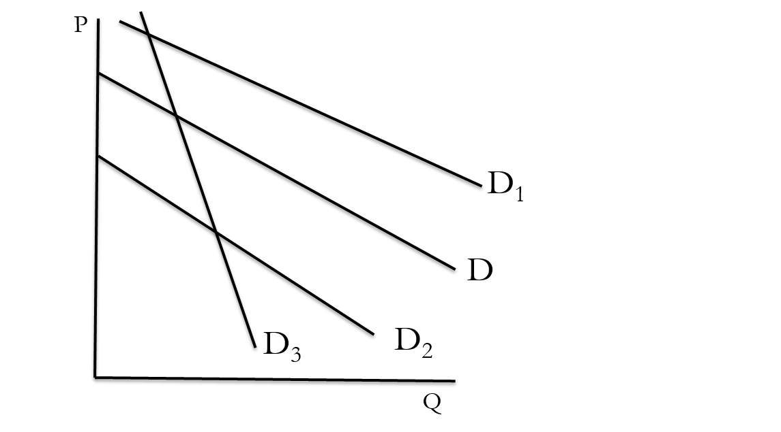
  - D₁
  - D₂
  - D₃
- [8. Supply and Demand] Consider the diagram below, and assume it refers to the supply and demand for oil. Suppose that a technological break-through makes solar energy much cheaper. Solar energy is a substitute for energy from oil. What will happen to the supply and demand for oil, as well as the equilibrium price and quantity?
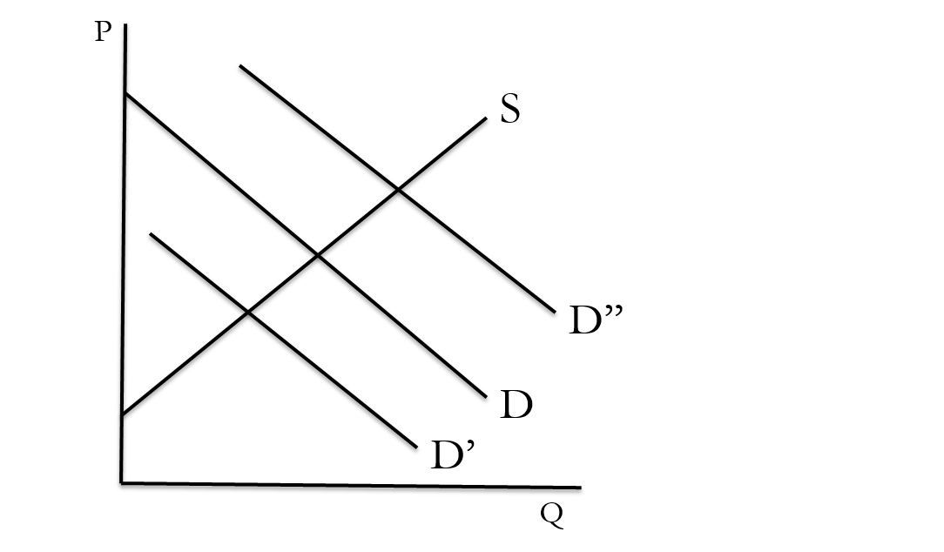
  - Demand decreases to D’ ; Quantity supplied falls; price falls; quantity falls
  - Demand decreases to D’ ; Supply also falls; price falls; quantity falls
  - Quantity decreases to D’ ; Quantity supplied falls; price falls; quantity falls
  - Demand increases to D’’ ; Quantity rises; price rises; quantity falls
- [8. Supply and Demand] Ramon Noodles are said to be a(n) _________ good because its demand falls as income rises. Goods whose demand rises with income are referred to as ______ goods.
  - Inelastic; elastic
  - Elastic; inelastic
  - Normal; inferior
  - Inferior; normal
  - Hicks; Marshallian
- [8. Supply and Demand] Assume that rice and beans are complements. If this is the case, then a rise in the price of rice will cause the demand for beans to ________, causing bean prices to _______.
  - Rise; rise
  - Fall; fall
  - Rise; fall
  - Fall; rise
- [8. Supply and Demand] If the supply of a good falls, and simultaneously, the demand for a good rises, what do we know about the price change?
  - Price will definitely rise
  - The price change is ambiguous (depends on the size of the curve shifts)
  - Price will definitely fall
- [8. Supply and Demand] Suppose that the market price falls due to an increase in supply. The demand curve does not shift. Still, this causes consumers to purchase more. This change in consumer behavior is described as a(n)
  - Increase in demand
  - Increase in quantity demanded
  - Demand paradigm-shift
  - Demand shuffle
- [8. Supply and Demand] If the intercept of a demand curve decreases, this refers to a(n)
  - Increase in demand
  - Increase in quantity demanded
  - Decrease in demand
  - Decrease in quantity demanded
- [8. Supply and Demand] If the slope of a supply curve decreases, this refers to a(n)
  - Increase in supply
  - Increase in quantity supplied
  - Decrease in supply
  - Decrease in quantity supplied

- [8. Supply and Demand] In the supply and demand curves given below, what are the correct supply and demand curve formulas?
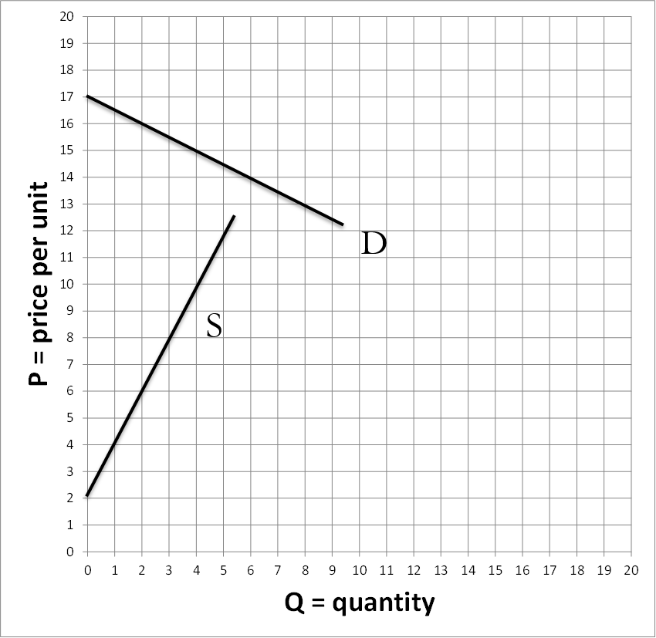
  - Supply: P = 2 + (0.5)(Q); Demand: P = 17 – (0.5)(Q)
  - Supply: P = 2 + (2)(Q); Demand: P = 17 – (2)(Q)
  - Supply: P = 2 + (2)(Q); Demand: P = 17 – (0.5)(Q)
  - Supply: P = 2 + (0.5)(Q); Demand: P = 17 – (2)(Q)
  - Supply: P = 2 + (0.5)(Q); Demand: P = 18 – (2)(Q)

- [8.3 The equilibrium price] Suppose the following supply and demand curves: Demand: 100 – (0.2)(Q); Supply: 22+0.4(Q). What is the equilibrium price and quantity?
  - Q^{E} = 122.2; P^{E} = $62.8
  - Q^{E} = 184.5; P^{E} = $55.5
  - Q^{E} = 130; P^{E} = $74
  - Q^{E} = 142; P^{E} = $80
  - Q^{E} = 151.4; P^{E} = $78.1

