(1) [Chapter 1] Why did ancient Greeks establish colonies around the Mediterranean?
- To escape the famine caused by political problems due to the Athenian king.
- To escape the food shortages caused by populations exceeding its agricultural capacity.
- To induce or force others to worship the Greek God Sterquilinus.
- In search of new crop varieties to send back to Athens.
(2) [Chapter 1] The food problem in Ancient Greece was a technological problem, not a political problem.
- True
- False
(3) [Chapter 1] In 2001 North Korea, the infant mortality rate was ____ per 1,000 births, compared to ____ in South Korea.
  - 88; 8
  - 24; 20
  - 50; 2
  - 76; 50
  - 619; 31
(4) [Chapter 1] To farm as Americans farm requires _________, free-enterprise, and free-trade.
- Private property
- Subsidies for technological research
- Fertilizer subsidies
- Legal patents
- The limited liability form of corporation
(5) [Chapter 1] The recent famines in North Korea were caused by
- Changing climate
- Pest infestations
- Political problems
- Lack of education by farmers
- Trade disputes with China
(6) [Chapter 1] Which of the following American products are legal to consume in North Korea, to help them deal with food shortages?
- Grits
- Gone With The Wind (movie and book)
- E-cigarettes
- The Civil War, a documentary and book by Ken Burns
- All of the above
(7) [Chapter 1] Economics teaches us that under the right conditions (private property, free-enterprise, and free-trade) our social interactions can be a
- Positive-sum game
- Zero-sum game
- Negative-sum game

(8) [Chapter 1] Per capita income in the U.S. started to grow really fast around
- 1000 CE
- 1300 CE
- 1800 CE
- 1900 CE
- 1950 CE
(9) [Chapter 1] The U.S. has a more business-friendly culture than Sweden.
- True
- False
(10) [Chapter 1] Liberal politicians Hillary Rodham Clinton and Elizabeth Warren tout their adherence to the teachings of economist Ludwig Von Mises.
- True
- False
(11) [Chapter 1] Which movie taught a young North Korean girl that in some societies men can love, and do not always rule over, women?
  - The Good Earth
  - Titanic
  - I, Claudius
  - Napolean Dynamite
  - The Fountainhead
(12) [Chapter 2] Economics is particularly concerned with how people interact with their friends and family
- True
- False
(13) [Chapter 2] Economists focus almost exclusively on how people interact in commerce, leaving the study of government to political scientists
- True
- False
(14) [Chapter 2] Economists believe even an ascetic monk wants more “stuff”
- True
- False
(15) [Chapter 2] Economists concentrate exclusively on the creation of wealth in terms of money, ignoring concepts like “a meaningful life.”
- True
- False
(16) [Chapter 2] Economists are particularly interested in making what is in one’s self-interest also in the interest of …
- Their family
- Their family and friends
- The government
- Society
(17) [Chapter 2] Suppose an economist believes organic food has no advantage over non-organic food. If a shopper pays a 20% premium for organic food, the economist concludes this is wasted money if
- The person disagrees with the economist on the benefits of organic food
- The food the person buys isn’t really “organic” but a fraud
- Both a and b
(18) [Chapter 2] This economist once remarked in his book The Wealth of Nations that it is in vain to expect others to produce our food out of love for us, but they will produce food in pursuit of their own self-interest.
- Bastiat
- Adam Smith
- Jayson Lusk
- David Hume
- David Ricardo
(19) [Chapter 2] As the world population has risen 250%, the price of agricultural products has
- Risen sharply (more than 60%)
- Risen only moderately (10-30%)
- Stayed roughly the same
- Fallen considerably (fallen more than 50%)
- None of the above
(20) [Chapter 2] Most of the poverty reductions in the last few decades has been achieved through
- Welfare programs
- Free-trade
- Subsidizing new technologies
- Climate change
- Food subisidies
(21) [Chapter 2] How was Jesse Lauriston Livermore an example of crony-capitalism?
- He was so influential he didn’t have to pay taxes
- FDR allowed Livermore to write his own financial sector regulations
- Calvin Coolidge always sought his blessing before he vetoed a bill
- He didn’t have to stop for red lights
(22) [Chapter 2] Why was the buffalo almost hunted to extinction?
- They were essentially worthless, so they were killed to make room for cattle
- The government subsidized buffalo kills
- No one owned the buffalo
- The buffalo often spread disease to cattle
- None of the above

(23) [Chapter 2] Why were gas stoves left running 24/7 in 1980s Uzbekistan?
- Because gas was free but matches were scarce
- Because the oven knobs would often break and replacement knobs were rationed
- Due to water problems, households had to boil all their water, even water used for bathing, and thus required constant boiling
- Because gas pipelines would leak excessively if gas was not continually flowing through the pipes
- None of the above
(24) [chapter not specified] Bailey dressed up as ______ in class on Jan 26.
- Adam Smith
- David Hume
- Bastiat
- Ludwig Von Mises
For questions 25-27 use the graph below
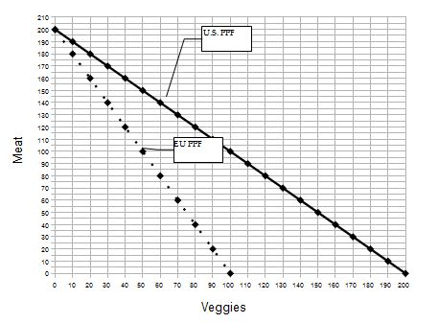
(25) [Chapter 3.2] In the graph above, the formula for the U.S. PPF is...?
- US: Meat = 200 - 1(Veggies)
- US: Meat = 100 - 1(Veggies)
- US: Meat = 200 - 2(Veggies)
- US: Meat = 200 - (1/2)(Veggies)

(26) [Chapter 3.2] In the graph above, the formula for the EU PPF is...?
- EU: Meat = 200 - (1/2)(Veggies)
- EU: Meat = 200 - 2(Veggies)
- EU: Meat = 200 - 1(Veggies)
- EU: Meat = 100 – (1/2)(Veggies)

Use this information to help you answer question 27: Suppose that, initially, the US and EU do not engage in trade. In autarky, the U.S. produces and consumes 1,000 Meat and 2,000 Veggies, while the EU produces and consumes 1,500 Meat and 2,000 Veggies. Once they engage in trade, the US produces 4,500 Veggies and no Meat, while the EU produces no Veggies and 3,000 Meat.
(27) [Chapter 3.2] Will both regions be better off if the U.S. and EU traded 2,000 Veggies for 1,000 Meat? (Note: If I don’t say a country loses or gains any Meat or Veggies you may assume they have the same amount of the good.)
- No, at least one country is worse off
- Yes, both countries gain 500 Meat
- Yes, the U.S. gains 500 Meat and the EU gains 150 Veggies
- Yes, the U.S. gains some veggies and the EU gains 500 meat
- Yes, the U.S. gains 500 veggies and the EU gains a certain amount of veggies.
(28) [Chapter 3.2] The acronym “PPF” stands for “Production Possibilities Frontier.”
- True
- False
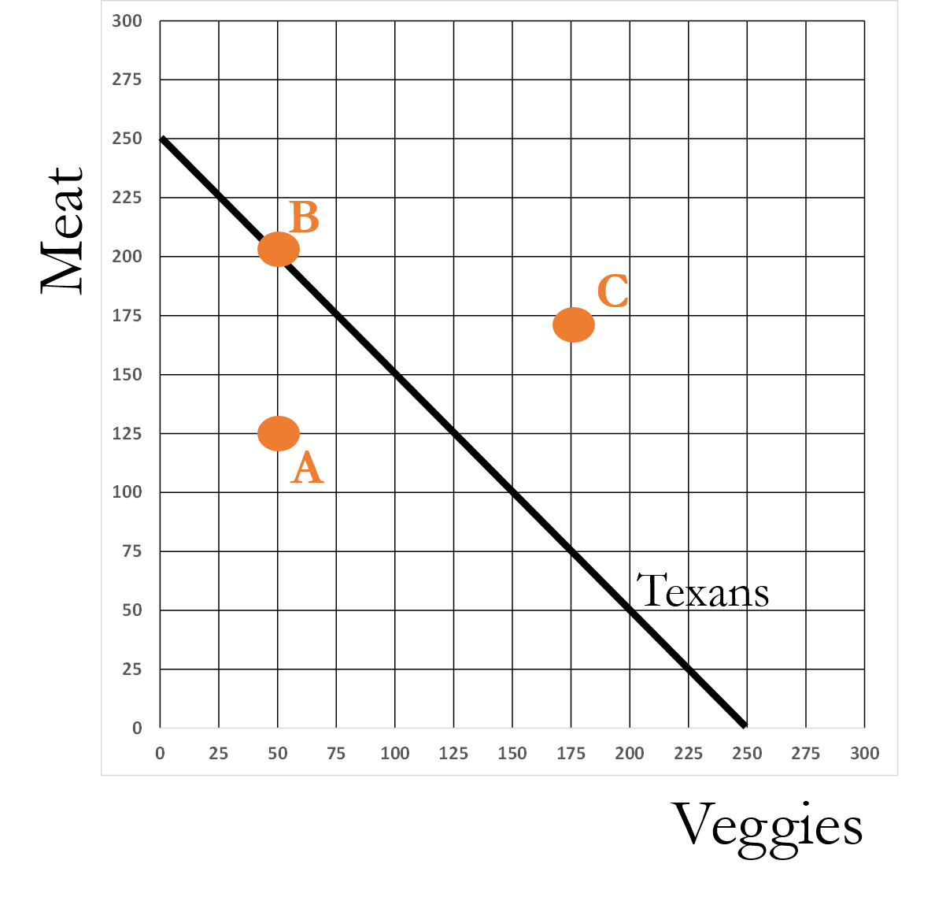
(29) [Chapter 3.2] In the figure above, Point C is referred to as an
- Inefficient point
- Efficient point
- Infeasible point
- Feasible point
- Ceteris paribus
(30) [Chapter 3.3] For every dollar a consumer spends in a grocery store, how much money is paid to the farmer for their contribution?
- $0.09
- $0.16
- $0.27
- $0.48
- $0.56

(31) [Chapter 3.3] Being able to trade allows regions to produce large amounts of a crop, and that allows them to increase their productivity by … ?
- Specializing and honing their skills
- Afford new technologies
- Force input suppliers to accept a lower price
- a and b only
- a, b, and c
(32) [Chapter 3.3] The first U.S. patent was awarded to Samuel Hopkins in 1790 for a new way of acquiring potash (a fertilizer and ingredient in soap production).
- True
- False
(33) [Chapter 3.4] If the number of dollar bills in a region falls, but everything else remains the same, prices in that region will tend to
- fall
- rise
- remain the same
(34) [Chapter 3.4] If a region attempts to export but not import, until prices in the region change, money will start to _______ in the region.
- Accumulate
- Become scarce
- Remain the same
(35) [Chapter 3.4] If a region attempts to import but not export, before trade is balanced, prices in the region will fall
- True
- False
(36) [Chapter 3.4] A nation must choose whether it wishes to export more than it imports, or vice-versa.
- True
- False
(37) [Chapter 3.4] Locavores like John English argue that buying local supports the local economy because as that money is passed from one person to another in that local region, it has a multiplier effect, allowing the local economy to accumulate wealth. (Note: I am asking what John English thinks, not what I think.)
- True
- False
(38) [Chapter 3.4] If locavores like John English are right, Stillwater could become wealthier by abolishing all trade with the outside world.
- True
- False

(39) [Chapter 3.4] _________ once said, “In a perfect world, everything that was sold, everything that was purchased and consumed would be local, so the local economy would receive the benefit of that …”
- Abraham Lincoln
- David Hume
- Tom Vilsack
- Jayson Lusk
- John English
(40) [No specified chapter] Who is the person in the picture below?
- Adam Smith
- David Hume
- Bastiat
- Ludwig Von Mises
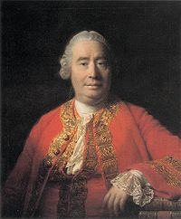

All questions until now should be answered on your scantron. The next page has three short answer questions. Answer these on this test booklet, so make sure your name and CWID is on this test booklet.

Short answer questions

(41) [Chapter 3.2] {2 Points} If the PPF for a clan is: grain = 10 - (3/4)(salmon), the opportunity cost of salmon is

______ _______________.

(42) [Chapter 3.2] {2 Points} If the PPF for a clan is: grain = 10 - (1/2)(salmon), the opportunity cost of grain is

______ _______________.

(43) [Chapter 3.3] {2 Points} Who or what feeds Stillwater?

