Exam 3
AGEC 1113
Spring 2017

Version B

Please answer only on your scantron. Be sure to put your correct CWID on your orange scantron. Be absolutely sure to write which test version you have on the top of the scantron.

You may use any calculator you like, even smartphones. Just make sure it doesn’t look like you are reading from your phone.

There are 35 total questions, each worth a different number of points.

(1) [Chapter 5.a, 1 Point] The opportunity cost of an action is …
  - The various list of alternative actions one could take
  - The least costly alternative
  - The value of the next best alternative
  - The few number of alternative actions an individual can contemplate when confronting any choice
  - The value of the opportunities the action provides

(2) [Chapter 5.a, 1 Point] It costs about $40,000 to train a guide dog and the blind person to use the guide dog. Donating to charities that provide such guide dogs is thus an altruistic act. However, Singer wants us to observe that
- Blind people can earn money by working whereas many in developing countries cannot even find a job
- For the same amount of money you could cure between 400 and 2,000 people of blindness in developing countries.
- Spending the same amount of money to subsidize chemical fertilizers in developing countries could save perhaps 30,000 lives over ten years.

(3) [Chapter 5.a, 1 Point] A farmer can make $75 an acre in profits raising canola, $50 an acre raising soybeans, or $40 an acre raising rye. The accounting costs are: canola = $150 per acre, soybeans = $170 per acre, rye = $100 per acre. What crop will the farmer plant, and what is its opportunity cost?
- Rye, OC = $100 per acre
- Rye, OC = $40 an acre
- Rye, OC = $75 an acre
- Canola, OC = $150 an acre
- Canola, OC = $50 an acre

(4) [Chapter 5.a, 1 Point]A farmer can make $175 an acre in profits raising canola, $150 an acre raising soybeans, or $140 an acre raising rye. The accounting costs are: canola = $250 per acre, soybeans = $270 per acre, rye = $200 per acre. How does the opportunity cost of raising canola change if the profits from raising rye increases by $5?
- OC of canola increases $5
- OC of canola increases $180
- OC of canola decreases $5
- OC of canola increases $170
- OC of canola does not change

(5) [Chapter 5.a, 1 Point] A farmer can make $175 an acre in profits raising canola, $150 an acre raising soybeans, or $140 an acre raising rye. The accounting costs are: canola = $250 per acre, soybeans = $270 per acre, rye = $200 per acre. How does the opportunity cost of raising canola change if the profits from raising soybeans increases by $10?
- OC of canola increases $10
- OC of canola increases $185
- OC of canola decreases $10
- OC of canola increases $165
- OC of canola does not change

(6) [Chapter 5.a, 1 Point] Suppose it is 2012. If you harvested your trees today you would harvest 15,000 tons per acre. However, if you let the trees live another year you could harvest 16,000 tons per acre in 2013. Assume that your profits are $0.73 per ton harvested, and that you could invest money at a risk-free interest rate of 11%. What are your accounting profits in 2013 if you harvest the trees in 2013?
- $4,000
- $13,733
- $10,333
- $11,680
- $10,000

(7) [Chapter 5.a, 1 Point] [Same info as previous question.] Suppose it is 2012. If you harvested your trees today you would harvest 15,000 tons per acre. However, if you let the trees live another year you could harvest 16,000 tons per acre in 2013. Assume that your profits are $0.73 per ton harvested, and that you could invest money at a risk-free interest rate of 11%. What are your accounting profits in 2013 if you harvest trees in 2012 and invest the profits at 11%?
- $12,154.50
- $13,903.24
- $9,031.00
- $11,937.56
- $14,118.52

(8) [Chapter 5.a, 1 Point] [Same info as previous question.] Suppose it is 2012. If you harvested your trees today you would harvest 15,000 tons per acre. However, if you let the trees live another year you could harvest 16,000 tons per acre in 2013. Assume that your profits are $0.73 per ton harvested, and that you could invest money at a risk-free interest rate of 11%. When should you harvest your trees?
- 2012
- 2013

(9) [Chapter 5.a, 1 Point]As the interest rate falls foresters will harvest trees at _____ age.
- a younger
- an older
- the same

(10) [Chapter 5.a, 1 Point]Suppose you invest $100,000 at an interest rate of 5% for 4 years. How much money will you have after 4 years?
- $95,302.00
- $121,550.63
- $105,385.76
- $114,943.29
- $104,945.12

(11) [Chapter 5.a, 1 Point] How much money would you need to invest today at an interest rate of 3% to have 50,000 after five years?
- $43,130.44
- $39,383.29
- $45,006.01
- $48,921.11
- $23,001.48

(12) [Chapter 5.a, 1 Point] What is wrong with the equation PV = (FV)^{-T}(1+r)
- Nothing is wrong with the equation
- Should say FV = (PV)^{-T}(1+r)
- Should say PV = (FV)(1+r)^{-T}
- Should say PV = (FV)^{-T}(1-r)
- PV = (FV)^{-r}(1+T)

(13) [Chapter 5.a, 3 Points] Suppose you have the opportunity to refinance your home mortgage loan. It will cost you $750 to do so right now, but will reduce your yearly payments by $200 right now and for three years after, as shown in the table below. What is the Net Present Value (NPV) of refinancing your loan? Assume a discount/interest rate of 2%.

Year | Benefit (reduction in yearly mortgage payment) | Cost of refinancing your mortgage
0 (now) | $200 | $750
1 | $200 | 0
2 | $200 | 0
3 | $200 | 0

- $3.33
- ($5.35)
- ($8.39)
- $26.78
- $0.00

(14) [Chapter 5.a, 1 Point] If the Net Present Value of an investment is negative, it means that
- The investment doesn’t make as much money as investing the money at the interest rate
- The investment will decrease the number of dollars you possess
- The investment may or may not make money, but it is too risky
- The opportunity cost does not matter in determining the desirability of the investment

Suppose that the supply and demand for pork went by the following formulas.

Supply: P = 100 + (1.25)(QS)
Demand: P = 1000 – (1.75)(QD)

(15) [Chapter 6, 1 Point] [Worth 3 Points] Which of the following charts are the correct depictions of this supply and demand curve?
- Chart A
- Chart B
- Chart C
- Chart D

Chart A
Chart B
Chart C
Chart D

(16) [Chapter 6, 1 Point] The demand curve below shows that, at a price of $800 consumers buy 100 units. That $800 price refers to
- The per unit price
- The price of all 100 units

(17) [Chapter 6, 1 Point] In the demand curve below, as price falls from $800 to $400,
- Quantity demanded increases by 200 units
- Demand increases by 200 units
- Quantity demanded decreases by 200 units
- Demand decreases by 200 units

(18) [Chapter 6, 1 Point] In the demand curve below, at a low price of $200, the persons buying the product are
- People who value wheat a lot
- People who value the wheat a little
- Both people who value the wheat a lot and people who value the wheat a little

(19) [Chapter 6, 1 Point] In the demand curve below, people purchase more as the price falls from $800 to $400. We refer to this change in consumer purchases as a(n)
- Increase in demand
- Decrease in demand
- Increase in quantity demanded
- Increase in demanded supplied
- Change in demand schedule

(20) [Chapter 6, 1 Point] In the supply curve below, if price increases from $250 to $350, there will be a(n)
- 100 unit increase in quantity supplied
- 100 unit shift in the supply curve
- 50 unit decrease in quantity supplied
- 50 unit increase in demanded supplied

(21) [Chapter 6, 1 Point] At a high price $400, compared to a low price of $100, the people producing wheat will be
- lower cost producers
- higher cost producers
- both lower and higher cost producers

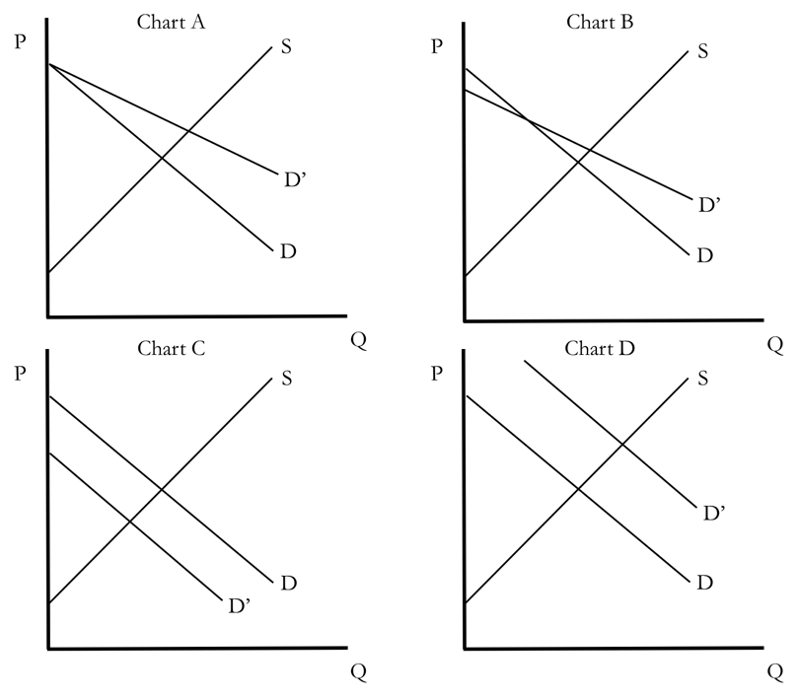
(22) [Chapter 6, 1 Point] Which of the following charts in the right figure illustrates an increase in demand?
- Chart A
- Chart B
- Chart C
- Chart D
- Chart A and D

(23) [Chapter 6, 1 Point] Which of the following charts in the right figure illustrates a decrease in demand?
- Chart A
- Chart B
- Chart C
- Chart D
- Chart A and D

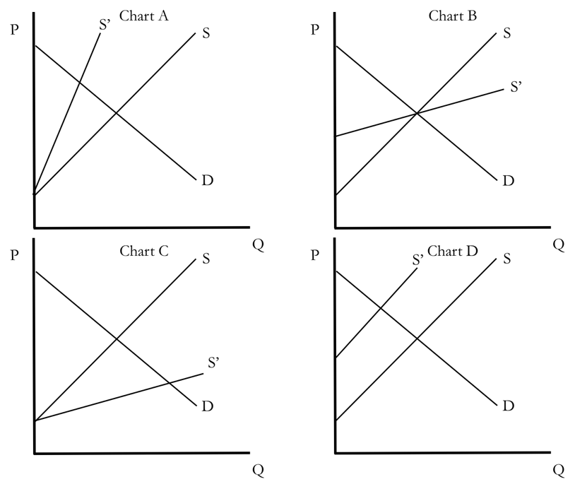
(24) [Chapter 6, 1 Point] Which of the following charts in the right figure illustrates an increase in supply
- Chart A
- Chart B
- Chart C
- Chart D
- Chart A and D

Suppose that the supply and demand for pork went by the following formulas. Use these formulas to answer 25-27.

Supply: P = 100,000 + (0.004)(QS)
Demand: P = 900,000 – (0.003)(QD)

(25) [Chapter 6, 4 Points] The equilibrium quantity is
- 750,000,000.00 units
- 110,000,380.12 units
- 9,843.00 units
- 114,285,714.29 units
- 53,039,092,094.84 units

(26) [Chapter 6, 4 Points] The equilibrium price is
- $557,142.86
- $294,439,092.00
- $1,392.48
- $3,928.24
- $391,342.94

(27) [Chapter 6, 3 Points] If price is $200,000, quantity supplied is
- 19,000,000
- 25,000,000
- 111,038.22
- 934,201,193.22
- 200,000,400.35

(28) [Chapter 6, 1 Point] If price is less than the equilibrium price, there will be
- an excess supply = surplus
- an excess demand = shortage
- Neither, the market will be at equilibrium

(29) [Chapter 6, 1 Point] Suppose that bad weather damages this year’s watermelon crop, killing about 30% of the watermelon plants that were growing. This is referred to as a(n)
- increase in demand
- decrease in quantity demanded
- decrease in quantity supplied
- decrease in supply
- increase in supply

(30) [Chapter 6, 1 Point] A supply increase causes the equilibrium
- quantity to rise and price to fall
- quantity to rise and price to rise
- quantity to fall and price to fall
- quantity to fall and price to rise

(31) [Chapter 6, 1 Point] A technological innovation that reduces the cost of watermelon production causes the equilibrium
- quantity to rise and price to fall
- quantity to rise and price to rise
- quantity to fall and price to fall
- quantity to fall and price to rise

(32) [Chapter 6, 1 Point] A demand decrease causes the equilibrium
- quantity to rise and price to fall
- quantity to rise and price to rise
- quantity to fall and price to fall
- quantity to fall and price to rise

(33) [Chapter 6, 1 Point] A demand increase causes the equilibrium
- quantity to rise and price to fall
- quantity to rise and price to rise
- quantity to fall and price to fall
- quantity to fall and price to rise

(34) [Chapter 6, 1 Point] If we see price fall and quantity rise, this would, without a doubt, be caused by
- Decrease in demand
- Increase in demand
- Decrease in supply
- Increase in supply
- Both a and c

(35) [Chapter 6, 1 Point] If we see price fall and quantity fall, this would, without a doubt, be caused by
- Decrease in demand
- Increase in demand
- Decrease in supply
- Increase in supply
- Both a and c

