Exam 1
AGEC 1113 w/ Norwood
Spring 2017

Version A

Name _______________________

Credit Card Number ___________________

Make absolutely sure you write the version of your exam at the top of your scantron.

Make absolutely sure you enter your correct CWID on your orange scantron sheet, and your name also.

You don’t need to put the course number or section number on the scantron.

Please mark all your answers on the orange scantron sheet.
Prediction Markets

For questions 1 through 4 assume the following market: Consider a futures contract that is worth $10 if OSU beats Iowa in men’s basketball on Feb 22. It is worth zero otherwise.

- If you believe OSU has a 35% chance of winning, you should be willing to…
  - Buy and/or sell at $3.5
  - Sell and/or buy at less than $3.5
  - Sell and/or buy at more than $3.5
  - Sell at less than $3.5 and/or buy at more than $3.5
  - Buy at less than $3.5 and/or sell at more than $3.5
- If someone submits a selling price of $6, that means they believe the chances of OSU winning are
  - Greater than 60%
  - Less than 60%
  - Equal to 60%
  - None of these
- If you buy a contract for $6 and OSU wins, what are your profits?
  - You earn $6
  - You lose $6
  - You earn $4
  - You lose $4
  - You earn $14
- If you buy a contract for $4 and then sell a contract for $7, and OSU wins, what are your profits?
  - You earn $3
  - You lose $3
  - You earn $7
  - You lose $7
  - You lose $4
- If someone buys a July 2017 Wheat futures contract, hoping to sell the same contract later at a higher price, they are
  - Going long
  - Going short
  - Offsetting
  - Transcribing
  - There is no term for this, or, this strategy does not make sense
- True or False? In order for someone to sell a July 2017 Wheat futures contract they must first buy 5,000 bushels of wheat
  - True
  - False
- How much is a bushel?
  - 38 lbs
  - 52 lbs
  - 10 gallons
  - 9.3 gallons
  - 100 kilograms

Chapter 1
- Which of the following individual’s contribution was to suggest changing ‘political economy’ to ‘economics’?
  - Quesnay
  - Alfred Marshall
  - Adam Smith
  - Bastiat
  - Plato / Socrates
- If an economist estimates how fisherman will respond to changes in laws about when they can fish, they are practicing _______ economics.
  - Positive
  - Transformative
  - Normative
  - Conscriptive
  - Relational
- When the ancient Greek’s used their version of the word ‘economics’, which was Oikonomia, it referred to
  - The management of trade between the Greeks, Persians, and Sicily
  - The art of using policy to manage city-states like Athens
  - The management of a household or estate
  - The management of a business, usually pottery, olives, and wheat
  - The regulation, or non-regulation, of market prices
- Adam Smith is considered the founder of modern economics through the writing of his book
  - Principles of Economics
  - Principles of Oikonomia
  - Economic Harmonies
  - Wealth of Nations
  - The Republic
- Economics, according to Dr. Norwood, has a particular interest in making self-interest
  - A prime motivator of behavior
  - A central tenet in public policy
  - Relevant in private affairs but not public affairs
  - Harmonious with social interest
- To encourage sustainable fishing, we tried limiting the days in which people could catch fish, but this didn’t work because
  - Fishermen learned to work together and surround fish populations during these days, resulting in very large fish catches during those days.
  - Fishermen invested in better equipment that would allow them to increase their catch of fish during those days.
  - There was a backlash of consumers because certain fish were only available for part of the year.
  - Fishermen became intensely competitive and began sabotaging each other’s efforts

- What is the term for a situation where a resource is shared, but some individuals exploit the resource at the expense of everyone?
  - Rival exploitation
  - Free-riders run amock
  - Travesty of public property
  - Calamity of the sharing
  - Tragedy of the commons
- The case of reindeer grazing lands in Finland proves that you cannot expect large groups of people to be able to properly coordinate the use of a shared resource
  - True
  - False
- What is this a map of?
  - Patterns of wind sources for wind energy
  - Areas with significant soil erosion in the U.S.
  - The prairie grasslands of the Midwest where the Buffalo used to graze
  - The Ogallala Aquifer
  - The Midwestern steppes

- Who is this economist below in the two pictures?
  - Adam Smith
  - Todd Margaret
  - Lionel Robbins
  - Alfred Marshall
  - Bastiat
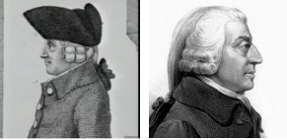

Chapter 2
- Looking back at the last century, when world population rises, the price of agricultural products
  - Falls
  - Rises
  - Stays about the same
  - There is no relationship between population and ag product prices
- The book A History of World Agriculture says that the recent rise in population was made possible through motorized, mechanized, and chemicalized agriculture.
  - True
  - False
- Which of the following cases experienced starvation partially due to the eradication of sparrows?
  - Ancient Athens
  - 1920s Russia
  - 1950s China
  - The Pilgrims
  - Modern day Venezuela
- The best measure of agricultural productivity is the amount of food produced per hour of labor
  - True
  - False
- Which of the following were ways the ancient Greeks dealt with a food supply that could not keep up with its rising population, according to Chapter 2?
  - Send citizens to colonize other areas
  - Banning of meat production
  - Forced rationing
  - Requiring different sized meals for Athenian citizens and Athenian slaves
- Suppose each U.S. state adopts a local foods policy whereby each state prohibits imports of food from any other state or country. What kind of "game" does this describe?
  - Positive-sum game
  - Negative-sum game
  - Zero-sum game
- Both 1920s Russia and modern-day Venezuela experience(d) problems of food provision. What problem did they have in common?
  - Attempted eradication of presumed pests, like sparrows
  - Communism
  - Reliance on local foods
  - Price controls
  - Reliance on urban agriculture
- Which of the following items is particularly necessary for people and businesses to specialize?
  - property rights
  - flexible markets
  - trade
  - decentralization
- Decentralization is important because ______ is dispersed throughout an economy
  - Property
  - Prices
  - Specialization
  - Information
  - Cultural norms
- Only in the last millennium has western civilization developed a respect for profit-making through business.
  - True
  - False

- Although the chart below illustrates a part of Creative Destruction, what part does it ignore?
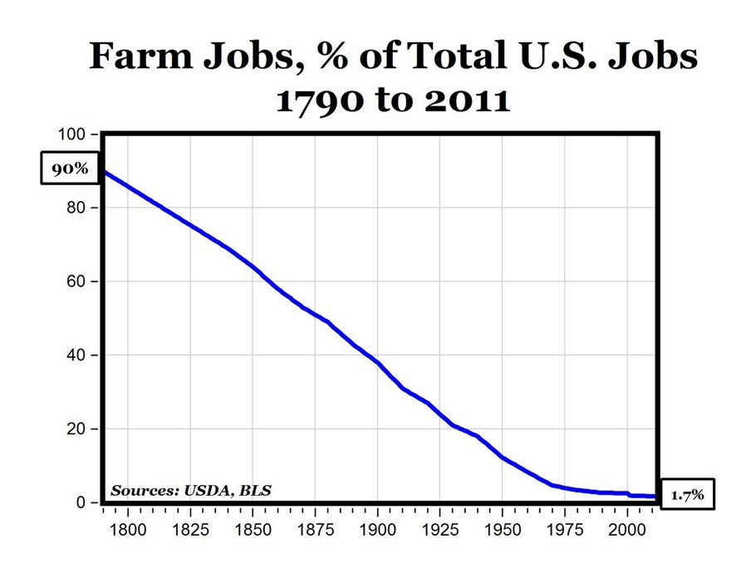
  - The permanent harms experienced by farmers who went out of business
  - The fact that while the percent of farm jobs was declining the total absolute number of farm jobs was rising
  - The fact that many other new jobs were created during the same time period
  - The fact that this was caused by technology, not trade
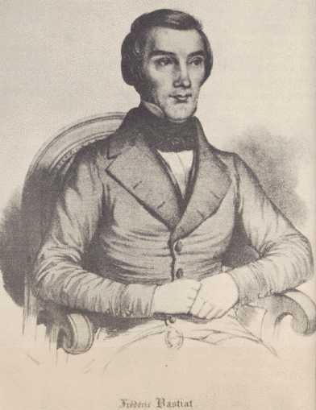
- Who is the economist to the right? He was also the economist who wrote, “I would venture to say that in a single day [the average person] consumes more than he could himself produce in ten centuries.”
  - Adam Smith
  - Frédéric Bastiat
  - Socrates
  - Alfred Marshall
  - Lionel Robbins
  - Quesnay

- In North Korea today
  - Citizens rely on market exchanges for food
  - Citizens rely on government collective farms for food
  - Citizens rely on government supply stores for food
  - All food comes from international aid

- What is the main reason the Irish starved during the period 1845-1850, according to Chapter 2?
  - The British would not allow any crop except potatoes to be planted in Ireland
  - British landlords decided to export much of Ireland’s food production instead of letting the Irish consume it
  - A fungal infection destroyed much of its potato production
  - An Irish cultural rejection of almost all foods except the potato
  - Price controls
- Why are much of Mongolian grasslands being destroyed?
  - Excessive grazing of yaks
  - Excessive burning of grasslands
  - Excessive grazing of cashmere goats
  - Insufficient fertilization of grasslands
  - Soil erosion
- What is the main cause of the Great Enrichment?
  - Cultural changes
  - Trade and specialization
  - Advent of private property
  - Democracy
  - Flexible prices
- One obstacle to food provision in Venezuela is that their constitution does not address food issues?
  - True
  - False

Chapter 3.2
- If the price of good A is $80 and the price of good B is $20, what is the opportunity cost of good A in terms of good B?
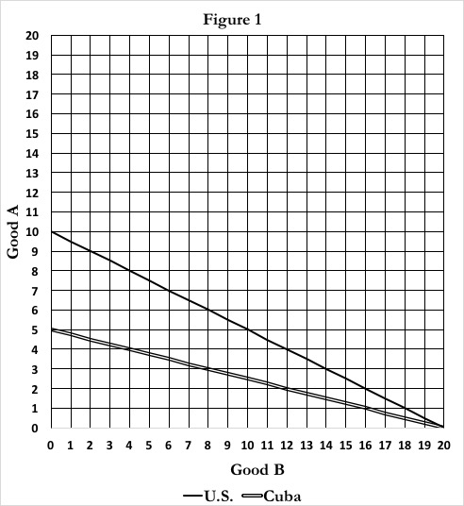
  - $80
  - 20 units of good B
  - 100 units of good B
  - 4 units of good B
  - 1/4 units of good B
- In Figure 1 to the right, what is the PPF of U.S.?
  - A = 20 – 1(B)
  - A = 20 – 2(B)
  - A = 10 – 2(B)
  - A = 10 – 0.5(B)
  - A = 10 – 1(B)

- In Figure 1 to the right, what is the PPF of Cuba?
  - A = 5 – 5(B)
  - A = 5 – 4(B)
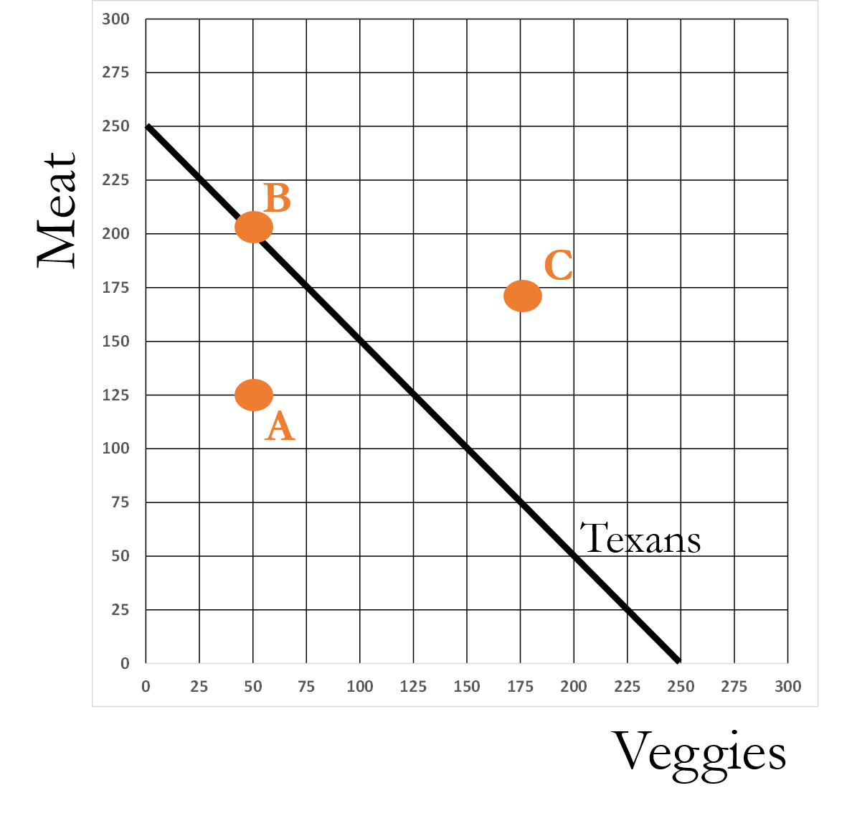
  - A = 5 – (0.2)(B)
  - A = 5 – (0.25)(B)
  - A = 5 – (1/20)(B)
- In the figure to the right, which are the feasible points of production?
  - A only
  - B only
  - C only
  - A and B
  - B and C

- If a group has the PPF, A = 10 – 2(B), the opportunity cost of B is
  - 2 units of A
  - 2 units of B
  - ½ units of A
  - ½ units of B
  - 12 units of A

- If a group has the PPF, A = 10 – 2(B), the opportunity cost of A is
  - 2 units of A
  - 2 units of B
  - ½ units of A
  - ½ units of B
  - 12 units of A
- A country has a comparative advantage in the production of sugar, compared to another country, if it can
  - Produce more of that sugar
  - Produce the sugar at a lower opportunity cost
  - Can produce more of the sugar without giving up production of other goods
- Two countries, trading two goods, are said to gain from trade if …
  - At least one country gets more of both goods
  - They both get more of both goods
  - They both get a larger number of total units of all goods
  - They both get more of at least one good without giving up any units of the other good
  - Each gets more units of one good than they give up in another good
- In the graph below, point A refers to autarky for the U.S. and Cuba. If they engaged in trade, how much beer will the U.S. produce, and how many cigars will Cuba produce.
  - U.S. = 20 Beers, Cuba = 10 Cigars
  - U.S. = 10 Beers, Cuba = 10 Cigars
  - U.S. = 10 Beers, Cuba = 20 Cigars
  - U.S. = 20 Beers, Cuba = 20 Cigars
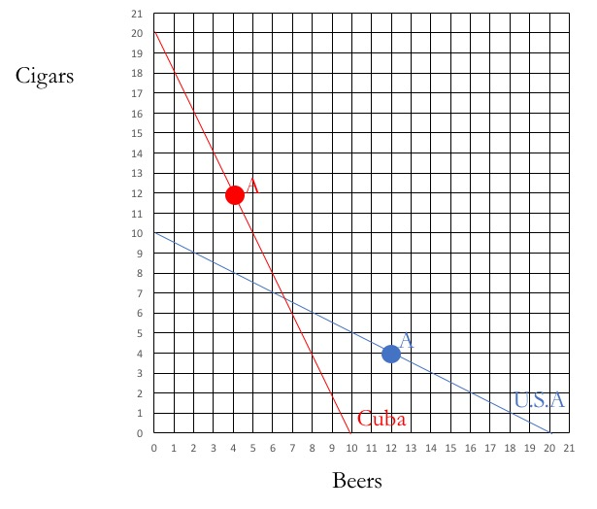
- Trade between countries is considered a zero-sum game because someone always loses from trade.
  - True
  - False

Trade Considerations
- In reality, exports from a country are always less than its imports
  - True
  - False
- The Jeep Patriot got its name because it is the car with the most American-made parts.
  - True
  - False
- What is the term for the social movement where countries or regions seek more control over its food supply, more sustainable production practices, and in the U.S., fewer regulations governing direct exchanges between small farmers and consumers.
  - Culinary Determination
  - Agrarian Rights
  - Food Sovereignty
  - Farm-to-Fork
  - Farm-to-Table
- What destroyed India’s artisan cooking oil industry?
  - New sanitation rules by the World Trade Organization
  - Smear campaigns by multinational corporations
  - New rules enacted by the Indian government
  - Trade sanctions issued by the United Nations
- Why does the U.S. both import and export beef?
  - Rules set by the World Trade Organization requires it to
  - Because of U.S. subsidies given to beef producers that require them to export
  - Because they aren’t really exporting and importing the same type of beef
  - The U.S. doesn’t both export and import beef. It only imports.
- What would happen to wheat exports from the U.S. if the U.S. no longer imported anything from other countries?
  - Wheat exports would fall
  - Wheat exports would rise
  - Wheat exports would remain unchanged
  - None of the above, as wheat cannot be exported from the U.S.

