Prediction Markets
- Consider a futures contract that is worth $10 if OSU beats Nebraska in men’s basketball. It is worth zero otherwise. If you believe OSU has a 70% chance of winning, you should be willing to…
  - Buy and/or sell at $7
  - Sell at less than $7 and/or buy at more than $7
  - Buy at less than $7 and/or sell at more than $7
  - Sell and/or buy at less than $7
  - Sell and/or buy at more than $7
- Consider a futures contract that is worth $10 if OSU beats Nebraska in men’s basketball. It is worth zero otherwise. If you believe OSU has a 30% chance of winning, you should be willing to…
  - Buy and/or sell at $3
  - Sell at less than $3 and/or buy at more than $3
  - Buy at less than $3 and/or sell at more than $3
  - Sell and/or buy at less than $3
  - Sell and/or buy at more than $3
- Consider a futures contract that is worth $20 if OSU beats Nebraska in men’s basketball. It is worth zero otherwise. If you believe OSU has a 70% chance of winning, you believe the contract’s value is
  - $3
  - $7
  - $6
  - $14
  - $20
- Consider a futures contract that is worth $50 if OSU beats Nebraska in men’s basketball. It is worth zero otherwise. If you believe OSU has a 50% chance of winning, you believe the contract’s value is
  - $25
  - $5
  - $15
  - $50
  - $100
- Consider a futures contract that is worth $10 if OSU beats Nebraska in men’s basketball. If someone is willing to sell it for $4 that implies
  - They believe OSU has a 40% chance of winning
  - They believe OSU has a 60% chance of winning
  - They believe OSU has less than a 40% chance of winning
  - They believe OSU has more than a 40% chance of winning
  - None of the above
- Consider a futures contract that is worth $10 if OSU beats Nebraska in men’s basketball. If someone is willing to buy it for $4 that implies
  - They believe OSU has a 40% chance of winning
  - They believe OSU has a 60% chance of winning
  - They believe OSU has less than a 40% chance of winning
  - They believe OSU has more than a 40% chance of winning
  - None of the above
- Consider a futures contract that is worth $10 if OSU beats Nebraska in men’s basketball. If you buy a contract for $4 and then sell a contract for $7, and OSU wins, what are your profits?
  - You earn $3
  - You lose $3
  - You earn $7
  - You lose $7
  - You lose $4
- Consider a futures contract that is worth $10 if OSU beats Nebraska in men’s basketball. If you buy a contract for $4 and then sell a contract for $6, and OSU loses, what are your profits?
  - You earn $2
  - You lose $2
  - You earn $10
  - You lose $10
  - You lose $6
- Consider a futures contract that is worth $10 if OSU beats Nebraska in men’s basketball. If you buy a contract for $4 and that is the only transaction you make, and OSU wins, what are your profits?
  - You earn $4
  - You lose $4
  - You earn $14
  - You lose $6
  - You earn $6
- Consider a futures contract that is worth $10 if OSU beats Nebraska in men’s basketball. If you sell a contract for $8 and that is the only transaction you make, and OSU wins, what are your profits?
  - You earn $8
  - You lose $8
  - You earn $2
  - You lose $2
  - You earn $10
- If someone sells a July 2017 Wheat futures contract, hoping to buy the same contract back at a lower price later, they are
  - Going long
  - Going short
  - Offsetting
  - Transcribing
  - There is no term for this, or, this strategy does not make sense
- If someone sells a July 2017 Wheat futures contract, believing prices will rise, they are
  - Going long
  - Going short
  - Offsetting
  - Transcribing
  - There is no term for this, or, this strategy does not make sense
- True or False? In order for someone to sell a July 2017 Wheat futures contract they must first buy 5,000 bushels of wheat
  - True
  - False
- True or False? In order for someone to buy a July 2017 Wheat futures contract they must first eventually take ownership of 5,000 bushels of wheat.
  - True
  - False
- What kind of wheat is traded in Kansas City Board of Trade futures?
  - Hard red winter wheat
  - Soft red winter wheat
  - Hard white winter wheat
  - Soft white spring wheat
  - Crushed white winter wheat
- How much is a bushel?
  - 38 lbs
  - 52 lbs
  - 10 gallons
  - 9.3 gallons
  - 100 kilograms

Chapter 1
- Of the intellectual contributors to economics below, which is the oldest (that is, who was the first to live)?
  - Quesnay
  - Alfred Marshall
  - Adam Smith
  - Bastiat
- Which of the following individual’s contribution was to write the Wealth of Nations?
  - Quesnay
  - Alfred Marshall
  - Adam Smith
  - Bastiat
- Which of the following individual’s contribution was to suggest changing ‘political economy’ to ‘economics’?
  - Quesnay
  - Alfred Marshall
  - Adam Smith
  - Bastiat
- If an economist argues that we should privatize fish in the ocean by giving fishermen quotas on the total amount they may catch in a year, she is practicing __________ economics.
  - Positive
  - Transformative
  - Normative
  - Conscriptive
  - Relational
- When the ancient Greek’s used their version of the word ‘economics’, which was Oikonomia, it referred to
  - The management of trade between the Greeks, Persians, and Sicily
  - The art of using policy to manage city-states like Athens
  - The management of a household or estate
  - The management of a business, usually pottery, olives, and wheat
  - None of the above
- Dr. Norwood’s definition of economics is much simpler and shorter than the typical definition.
  - This is true
  - This is false, Dr. Norwood’s has the same number of words
  - This is false, Dr. Norwood’s is longer and more complex
- When Louis XV, King of France, followed the advice of his Les Économists, it benefitted the economy for a while but eventually led to food problems. What was this advice that he followed?
  - Allow free trade and flexible prices.
  - Erect restrictions to trade and prices set by the government.
  - Allow free trade within France but strict restrictions on trade internationally.
  - Printing of money to pay for government services.
  - The conversion of paper to gold and silver currency.
- According to an A&E documentary, Adam Smith is the 3rd most influential person of the second millennial.
  - True
  - False, he was the 10th most important person
  - False, he was the 20th most important person
  - False, he was the 30th most influential person
- Why did Uzbekistans leave their stoves running 24/7 during the 1980s?
  - Because natural gas was free and matches were scarce
  - Because electricity was free and the stoves often broke if they went unused for a period of time
  - Because the stoves imported from Communist Russia tended to break when they went unused for a period of time
  - Because stoves were the only form of heat the public housing had in winter
- When economists argued that slavery should be ended, Thomas Carlyle deemed economics to be
  - A dismal science
  - A Christian philosophy
  - An intellectual blessing
  - A social science
  - A normative science
- Economics, according to Dr. Norwood, has a particular interest in making self-interest
  - A prime motivator of behavior
  - A central tenet in public policy
  - Relevant in private affairs but not public affairs
  - Harmonious with social interest
- Economics, according to Dr. Norwood, is concerned only with monetary prosperity.
  - True
  - False
- People generally have unlimited wants
  - True
  - False
- Economists generally allow individuals to decide what is best for themselves when it comes to their own happiness
  - True
  - False
- About two centuries ago the British learned the only way to force ship captains to keep prisoners being transported to Australia alive during the voyage was to design strict regulations and have a soldier aboard the ship.
  - True
  - False
- What famous economist is on British currency, according to the show Todd Margaret?
  - Quesnay
  - Alfred Marshall
  - Adam Smith
  - Bastiat
  - Lionel Robbins
- To encourage sustainable fishing, we tried limiting the days in which people could catch fish, but this didn’t work because
  - Fishermen learned to work together and surround fish populations during these days, resulting in very large fish catches during those days.
  - Fishermen invested in better equipment that would allow them to increase their catch of fish during those days.
  - There was a backlash of consumers because certain fish were only available for part of the year.
- What policy finally resulted in sustainable fishing?
  - Using catch shares, where individual fisherman are given the right to catch only a certain number (or a certain proportion) of the fish population.
  - Bestowing the entire population of a fish species as private property to one company.
  - Bestowing the entire population of a fish species as private property to one country, as opposed to it being open fishing for any country.
  - Using water shares, where individual fisherman are bestowed a specific area of water that is basically their property, allowing them to catch only fish from that specific area.
- What is the term for a situation where a resource is shared, but some individuals exploit the resource at the expense of everyone?
  - Rival exploitation
  - Free-riders run amock
  - Travesty of public property
  - Tragedy of the commons
- Which of the following examples suffer from the Tragedy of the Commons?
  - Aquifer use in the Midwestern U.S.
  - Public bathrooms in New York
  - Grazing lands for reindeer in Finland
  - Soil erosion in the U.S.
  - Both a and b
  - Both c and d
- Why isn’t soil erosion on privately owned farms in the U.S. considered a Tragedy of the Commons?
  - Because some soil erosion is unavoidable, so it is not a tragedy we can help
  - Because the soil is owned by the farmer
  - Because the farmer, like society, pays the cost of soil erosion
  - a, b, and c
  - both b and c
- The case of reindeer grazing lands in Finland prove that you cannot expect large groups of people to be able to properly coordinate the use of a shared resource
  - True
  - False
- If Ogallala aquifer users in the Midwestern U.S. were to adopt Finland reindeer farmers’ approach to share resources, they would
  - Meet and agree on how much water each farmer extracts in a year
  - Privatize the water, selling permits that give farmers the right to extract a certain amount of water
  - Set policies that allow farmers to only extract water during certain times of the year
- What is this a map of?
  - Patterns of wind sources for wind energy
  - Areas with significant soil erosion in the U.S.
  - The prairie grasslands of the Midwest where the Buffalo used to graze
  - The Ogallala Aquifer
  - The Midwestern steppes
- What does the circled region below refer to?
  - Small republics that separated from Finland due to disagreements on the sharing of grassland for reindeer
  - Districts where reindeer farmers agree to quotas on how many animals they will graze on the common grazing areas
  - Districts where each area agrees on one type of animal to graze on the common grazing areas
  - Small republics ruled by Santa’s elves
- Who is this economist below?
  - Adam Smith
  - Todd Margaret
  - Lionel Robbins
  - Alfred Marshall
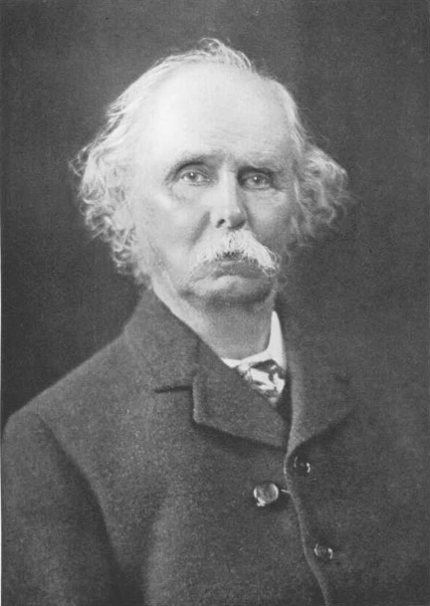
Chapter 2
- Looking back at the long arc of history, when world population rises per person wealth
  - Falls
  - Rises
  - Stays about the same
  - There is no relationship between population and wealth
- Looking back at the last century, when world population rises, the prices of agricultural products
  - Falls
  - Rises
  - Stays about the same
  - There is no relationship between population and wealth

- Which regions have been particularly stellar in generating prosperity throughout the last two centuries?
  - Western Europe
  - Eastern Europe
  - Former USSR
  - a and b
  - a, b, and c
- In the book A History of World Agriculture, Mazoyer and Roudart credit the rise in human populations to three main agricultural events
  - (1) Neolithic agriculture (2) domestication of livestock and (3) motorized, mechanized, and chemicalized agriculture
  - (1) domestication of livestock (2) domestication of plants and (3) motorized, mechanized, and chemicalized agriculture
  - (1) domestication of livestock (2) domestication of plants and (3) irrigation agriculture
  - (1) Neolithic agriculture (2) irrigation agriculture and (3) motorized, mechanized, and chemicalized agriculture
- How many of the following statements are true: (1) the U.S. produces more nutrients per capita for almost every nutrient compared to a century ago (2) the number of people living in extreme poverty is rising (3) the number of people not living in extreme poverty is rising
  - 1
  - 2
  - 3
- In class we discussed four cases where nations had trouble feeding itself: ancient Athens, 1950s China, recent North Korea, and contemporary Venezuela. How many of these three cases was the problem political in nature?
  - 0
  - 1
  - 2
  - 3
  - 4
- What is the best way to measure agricultural productivity?
  - Amount of food produced per hour of labor
  - Amount of food produced per acre of land
  - Amount of food produced per dollar spent on fossil fuels
  - Amount of food produced per dollar spent on energy
  - Number of different food types produced per acre of land
- The case of North and South Korea demonstrates that two countries can have similar food problems despite drastically different political systems.
  - True
  - False
- Why does North Korea allow its citizens to watch Gone With the Wind?
  - To demonstrate to its citizens the violent and segregated history of the U.S.
  - To demonstrate that other countries also have trouble feeding its people despite different political systems
  - To inspire them to preserve during times of food shortages
  - Because they only allow films that took place before North Korea existed as a nation
- In warfare, even if one country is the clear victor, damage is done to both countries. This makes warfare a
  - Positive-sum game
  - Zero-sum game
  - Negative-sum game
- If Paul robs Peter, stealing $10, that is a
  - Positive-sum game
  - Zero-sum game
  - Negative-sum game
- If Paul fears Peter will attempt to rob him, and Peter thus pays thugs to protect him, that is a
  - Positive-sum game
  - Zero-sum game
  - Negative-sum game
- Which of the following items is necessary for people and businesses to specialize?
  - property rights
  - flexible markets
  - trade
  - decentralization
- Why is specialization so important for food production?
  - It ensures a diversity of foods
  - It increases efficiency
  - It ensures decentralization
  - It increases economic stability
- Decentralization is important because ______ is dispersed throughout an economy
  - Property
  - Prices
  - Specialization
  - Information
  - Cultural norms
- Why are prices an important part of decentralized decision making
  - It makes sure that people are rewarded for their efforts (so long as prices are flexible)
  - Numbers can be easier to understand than words
  - They are good communicators of information
  - They designate who owns what as property
- Ancient Athens was unique in that it required its politicians to also be businesspeople
  - True
  - False
- What is the term referring to the process by which immigration, trade, and technology eliminates jobs in one sector while creating new jobs in other sectors?
  - Economic Conjustments
  - Economic Repairments
  - Destructive Repairment
  - Creative Destruction
- What concept describes the graph below.
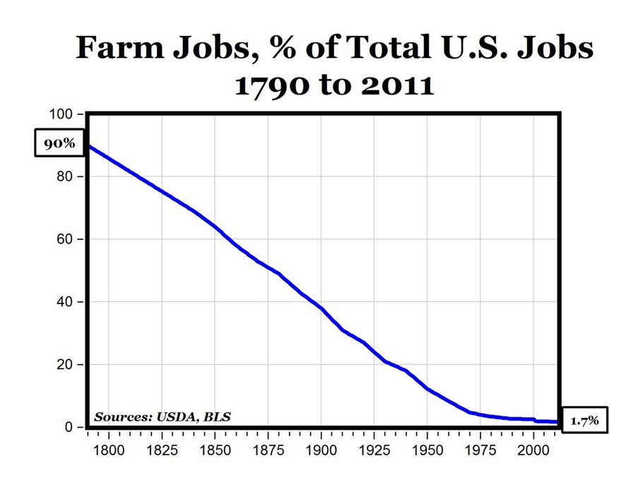
  - Economic Conjustments
  - Economic Repairments
  - Destructive Repairment
  - Creative Destruction
- The graph below illustrates what about Creative Destruction?
  - Creative Destruction really does destroy more jobs than it creates, creating unemployment.
  - Creative Destruction creates roughly as many jobs as it destroys, leaving unemployment rates roughly the same as an economy evolves.
- Who is the economist below?
  - Adam Smith
  - Frédéric Bastiat
  - Socrates
  - Alfred Marshall
  - Lionel Robbins
  - Quesnay
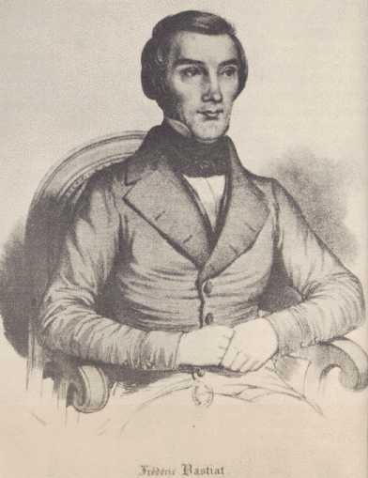
- Who is the economist below?
  - Adam Smith
  - Frédéric Bastiat
  - Socrates
  - Alfred Marshall
  - Lionel Robbins
  - Quesnay
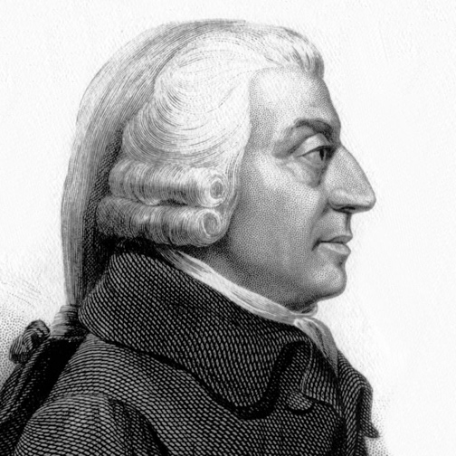
- During the age of Voltaire (18th Century) both England and France had the utmost respect for “the commercial life and the diversity of religion”.
  - True
  - False
- A crony-capitalist is someone who
  - Makes much more money than the normal, successful person
  - Refuses to make much money in the idea that profits are immoral
  - Makes their money not through creating value for others but through political power
  - Makes money by exploiting developing nations with few workers’ rights
- In North Korea today
  - Citizens rely on market exchanges for food
  - All food comes from government collective farms
  - All food comes from government supply stores
  - All food comes from international aid
- The world does not produce enough calories to feed the world population
  - True
  - False
- In the U.S. about _____ of households have serious food security problems.
  - 0.5%
  - 1%
  - 2.5%
  - 5%
  - 10%
- What is the major cause of the Irish famine in 1845-1852?
  - Landowners exporting much of the food its tenants produced
  - Insect infestations of potato crops
  - Drought
  - Excess soil erosion
- Why are much of Mongolian grasslands being destroyed?
  - Excessive grazing of yaks
  - Excessive burning of grasslands
  - Excessive grazing of cashmere goats
  - Insufficient fertilization of grasslands
- In the U.S., soil erosion
  - Still occurs and the rate of erosion rising
  - Still occurs but the rate of erosion is falling
  - Still occurs at about the same rate
  - No longer occurs
- Why is the rate of soil erosion falling?
  - More awareness and concern
  - Better technologies
  - Less rainfall
  - Both a and b
  - a, b, and c
- No society has been able to feed itself without private property and markets.
  - True
  - False
- What is the main cause of the Great Enrichment?
  - Cultural changes
  - Trade and specialization
  - Advent of private property
  - Democracy
- Which of the following cultural change is associated with the Great Enrichment?
  - Better awareness of natural resources
  - Acceptance of fossil fuels as an energy source
  - Fondness for public school systems
  - Belief in equality of people
- Which of the following best explains the current food provision problems in Venezuela?
  - Price controls and confiscation of farms
  - Forced price reductions for farmers not supporting the Bolivarian revolution
  - Prohibiting trade between the northern and southern portions of Venezuela
- How many items in the following list played a role in creating food shortages in Venezuela? (1) High oil prices (2) Death of Hugo Chavez (3) New constitution that does not address food (4) Price controls (5) Confiscation of farms (6) import tariff on dairy products
  - 1
  - 2
  - 3
  - 4
  - 5
- How did price controls create food shortages in Venezuela?
  - Because producers could only sell at low prices they had no incentive to produce food
  - Because producers could only sell at high prices they predicted no consumers would buy their food, so they didn’t produce any
  - Preventing food producers from negotiating their own prices led to a strike by producers and a boycott by consumers, and little food was produced as a result.
- If the Bolivarian Revolution began by Hugo Chavez resulted in the policies causing the current food shortages, what was the reason for the initial support of the Revolution, and why do many people still support it?
  - Before Hugo Chavez oil prices were excessively high
  - Before Hugo Chavez oil prices were excessively low
  - Before Hugo Chavez a large portion of the poor were marginalized
  - Before Hugo Chavez the business community was persecuted
- One obstacle to food provision in Venezuela is that their constitution does not address food issues?
  - True
  - False
- In response to food provision problems in Venezuela the current president urged households to
  - Send letters to Cuba requesting food aid
  - Reduce their consumption of food by 25%
  - Begin producing their own eggs by raising chickens
  - Ask Pope Francis for prayers

Chapter 3.1
- The Parable of the Magic Island is intended to demonstrate that what is akin to magic, in that you can acquire a permanent increase in wealth by paying only a temporary economic adjustment cost?
  - Trade
  - Democracy
  - Federalism
  - Mercantilism
- Which of the following pose similar benefits and costs as trade with other nations?
  - Democracy
  - Federalism
  - Technological improvements
  - Emigration
- Has trade with China harmed any particular segment of Americans more than others?
  - No, all sectors benefit equally
  - No, all sectors are harmed equally
  - Yes, high skill and highly educated workers are particularly harmed
  - Yes, low skill and uneducated workers are particularly harmed

Chapter 3.2
- If the price of good A is $100 and the price of good B is $20, what is the opportunity cost of good A in terms of good B?
  - $100
  - 2 units of good B
  - 100 units of good B
  - 5 units of good B
  - 1/5 units of good B
- If the price of good A is $500 and the price of good B is $400, what is the opportunity cost of good B in terms of good A?
  - $500
  - 4 units of good A
  - 5/4 units of good A
  - 4/5 units of good A
  - 9 units of good B
- In Figure 1 below, what is the PPF of U.S.?
  - A = 20 – 1(B)
  - A = 20 – 2(B)
  - A = 10 – 2(B)
  - A = 10 – 0.5(B)
  - A = 10 – 1(B)
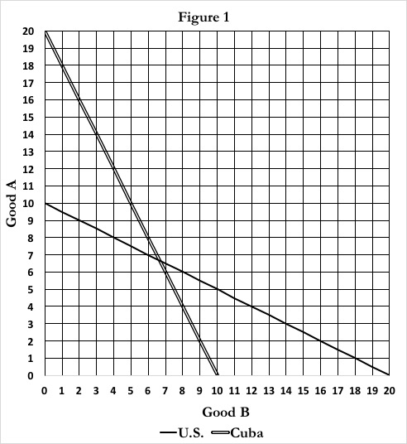
- In Figure 1 above, what is the PPF of Cuba?
  - A = 20 – 1(B)
  - A = 20 – 2(B)
  - A = 10 – 2(B)
  - A = 10 – 0.5(B)
  - A = 10 – 1(B)
- In Figure 1 above, gor the U.S., the point A = 8 and B = 4 is an ____ point.
  - Infeasible
  - Infeasible but efficient
  - Feasible but inefficient
  - Feasible and efficient
- In Figure 1 above, for the Cuba, the point A = 8 and B = 4 is an ____ point.
  - Infeasible
  - Infeasible but efficient
  - Feasible but inefficient
  - Feasible and efficient
- In Figure 1 above, for a country with the PPF A = 1 – 1(B), the point A = 8 and B = 4 is an ____ point.
  - Infeasible
  - Infeasible but efficient
  - Feasible but inefficient
  - Feasible and efficient
- The term ‘PPF’ stands for
  - Production possibilities frontier
  - Possible production feasibilities
- If a group has the PPF, A = 1,000 – 100(B), the opportunity cost of B is
  - 1,000 units of A
  - 1,000 units of B
  - -100 units of A
  - 100 units of A
  - 1,100 units of B
- If a group has the PPF, A = 1,000 – 10(B), the opportunity cost of A is
  - 1/10 units of B
  - 10 units of B
  - 10 units of A
  - 1/100 units of A
  - 1/100 units of B
- A country has a comparative advantage in the production of sugar, compared to another country, if it can
  - Produce more of that sugar
  - Produce the sugar at a lower opportunity cost
  - Can produce more of the sugar without giving up production of other goods
- Suppose that, initially, the US and EU do not engage in trade. In autarky, the U.S. produces and consumes 1,000 Meat and 2,000 Veggies, while the EU produces and consumes 1,500 Meat and 2,000 Veggies. Once they engage in trade, the US produces 4,500 Veggies and no Meat, while the EU produces no Veggies and 3,000 Meat. Will both regions be better off if the U.S. and EU traded 2,000 Veggies for 1,000 Meat? (Note: If I don’t say a country loses or gains any Meat or Veggies you may assume they have the same amount of the good.)
  - No, at least one country is worse off
  - Yes, both countries gain 500 Meat
  - Yes, the U.S. gains 500 Meat and the EU gains 150 Veggies
  - Yes, the U.S. gains some veggies and the EU gains 500 meat
  - Yes, the U.S. gains 500 veggies and the EU gains a certain amount of veggies
- Two countries, trading two goods, are said to gain from trade if …
  - They both get more of both goods
  - They both get a larger number of total units of all goods
  - They both get more of at least one good without giving up any units of the other good
- In the graph below, what is the PPF for the U.S.?
Beer = ________ + _________(Sugar)
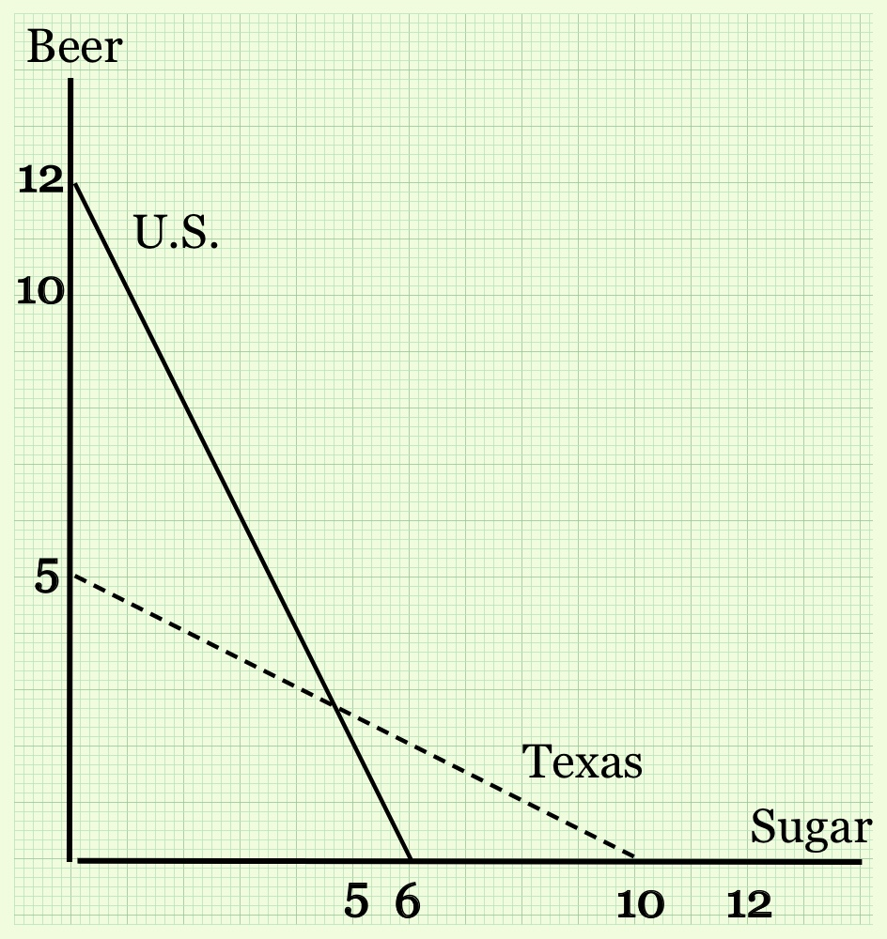
- In the graph below, what is the PPF for the Texas?
Beer = ________ + _________(Sugar)
- In the graph below, point A refers to autarky for the U.S. and Cuba. If they engaged in trade, how much beer will the U.S. produce, how many cigars will Cuba produce, and identify a trade that will leave both of them better off.
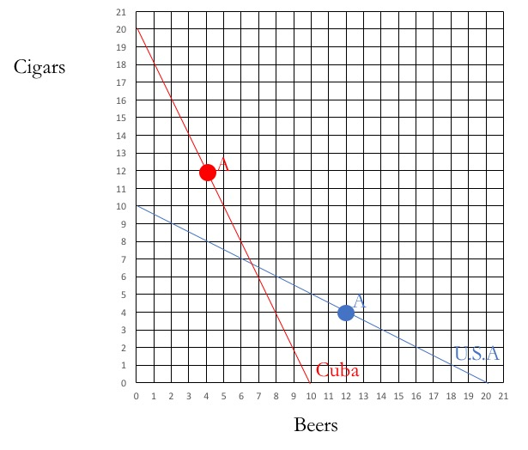

Chapter 3.3
- For every dollar a consumer spends in a grocery store, how much money is paid to the farmer for their contribution?
  - $0.09
  - $0.16
  - $0.27
  - $0.48
  - $0.56
- Being able to trade allows regions to produce large amounts of a crop, and that allows them to increase their productivity by … ?
  - Specializing and honing their skills
  - Afford new technologies
  - Force input suppliers to accept a lower price
  - a and b only
  - a, b, and c
- The first U.S. patent was awarded to Samuel Hopkins in 1790 for a new way of acquiring potash (a fertilizer and ingredient in soap production).
  - True
  - False
- There needs to be some differences between two countries, like different climates or resources, before they can gain from trade.
  - True
  - False

Trade Considerations
- In reality, exports from a country are always less than its imports
  - True
  - False
- Even though many of an iPhone’s components come from many different countries, our trade statistics count the iPhone as
  - An American-made product
  - A Chinese export
- The Jeep Patriot got its name because it is car with the most American made parts.
  - True
  - False
- Which of the following is NOT an objective of the Food Sovereignty movement?
  - A country’s right to determine its own food supply
  - A country’s right to export food to any region without tariffs
  - Sustainable agricultural practices
  - Right to culturally appropriate food
- What destroyed India’s artisan cooking oil industry?
  - New sanitation rules by the World Trade Organization
  - Smear campaigns by multinational corporations
  - New rules enacted by the Indian government
- Why is the World Trade Organization (WTO) sometimes seen as neo-colonization by developing countries?
  - Because only the richest nations are members of the WTO
  - Because the rules set by the WTO seem similar to laws set by western conquering governments in the past
  - Because rules set by the WTO require developing nations to use courts in the U.S. and western Europe
- Why is the World Trade Organization (WTO) sometimes seen as neo-colonization by developing countries?
  - Because only the richest nations are members of the WTO
  - Because the rules set by the WTO meant to encourage trade reduce a country’s ability to pass their own laws about food
  - Because rules set by the WTO require developing nations to use courts in the U.S. and western Europe
- Why is there a Food Sovereignty movement in northeastern states like Maine and Vermont?
  - So that small farmers can sell directly to consumers without having to abide by food health laws
  - So that the northeast can avoid high grain diets
  - To force big food corporations to abide by the same laws as small farmers
- Why does the U.S. both import and export beef?
  - Rules set by the World Trade Organization requires it to
  - Because of U.S. subsidies given to beef producers that require them to export
  - Because they aren’t really exporting and importing the same type of beef
  - The U.S. doesn’t both export and import beef. It only imports.
- What type of beef does the U.S. import, compared to the beef it exports?
  - Leaner beef
  - More tender beef
  - Beef in the form of sausage
  - Beef in the form of frozen hamburger patties
- What would happen to the price of wheat if the U.S. no longer traded with other countries?
  - It would fall
  - It would rise
  - It would remain the same
- What would happen to the price of wheat if the U.S. no longer imported from other countries?
  - It would fall
  - It would rise
  - It would remain the same

