# (Chapter 4.a

(1) What does slope equal?

 Slope = run / rise

 Slope = x / y

 Slope = rise / run

 Slope = y / x

 None of these

(2) Referring to a graph like the one below, if Y increases by 4 and X increases by 2, then what does slope equal?

 Slope = 8

 Slope =  2

 Slope = 4

 Slope = 1/4

 Slope = 1/2

 None of these

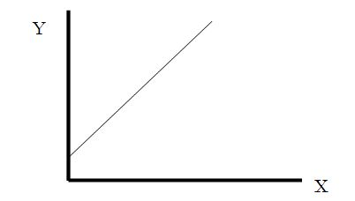

(3) In the graph below, which line has a slope greater than one?

 A

 B

 C

 None of these

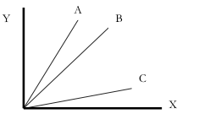

(4) In the graph below, which line has a slope equal to one?

 A

 B

 C

 None of these



(5) In the graph below, which line is a tangent line of the function in bold?

 A

 B

 C

 None of these

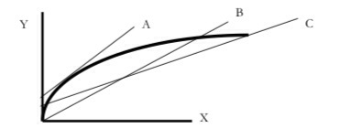

(6) In the graph below, the dotted line is a tangent line of the function at point ...?

 A

 B

 C

 None of these

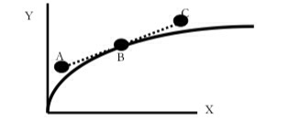

(7) What does the slope of a tangent line tell you?

 How Y changes in response to a tiny increase in X, starting at some value of X

 How Y changes in response to a large increase in X, starting at some value of X

 How X changes in response to a tiny increase in Y, starting at some value of X

 How X changes in response to a large increase in Y, starting at some value of Y

(8) A tangent line's purpose is to ...?

 Give the slope of the entire function

 Give the slope between two points of a function

 Give the slope at one point on a function

 Tangent lines have nothing to do with the slope of a function

(9) In the graph below, which line corresponds to the function Y = 2 + 3(X)

 A

 B

 C

 D

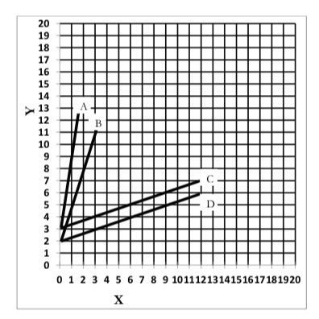

(10) In the graph below, which line corresponds to the function Y = 3 + 1(X)

 A

 B

 C

 D

 None of these

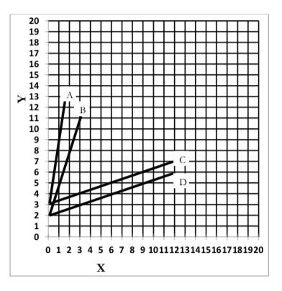

(11) In the figure below, which picture indicates a line with a positive slope?

 A

 B

 C

 D

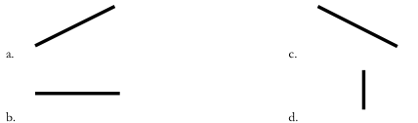

(12) In the figure below, which picture indicates a line with a negative slope?

 A

 B

 C

 D



(13) In the figure below, which picture indicates a line with a slope of zero?

 A

 B

 C

 D



(14) If the slope of the tangent line is 1.5, then

 X has a positive impact on Y

 X has a negative impact on Y

 X has no impact on Y

(15) If the slope of the tangent line is -1.5, then

 X has a positive impact on Y

 X has a negative impact on Y

 X has no impact on Y

(16) If the slope of the tangent line is zero, then

 X has a positive impact on Y

 X has a negative impact on Y

 X has no impact on Y

# Chapter 4.b

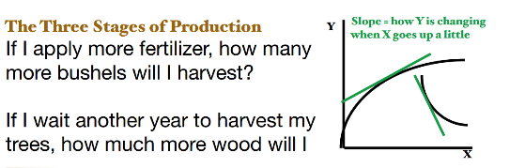

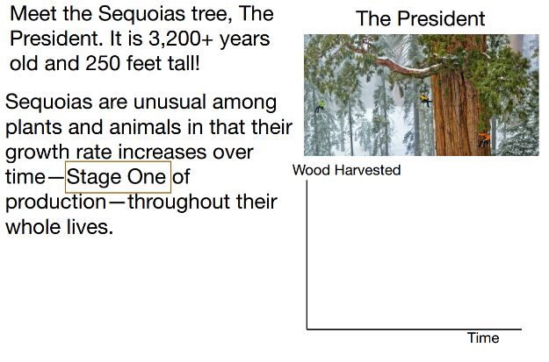

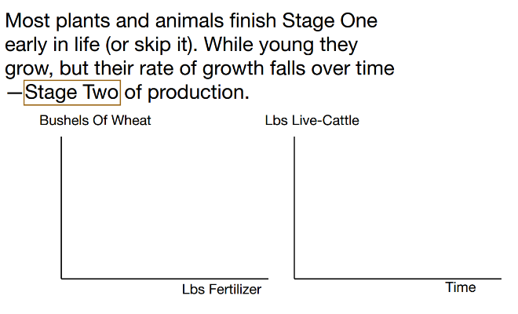

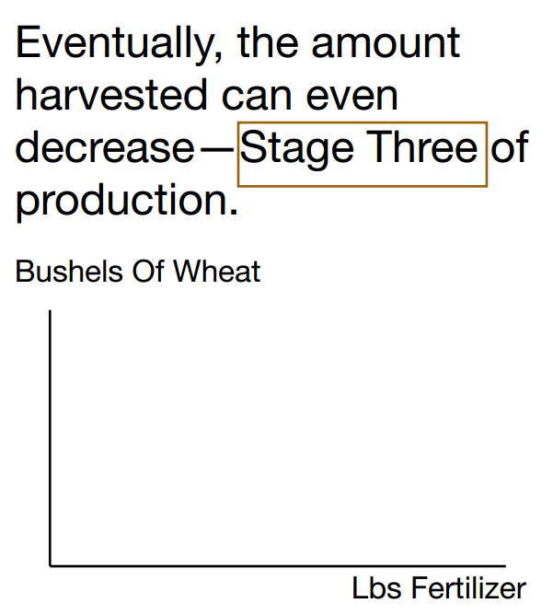

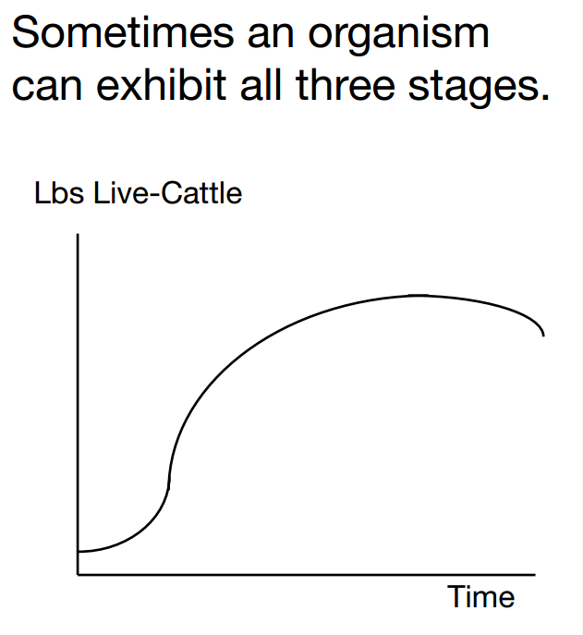

(1) In a production function like the one below, where X is an input (e.g., fertilizer) and Y is an output (e.g., wheat yield), the slope of the tangent line at a value of X tells us ...?

 the marginal product at X

 the average product at X

 the supreme product at X

 the product-product at X

(2) In the graph below, is the marginal product at X = 4 a larger or smaller number than the marginal product at X = 8?

 larger

 smaller

 they are the same

 impossible to tell

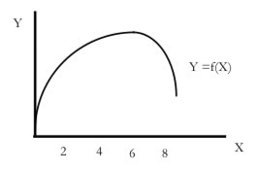

(3) In the graph below, the slope of the tangent line at X = 4 is ...?

 negative

 zero

 positive

 impossible to tell

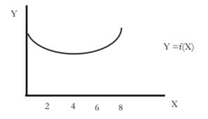

(4) In the graph below, the marginal product of X at X = 2 is ...?

 negative

 zero

 positive

 impossible to tell



(5) The graph below exhibits which stages of production?

 Stage 1 only

 Stage 2 only

 Stage 3 only

 Stages 1 and 2

 Stages 2 and 3

 Stages 1 and 3

 Stages 1, 2, and 3

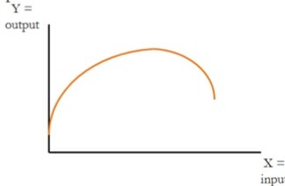

(6) The production function below exhibits only Stage 2 of production, because the marginal product of X is everywhere _______ and that marginal product is ______ as X rises.

 negative; falling

 negative; rising

 positive; falling

 positive; rising

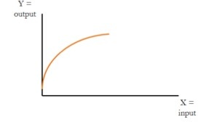

(7) The production function below exhibits only Stage 1 of production, because the marginal product of X is everywhere _______ and that marginal product is ______ as X rises.

 negative; falling

 negative; rising

 positive; falling

 positive; rising

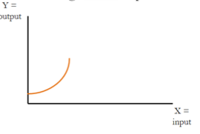

(8) The graph below exhibits which stages of production? Check all that apply.

__ Stage 1

__ Stage 2

__ Stage 3

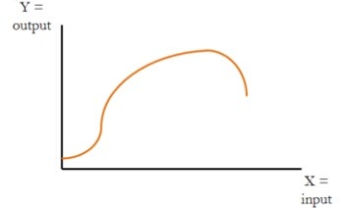

(9) In the graph below, the marginal product of X is the

change in _______ due to a small (say, one unit)

increase in ______.



(10) Phosphorus fertilizer is an input into buckwheat production. The marginal product of phosphorus is the

change in __________ production due to a small (say,

1 unit) increase in __________.

(11) In Figure 1 below, among lines 1, 2, and 3, which line has the smallest slope?

1. Line 1
2. Line 2
3. Line 3
4. Impossible to tell

(12) In Figure 1 below, among lines 1, 2, and 3, which line has the largest slope?

1. Line 1
2. Line 2
3. Line 3
4. Impossible to tell

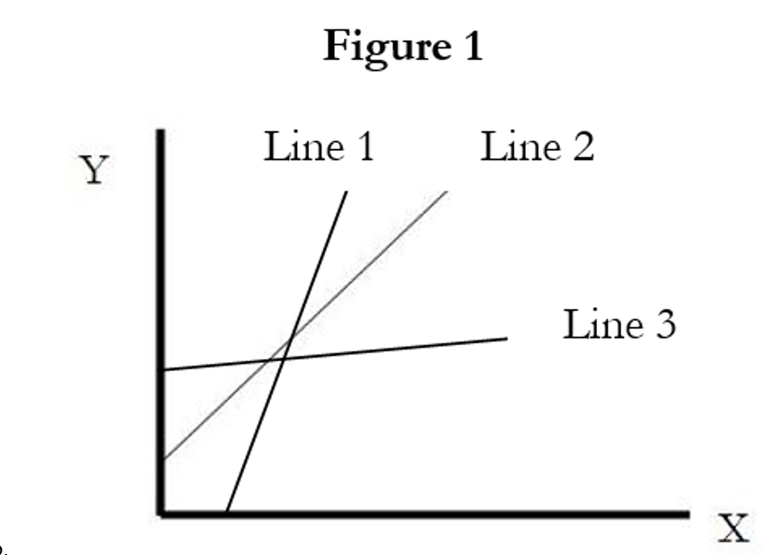

(13) In Figure 2 below, if X is an input like factory labor and Y is the output of the factory which is sold to consumers, the slope of the tangent line at any point tells us

1. The average product
2. The marginal product
3. The consequential product
4. The tangent product
5. None of the above

(14) In Figure 2 below, the slope of the tangent line at x = 2 is

1. Negative
2. Zero
3. Positive
4. Impossible to tell

(15) In Figure 2 below, the slope of the tangent line at X = 4 is __________ the slope of the tangent line at X = 2.

1. Greater than
2. Less than
3. Equal to

(16) In Figure 2 below, the production function exhibits which stages of production?

1. Stages 1, 2, and 3.
2. Stage 1 only
3. Stage 2 only
4. Stage 3 only
5. Stages 2 and 3

**Figure 2**

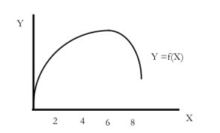

(17) In Stage 1 of production, the slope of the tangent line is

* 1. Positive and falling
  2. Positive and rising
  3. Negative and falling
  4. Negative and rising
  5. Zero and falling

# Chapter 4.c

In thisexample the input is nitrogen fertilizer and the output is wheat yield.

|  |  |  |  |
| --- | --- | --- | --- |
| **Produce Wheat?** | **Change in N (lbs / acre)** | **Change in Wheat yield (bushels / acre)** | **MP** |
| NO | ----- | ----- | ----- |
| Yes | 0 →10 | 23→25 |  |
| Yes | 10→20 | 25→30.5 |  |
| Yes | 20→30 | 30.5→33 |  |
| Yes | 30→40 | 33→35 |  |
| Yes | 40→50 | 35→36 |  |
| Yes | 50→60 | 36→36.2 |  |

1. Stage 1 begins at __________ lbs of nitrogen per acre and ends at ___________ lbs.
2. Stage 2 begins at __________ lbs of nitrogen per acre and ends at ___________ lbs.
3. Stage 3 begins at __________ lbs of nitrogen per acre and ends at ___________ lbs.

|  |  |  |  |
| --- | --- | --- | --- |
| **Produce Wheat?** | **Change in N (lbs / acre)** | **Change in Wheat yield (bushels / acre)** | **MP** |
| NO | ----- | ----- | ----- |
| Yes | 0 →10 | 23→25 |  |
| Yes | 10→20 | 25→30.5 |  |
| Yes | 20→30 | 30.5→40 |  |
| Yes | 30→40 | 40→35 |  |
| Yes | 40→50 | 35→33 |  |
| Yes | 50→60 | 33→29 |  |

1. Stage 1 begins at __________ lbs of nitrogen per acre and ends at ___________ lbs.
2. Stage 2 begins at __________ lbs of nitrogen per acre and ends at ___________ lbs.
3. Stage 3 begins at __________ lbs of nitrogen per acre and ends at ___________ lbs.

|  |  |  |  |
| --- | --- | --- | --- |
| **Produce Wheat?** | **Change in N (lbs / acre)** | **Change in Wheat yield (bushels / acre)** | **MP** |
| NO | ----- | ----- | ----- |
| Yes | 0 →10 | 23→25 |  |
| Yes | 10→20 | 25→30.5 |  |
| Yes | 20→30 | 30.5→40 |  |
| Yes | 30→40 | 40→45 |  |
| Yes | 40→50 | 45→47 |  |
| Yes | 50→60 | 47→43 |  |

1. Stage 1 begins at __________ lbs of nitrogen per acre and ends at ___________ lbs.
2. Stage 2 begins at __________ lbs of nitrogen per acre and ends at ___________ lbs.
3. Stage 3 begins at __________ lbs of nitrogen per acre and ends at ___________ lbs.

|  |  |  |  |
| --- | --- | --- | --- |
| **Produce Wheat?** | **Change in N (lbs / acre)** | **Change in Wheat yield (bushels / acre)** | **MP** |
| NO | ----- | ----- | ----- |
| Yes | 0 →10 | 23→25 |  |
| Yes | 10→20 | 25→30.5 |  |
| Yes | 20→30 | 30.5→40 |  |
| Yes | 30→40 | 40→45 |  |
| Yes | 40→50 | 45→47 |  |
| Yes | 50→60 | 47→47.4 |  |

1. Stage 1 begins at __________ lbs of nitrogen per acre and ends at ___________ lbs.
2. Stage 2 begins at __________ lbs of nitrogen per acre and ends at ___________ lbs.
3. Stage 3 begins at __________ lbs of nitrogen per acre and ends at ___________ lbs.

Now let’s consider cattle in a feedlot. The input is “days on feed” in a feedlot and the output is the weight of the animal. These are real data, but are just six observations out of 5001.

|  |  |  |
| --- | --- | --- |
| Cattle ID | Live-weight (lbs) | Days on feed (DOF) |
| 12408 | 601 | 1 |
| 12408 | 1240 | 138 |
| 12408 | 1398 | 180 |
| 12411 | 608 | 1 |
| 12411 | 1210 | 138 |
| 12411 | 1316 | 180 |

13. For animal 12408, what is the marginal product of DOF between 1 and 138 DOF? *Note this is the average marginal product between two points, or the rise/run between two points. This is not the slope of a tangent line.*

MP = __________ lbs

14. How do we interpret the previous answer?

15. For animal 12408, what is the marginal product of DOF between 138 and 180 DOF?

MP = __________ lbs

16. For animal 12411, what is the marginal product of DOF between 1 and 138 DOF?

MP = __________ lbs

17. For animal 12411, what is the marginal product of DOF between 138 and 180 DOF?

MP = __________ lbs

Use all 5001 observations and statistics, we can acquire a formula for MP, allowing us to calculate the MP not as an average between two points, but at a single point. Here, the MP is the slope of a tangent line of a graph with DOF on the x-axis and live-weight on the y-axis. This MP is calculated to represent the weight gain of the average steer/heifer in the data. Plot this formula.

MP = 4.36 – 0.0157(DOF)

18. What is the marginal product at 25 days?

MP = __________ lbs

19. What is the marginal product at 200 days.

MP = __________ lbs

20. We can estimate the DOF that maximizes the size of the steer/heifer. We do this by observing that when the steer/heifer is at its maximum weight the MP is zero. So use the formula to solve for the DOF that sets MP equal to zero.

21. The increase in revenues from one more DOF is referred to as the *marginal value product* (MVP) of DOF. It equals the MP times the output price in $ / lb the feedlot receives. The increase in cost from one more DOF is the *input price*. It makes sense that the rancher will increase DOF whenever the marginal value product is greater than the input price.

Plot the MVP and the price of DOF in the graph below. Assume the output price is $0.75/lb and the price of one DOF equals $1.41. Using visual approximation *and* algebra, solve for the DOF that maximizes profits.



# Chapter 4.d

1. In Oklahoma, wheat is planted in the __________ and harvested in the __________.
   1. fall, summer
   2. summer, fall
   3. spring, late fall
   4. fall, fall
2. Farmers who raise wheat for grain cannot also allow cattle to graze on that wheat.
   1. True
   2. False
3. If farmers attempt to graze cattle on wheat and then harvest wheat grain, they must remove the cattle from the field around ….?
   1. Late February or beginning of March, roughly
   2. Late April or beginning of May, roughly
   3. Late August or beginning of September, roughly
   4. Late December or beginning of January, roughly
4. If farmers attempt to graze cattle on wheat and then harvest wheat grain, they must remove the cattle from the field when ….?
   1. The wheat develops its first hollow stem
   2. The wheat begins to form seeds
   3. The wheat begins to flower
   4. The bees begin pollinating the wheat
5. A feedlot purchases cattle and then feeds them a diet high in grain for a number of months, and then sells the animal for slaughter. Which are examples of variable inputs / costs for the feedlot?
   1. Corn for feed
   2. Antibiotics added to feed
   3. Labor
   4. The land and fences comprising the feedlot
   5. Interest on the loan taken to build the feedlot
6. What are the three major variable costs involved in wheat production?
   1. Fertilizer, pesticides, and machinery expenses
   2. Seed, fertilizer, and pesticides
   3. Seed, pesticides, and machinery expenses
   4. Seed, crop insurance, and pesticides
7. In an enterprise budget, the term “fertilizer” largely refers to
   1. Nitrogen, phosphorus, and potassium
   2. Nitrogen, carbon, and phosphorus
   3. Carbon, phosphorus, and dolomite
   4. Potassium, nitrogen, and selenium

(8.a) Fill in the missing cells below.

(8.b) If we don’t produce any wheat our profits will be $__________ per acre.

(8.c) If we produce wheat but don’t apply any nitrogen our profits will be $__________ per acre.

(8.d) The profit-maximizing level of nitrogen use is ____________ lbs

N per acre, producing ________ bushels of wheat per acre and providing profits of $___________

per acre.

|  |  |  |
| --- | --- | --- |
| **Price of wheat** |  | $ / bushel |
| **Price of nitrogen** |  | $ / lb |
| **Fixed Costs** |  | $ / acre |
| **Other Variable Costs** |  | $ / acre |

|  |  |  |  |  |  |
| --- | --- | --- | --- | --- | --- |
| **Produce wheat?** | **Nitrogen (lbs / acre)** | **Wheat yield (bushels / acre)** | **Cost of nitrogen application**  **($ / acre)** | **Total fixed costs ($ / acre)** | **Total variable costs**  **($ / acre)** |
| NO | 0.00 | ----------- | ----------- |  | ----------- |
| Yes | 0.00 |  | ----------- |  |  |
| Yes | 10.00 |  |  |  |  |
| Yes | 20.00 |  |  |  |  |
| Yes | 30.00 |  |  |  |  |
| Yes | 40.00 |  |  |  |  |
| Yes | 50.00 |  |  |  |  |
| Yes | 60.00 |  |  |  |  |

|  |  |  |  |  |  |
| --- | --- | --- | --- | --- | --- |
| **Produce wheat?** | **Nitrogen (lbs / acre)** | **Wheat yield (bushels / acre)** | **Total costs**  **($ / acre)** | **Revenues**  **($ / acre)** | **Profits**  **($ / acre)** |
| NO | 0.00 | ----------- |  | ----------- |  |
| Yes | 0.00 |  |  |  |  |
| Yes | 10.00 |  |  |  |  |
| Yes | 20.00 |  |  |  |  |
| Yes | 30.00 |  |  |  |  |
| Yes | 40.00 |  |  |  |  |
| Yes | 50.00 |  |  |  |  |
| Yes | 60.00 |  |  |  |  |

(9.a) Fill in the missing cells below.

(9.b) If we don’t produce any wheat our profits will be $__________ per acre.

(9.c) If we produce wheat but don’t apply any nitrogen our profits will be $__________ per acre.

(9.d) The profit-maximizing level of nitrogen use is ____________ lbs

N per acre, producing ________ bushels of wheat per acre and providing profits of $___________

per acre.

|  |  |  |
| --- | --- | --- |
| **Price of wheat** |  | $ / bushel |
| **Price of nitrogen** |  | $ / lb |
| **Fixed Costs** |  | $ / acre |
| **Other Variable Costs** |  | $ / acre |

|  |  |  |  |  |  |
| --- | --- | --- | --- | --- | --- |
| **Produce wheat?** | **Nitrogen (lbs / acre)** | **Wheat yield (bushels / acre)** | **Cost of nitrogen application**  **($ / acre)** | **Total fixed costs ($ / acre)** | **Total variable costs**  **($ / acre)** |
| NO | 0.00 | ----------- | ----------- |  | ----------- |
| Yes | 0.00 |  | ----------- |  |  |
| Yes | 10.00 |  |  |  |  |
| Yes | 20.00 |  |  |  |  |
| Yes | 30.00 |  |  |  |  |
| Yes | 40.00 |  |  |  |  |
| Yes | 50.00 |  |  |  |  |
| Yes | 60.00 |  |  |  |  |

|  |  |  |  |  |  |
| --- | --- | --- | --- | --- | --- |
| **Produce wheat?** | **Nitrogen (lbs / acre)** | **Wheat yield (bushels / acre)** | **Total costs**  **($ / acre)** | **Revenues**  **($ / acre)** | **Profits**  **($ / acre)** |
| NO | 0.00 | ----------- |  | ----------- |  |
| Yes | 0.00 |  |  |  |  |
| Yes | 10.00 |  |  |  |  |
| Yes | 20.00 |  |  |  |  |
| Yes | 30.00 |  |  |  |  |
| Yes | 40.00 |  |  |  |  |
| Yes | 50.00 |  |  |  |  |
| Yes | 60.00 |  |  |  |  |

(10.a) Fill in the missing cells below.

(10.b) If we don’t produce any wheat our profits will be $__________ per acre.

(10.c) If we produce wheat but don’t apply any nitrogen our profits will be $__________ per acre.

(10.d) The profit-maximizing level of nitrogen use is ____________ lbs

N per acre, producing ________ bushels of wheat per acre and providing profits of $___________

per acre.

|  |  |  |
| --- | --- | --- |
| **Price of wheat** |  | $ / bushel |
| **Price of nitrogen** |  | $ / lb |
| **Fixed Costs** |  | $ / acre |
| **Other Variable Costs** |  | $ / acre |

|  |  |  |  |  |  |
| --- | --- | --- | --- | --- | --- |
| **Produce wheat?** | **Nitrogen (lbs / acre)** | **Wheat yield (bushels / acre)** | **Cost of nitrogen application**  **($ / acre)** | **Total fixed costs ($ / acre)** | **Total variable costs**  **($ / acre)** |
| NO | 0.00 | ----------- | ----------- |  | ----------- |
| Yes | 0.00 |  | ----------- |  |  |
| Yes | 10.00 |  |  |  |  |
| Yes | 20.00 |  |  |  |  |
| Yes | 30.00 |  |  |  |  |
| Yes | 40.00 |  |  |  |  |
| Yes | 50.00 |  |  |  |  |
| Yes | 60.00 |  |  |  |  |

|  |  |  |  |  |  |
| --- | --- | --- | --- | --- | --- |
| **Produce wheat?** | **Nitrogen (lbs / acre)** | **Wheat yield (bushels / acre)** | **Total costs**  **($ / acre)** | **Revenues**  **($ / acre)** | **Profits**  **($ / acre)** |
| NO | 0.00 | 0.00 |  | ----------- |  |
| Yes | 0.00 | 23.00 |  |  |  |
| Yes | 10.00 | 25.00 |  |  |  |
| Yes | 20.00 | 30.50 |  |  |  |
| Yes | 30.00 | 40.00 |  |  |  |
| Yes | 40.00 | 45.00 |  |  |  |
| Yes | 50.00 | 47.00 |  |  |  |
| Yes | 60.00 | 43.00 |  |  |  |

(11.a) Fill in the missing cells below.

(11.b) If we don’t produce any wheat our profits will be $__________ per acre.

(11.c) If we produce wheat but don’t apply any nitrogen our profits will be $__________ per acre.

(11.d) The profit-maximizing level of nitrogen use is ____________ lbs

N per acre, producing ________ bushels of wheat per acre and providing profits of $___________

per acre.

|  |  |  |
| --- | --- | --- |
| **Price of wheat** |  | $ / bushel |
| **Price of nitrogen** |  | $ / lb |
| **Fixed Costs** |  | $ / acre |
| **Other Variable Costs** |  | $ / acre |

|  |  |  |  |  |  |
| --- | --- | --- | --- | --- | --- |
| **Produce wheat?** | **Nitrogen (lbs / acre)** | **Wheat yield (bushels / acre)** | **Cost of nitrogen application**  **($ / acre)** | **Total fixed costs ($ / acre)** | **Total variable costs**  **($ / acre)** |
| NO | 0.00 | ----------- | ----------- |  | ----------- |
| Yes | 0.00 |  | ----------- |  |  |
| Yes | 10.00 |  |  |  |  |
| Yes | 20.00 |  |  |  |  |
| Yes | 30.00 |  |  |  |  |
| Yes | 40.00 |  |  |  |  |
| Yes | 50.00 |  |  |  |  |
| Yes | 60.00 |  |  |  |  |

|  |  |  |  |  |  |
| --- | --- | --- | --- | --- | --- |
| **Produce wheat?** | **Nitrogen (lbs / acre)** | **Wheat yield (bushels / acre)** | **Total costs**  **($ / acre)** | **Revenues**  **($ / acre)** | **Profits**  **($ / acre)** |
| NO | 0.00 | ----------- |  | ----------- |  |
| Yes | 0.00 |  |  |  |  |
| Yes | 10.00 |  |  |  |  |
| Yes | 20.00 |  |  |  |  |
| Yes | 30.00 |  |  |  |  |
| Yes | 40.00 |  |  |  |  |
| Yes | 50.00 |  |  |  |  |
| Yes | 60.00 |  |  |  |  |

(12.a) Fill in the missing cells below.

(12.b) If we don’t produce any wheat our profits will be $__________ per acre.

(12.c) If we produce wheat but don’t apply any nitrogen our profits will be $__________ per acre.

(12.d) The profit-maximizing level of nitrogen use is ____________ lbs

N per acre, producing ________ bushels of wheat per acre and providing profits of $___________

per acre.

|  |  |  |
| --- | --- | --- |
| **Price of wheat** |  | $ / bushel |
| **Price of nitrogen** |  | $ / lb |
| **Fixed Costs** |  | $ / acre |
| **Other Variable Costs** |  | $ / acre |

|  |  |  |  |  |  |
| --- | --- | --- | --- | --- | --- |
| **Produce wheat?** | **Nitrogen (lbs / acre)** | **Wheat yield (bushels / acre)** | **Cost of nitrogen application**  **($ / acre)** | **Total fixed costs ($ / acre)** | **Total variable costs**  **($ / acre)** |
| NO | 0.00 | ----------- | ----------- |  | ----------- |
| Yes | 0.00 |  | ----------- |  |  |
| Yes | 10.00 |  |  |  |  |
| Yes | 20.00 |  |  |  |  |
| Yes | 30.00 |  |  |  |  |
| Yes | 40.00 |  |  |  |  |
| Yes | 50.00 |  |  |  |  |
| Yes | 60.00 |  |  |  |  |

|  |  |  |  |  |  |
| --- | --- | --- | --- | --- | --- |
| **Produce wheat?** | **Nitrogen (lbs / acre)** | **Wheat yield (bushels / acre)** | **Total costs**  **($ / acre)** | **Revenues**  **($ / acre)** | **Profits**  **($ / acre)** |
| NO | 0.00 | ----------- |  | ----------- |  |
| Yes | 0.00 |  |  |  |  |
| Yes | 10.00 |  |  |  |  |
| Yes | 20.00 |  |  |  |  |
| Yes | 30.00 |  |  |  |  |
| Yes | 40.00 |  |  |  |  |
| Yes | 50.00 |  |  |  |  |
| Yes | 60.00 |  |  |  |  |

(13.a) Fill in the missing cells below.

(13.b) If we don’t produce any wheat our profits will be $__________ per acre.

(13.c) If we produce wheat but don’t apply any nitrogen our profits will be $__________ per acre.

(13.d) The profit-maximizing level of nitrogen use is ____________ lbs

N per acre, producing ________ bushels of wheat per acre and providing profits of $___________

per acre.

|  |  |  |
| --- | --- | --- |
| **Price factory receives for its product** |  | $ / unit produced |
| **Hourly price / wage paid to workers** |  | $ / hour |
| **Fixed Costs** |  | $ / acre |
| **Other Variable Costs** |  | $ / acre |

|  |  |  |  |  |
| --- | --- | --- | --- | --- |
| **Total hours of labor** | **Factory Production** | **Labor Costs** | **Revenues** | **Profits** |
| 100 | 10000 |  |  |  |
| 200 | 13000 |  |  |  |
| 300 | 16000 |  |  |  |
| 400 | 17000 |  |  |  |
| 500 | 17500 |  |  |  |
| 600 | 17600 |  |  |  |
| 700 | 17650 |  |  |  |
| 800 | 17000 |  |  |  |
| 900 | 16800 |  |  |  |
| 1000 | 16500 |  |  |  |

(14) To maximize profits, a farmer does not apply the amount of nitrogen that maximizes yield. Why?

1. Because that amount of nitrogen use causes fixed costs to rise.
2. Because if we apply that much nitrogen, the last few lbs of nitrogen costs more than the additional revenues they provide.
3. Because that much nitrogen would harm the crops and lower yield.
4. Because that would result in so much wheat being produced that the price of wheat would fall.
5. b, d

(15) A farmer who applies however much nitrogen is needed to maximize yield is making the mistake of…

1. …not thinking about the impact each lb of nitrogen has on yield.
2. …not thinking about how higher yields reduce crop prices.
3. …not thinking about the cost of nitrogen.
4. …spending too little time thinking about how nitrogen use and fixed costs are correlated.
5. a , c

(16) A farmer should increase the amount of nitrogen she applies per acre of wheat…

1. …whenever its marginal product is positive.
2. …until the marginal product equals zero.
3. …until the marginal product turns negative.
4. …until it equals one.
5. None of these.

(17) Like a farmer applying nitrogen, a factory should increase labor hours so long as…

1. …the factory is operating in stage 2 of production.
2. …not thinking about how higher yields reduce crop prices.
3. …the marginal product of labor is positive.
4. …the value of the additional factory production is greater than the cost of the extra labor hours.
5. a , c

(1) Starting from the profit formula: Profits = P*Q – TC, prove that the formula for profits equals: Profits = {P – (AC)}Q. Provide by showing in detail the transition from the former equation to the latter.

We have studied the production decisions of a wheat farmer. This farmer pays fixed costs no matter what, but pays variable costs only if she produces wheat. We studied in detail the decision of how much nitrogen fertilizer to apply, assuming the use of other variable inputs is constant (so long as she does produce some wheat). The terminology we use is:

* P = price of wheat, in $ per bushel
* Q = wheat production, measured in bushels per acre
* TC, VC, and FC are all costs measured in $ per acre

(2) If revenues = P*Q, what are its units? = ____________________

(3) If profits = P*Q - TC, what are its units? = ____________________

(4) If average variable costs (AVC) = VC/Q, what are its units? = ____________________

(5) If average costs (AC) = TC/Q, what are its units? = ____________________

(6) If profits = $100 and revenues equal $5,000, what are total costs? ____________________

(7) If profits = $100 and total costs equal $5,000, what are total revenues? ____________________

(8) If profits = $100, total revenues = $5,000, and fixed costs = $500, what are variable costs? ____________________

(9) If profits = $100, total revenues = $5,000, and variable costs = $500, what are fixed costs? ____________________

(10) Suppose that a farmer produces wheat and makes positive profits (didn’t lose money, but made money). What do we know about the relation of price to certain costs? *Circle all that are correct*.

|  |  |
| --- | --- |
| a. P > AC | c. P < AC |
|  |  |
| b. P > AVC | d. P < AVC |

(11) Suppose that a farmer produces wheat and makes negative profits (loses money). Note that she decided to produce wheat knowing she would lose money. What do we know about the relation of price to certain costs? *Circle all that are correct*.

|  |  |
| --- | --- |
| a. P > AC | c. P < AC |
|  |  |
| b. P > AVC | d. P < AVC |

(12) Suppose wheat prices are so low that a farmer decides not to produce wheat. What do we know about the relation of price to certain costs? *Circle all that are correct*.

|  |  |
| --- | --- |
| a. P > AC | c. P < AC |
|  |  |
| b. P > AVC | d. P < AVC |

(13) Suppose that by the end of this class a student has the following grades. What will be the final numerical grade for the student? Given this numerical grade, what will be her letter grade? You will need to consult the syllabus for further information on how to calculate the grades.

|  |  |
| --- | --- |
| Exam 1 = 100 | Paper = 95 |
| Exam 2 = 90 | Attendance = 83 |
| Exam 3 = 80 | 10 homework grades which equal: 100, 100, 90, 90, 80, 80, 70, 70, 60, 60 |
| Final exam = 70 |  |

Final numerical grade = ___________________

Final letter grade = ___________________

(14) How large is an acre, relative to the size of a football field (minus the end zones)..

(15) What exactly is a “bushel” of anything, in the U.S.?

(Question 8 revisited)

|  |  |  |
| --- | --- | --- |
| Price of wheat | 4 | $ / bushel |
| Price of nitrogen | 0.1 | $ / lb |
| Fixed costs | 50 | $ / acre |
| Other variable costs | 60 | $ / acre |

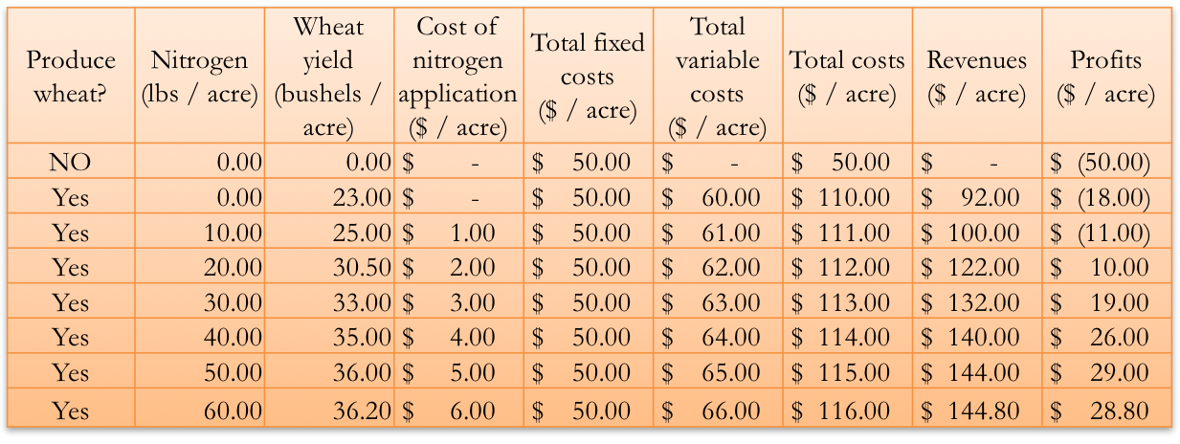

|  |  |  |  |  |  |
| --- | --- | --- | --- | --- | --- |
| **Produce wheat?** | **Nitrogen (lbs / acre)** | **Wheat yield (bushels / acre)** | **Average variable cost** | **Average total cost** | **Total Profits**  **(price – average total cost)(yield)** |
| NO | 0.00 | ----------- |  |  |  |
| Yes | 0.00 | 23 |  |  |  |
| Yes | 10.00 | 25 |  |  |  |
| Yes | 20.00 | 30.5 |  |  |  |
| Yes | 30.00 | 33 |  |  |  |
| Yes | 40.00 | 35 |  |  |  |
| Yes | 50.00 | 36 |  |  |  |
| Yes | 60.00 | 36.2 |  |  |  |

Should we produce wheat? _____________

How do we know?

(Question 9 revisited)

|  |  |  |
| --- | --- | --- |
| Price of wheat | **2.25** | $ / bushel |
| Price of nitrogen | 0.1 | $ / lb |
| Fixed costs | 50 | $ / acre |
| Other variable costs | 60 | $ / acre |

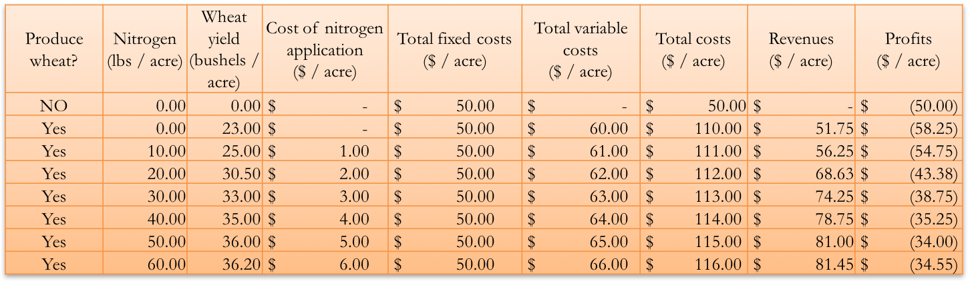

|  |  |  |  |  |  |
| --- | --- | --- | --- | --- | --- |
| **Produce wheat?** | **Nitrogen (lbs / acre)** | **Wheat yield (bushels / acre)** | **Average variable cost** | **Average total cost** | **Total Profits**  **(price – average total cost)(yield)** |
| NO | 0.00 | ----------- |  |  |  |
| Yes | 0.00 | 23 |  |  |  |
| Yes | 10.00 | 25 |  |  |  |
| Yes | 20.00 | 30.5 |  |  |  |
| Yes | 30.00 | 33 |  |  |  |
| Yes | 40.00 | 35 |  |  |  |
| Yes | 50.00 | 36 |  |  |  |
| Yes | 60.00 | 36.2 |  |  |  |

Should we produce wheat? _____________

How do we know?

(Question 10 revisited)

|  |  |  |
| --- | --- | --- |
| Price of wheat | **1.75** | $ / bushel |
| Price of nitrogen | 0.1 | $ / lb |
| Fixed costs | 50 | $ / acre |
| Other variable costs | 60 | $ / acre |

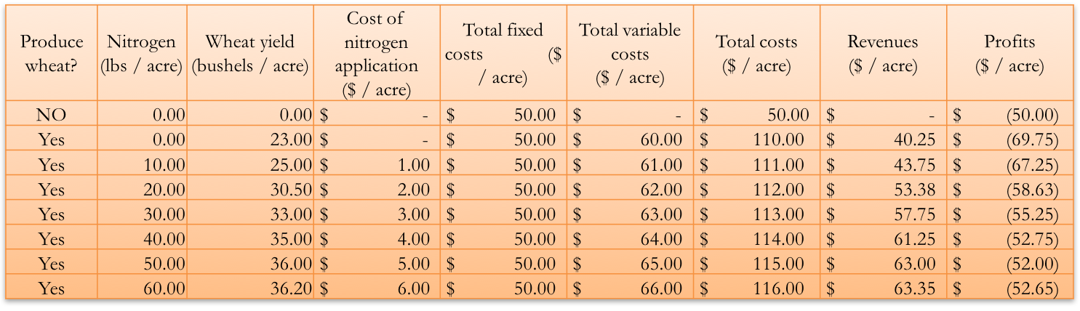

|  |  |  |  |  |  |
| --- | --- | --- | --- | --- | --- |
| **Produce wheat?** | **Nitrogen (lbs / acre)** | **Wheat yield (bushels / acre)** | **Average variable cost** | **Average total cost** | **Total Profits**  **(price – average total cost)(yield)** |
| NO | 0.00 | ----------- |  |  |  |
| Yes | 0.00 | 23 |  |  |  |
| Yes | 10.00 | 25 |  |  |  |
| Yes | 20.00 | 30.5 |  |  |  |
| Yes | 30.00 | 33 |  |  |  |
| Yes | 40.00 | 35 |  |  |  |
| Yes | 50.00 | 36 |  |  |  |
| Yes | 60.00 | 36.2 |  |  |  |

Should we produce wheat? _____________

How do we know?