Name: ________________________________

- [1 Point] The Parable of the Magic Island is intended to demonstrate that trading with others is akin to magic, in that it allows a nation to acquire a permanent increase in wealth by only paying a temporary economic adjustment cost.
  - True
  - False
- [1 Point] The parable of the Magic Island is intended to demonstrate that, like magic, the benefits from international trade are simply not real.
  - True
  - False
Suppose we have two countries, the U.S. and Cuba, whose production possibilities frontiers (PPFs) for producing beer and cigars are as follows

U.S.: Number Cigars Produced = 10 - (2)(Number Beers Produced)
Cuba: Number Cigars Produced = 10 - (1)(Number Beers Produced)

- [4 Points] Plot the PPF’s for each country below. Clearly label which country corresponds to each PPF.

Cigars
Beer

- [1 Point] For the U.S., the opportunity cost of producing one beer is ___________ cigar(s)
- [1 Point] For the U.S., the opportunity cost of producing one cigar is __________ beer(s)
- [1 Point] For Cuba, the opportunity cost of producing one beer is _________ cigar(s)
- [1 Point] For Cuba, the opportunity cost of producing one cigar is __________ beer(s)

- [1 Point] A production possibilities frontier is the maximum combo of goods a nation can produce.
  - True
  - False
- [1 Point] Trade allows nations to move beyond its production possibilities frontier and consume more goods than it naturally could.
  - True
  - False

- [1 Point] If the PPF for a country is: grain= 200-(2)(salmon), the opportunity cost of grain is ____________ (list both the number and the units)
- [1 Point] If the PPF for a country is: grain= 200-(2)(salmon), the opportunity cost of salmon is ____________ (list both the number and the units)
- [1 Point] If the PPF for a country is: grain= 100-(3/4)(salmon), the opportunity cost of salmon is ____________ (list both the number and the units)
- [1 Point] If the PPF for a country is: grain= 100-(3/4)(salmon), the opportunity cost of grain is ____________ (list both the number and the units)

Use this graph to answer questions 14 and 15.

- [2 Points] In the graph above, the formula for U.S. PPF is…?
- US: Meat = 1000 - 1(Veggies)
- US: Meat = 1000 - 2 (Veggies)
- US: Meat = 500 - (1/2)(Veggies)
- US: Meat = 500 - 2 (Veggies)
- [2 Points] In the graph above, the formula for E.U. PPF is…?
- EU: Meat = 500 - 1(Veggies)
- EU: Meat = 500 – (3/4)(Veggies)
- EU: Meat = 1000 –(1/2)(Veggies)
- EU: Meat = 500 – (1/2)(Veggies)

- [5 Points] In the graph below, create your own PPF for Wu Tang Clan and another PPF for No Tang Clan. Make them such that Wu Tang Clan has a comparative advantage in Good A and No Tang Clan has a comparative advantage in Good B. The PPF can be drawn however you like, so long as both the y-intercept and the x-intercept fit on the graph below (both must be between 0 and 10,000) and the slope of either line cannot be -1. Clearly (very clearly) label which PPF belongs to each clan.

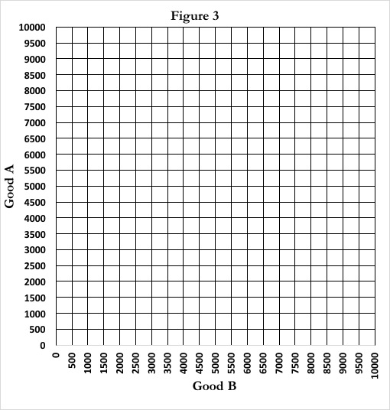

- [5 Points] In the space below, and on the back of this page if you need it, describe how you know that the PPF for the two clans is such that Wu Tang Clan has a comparative advantage in Good A. Be specific, clear, and thorough in your answer.

