Name: ___Answer Key_________________

- [1 Point] The Parable of the Magic Island is intended to demonstrate that trading with others is akin to magic, in that it allows a nation to acquire a permanent increase in wealth by only paying a temporary economic adjustment cost.
  - True
  - False
- [1 Point] The parable of the Magic Island is intended to demonstrate that, like magic, the benefits from international trade are simply not real.
  - True
  - False
Suppose we have two countries, the U.S. and Cuba, whose production possibilities frontiers (PPFs) for producing beer and cigars are as follows

U.S.: Number Cigars Produced = 10 - (2)(Number Beers Produced)
Cuba: Number Cigars Produced = 10 - (1)(Number Beers Produced)

- [4 Points] Plot the PPF’s for each country below. Clearly label which country corresponds to each PPF.

U.S.
Cuba
Cigars
Beer

- [1 Point] For the U.S., the opportunity cost of producing one beer is _____2______ cigar(s)
- [1 Point] For the U.S., the opportunity cost of producing one cigar is _____.5_____ beer(s)
- [1 Point] For Cuba, the opportunity cost of producing one beer is _____1____ cigar(s)
- [1 Point] For Cuba, the opportunity cost of producing one cigar is _____1_____ beer(s)

- [1 Point] A production possibilities frontier is the maximum combo of goods a nation can produce.
  - True
  - False
- [1 Point] Trade allows nations to move beyond its production possibilities frontier and consume more goods than it naturally could.
  - True
  - False

- [1 Point] If the PPF for a country is: grain= 200-(2)(salmon), the opportunity cost of grain is 0.5 salmon (list both the number and the units)
- [1 Point] If the PPF for a country is: grain= 200-(2)(salmon), the opportunity cost of salmon is 2 grain (list both the number and the units)
- [1 Point] If the PPF for a country is: grain= 100-(3/4)(salmon), the opportunity cost of salmon is ¾ grain (list both the number and the units)
- [1 Point] If the PPF for a country is: grain= 100-(3/4)(salmon), the opportunity cost of grain is 4/3 salmon (list both the number and the units)

Use this graph to answer questions 14 and 15.

- [2 Points] In the graph above, the formula for U.S. PPF is…?
- US: Meat = 1000 - 1(Veggies)
- US: Meat = 1000 - 2 (Veggies)
- US: Meat = 500 - (1/2)(Veggies)
- US: Meat = 500 - 2 (Veggies)
- [2 Points] In the graph above, the formula for E.U. PPF is…?
- EU: Meat = 500 - 1(Veggies)
- EU: Meat = 500 – (3/4)(Veggies)
- EU: Meat = 1000 –(1/2)(Veggies)
- EU: Meat = 500 – (1/2)(Veggies)

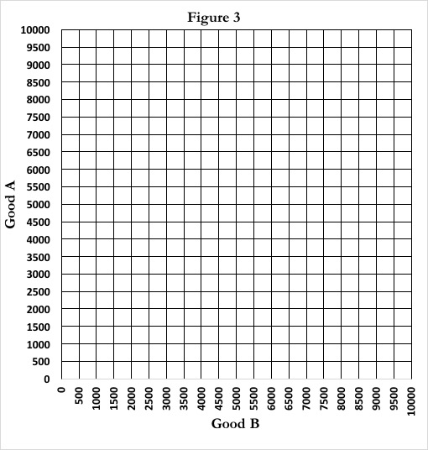
- [5 Points] In the graph below, create your own PPF for Wu Tang Clan and another PPF for No Tang Clan. Make them such that Wu Tang Clan has a comparative advantage in Good A and No Tang Clan has a comparative advantage in Good B. The PPF can be drawn however you like, so long as both the y-intercept and the x-intercept fit on the graph below (both must be between 0 and 10,000) and the slope of either line cannot be -1. Clearly (very clearly) label which PPF belongs to each clan.
Wu Tang Clan
No Tang Clan

- [5 Points] In the space below, and on the back of this page if you need it, describe how you know that the PPF for the two clans is such that Wu Tang Clan has a comparative advantage in Good A. Be specific, clear, and thorough in your answer.
  - The slope of the PPF tells you the amount of Good A a clan must give up to produce one unit of Good B. Like, if the slope is -2, that means the clan must give up 2 units of Good A to produce one unit of Good B.
  - The reciprocal of this slope is the amount of Good B a clan must give up to produce one unit of Good A. So if the slope is -2, then the clan must give up ½ units of Good B to acquire one unit of Good A.
  - The opportunity cost of Good A is the number of units of Good B a clan must give up to produce one unit of Good A.
  - A clan as the comparative advantage in Good A if it produces Good A at a lower opportunity cost.
  - In this graph, we know Wu Tang Clan as a comparative advantage in Good A because its slope is larger in absolute value, which means the reciprocal of its slope in absolute value is lower, which means it gives up less of Good B to produce one unit of Good A, which means it produces Good A at a lower opportunity cost, which by definition means Wu Tang Clan has a comparative advantage in Good A.

OR
  - The slope of the PPF tells you the amount of Good A a clan must give up to produce one unit of Good B. That is, by definition, the opportunity cost of Good B. Like, if the slope is -2, that means the clan must give up 2 units of Good A to produce one unit of Good B.
  - By definition the opportunity cost of Good A is the inverse of the opportunity cost of Good B, so whichever PPF has the steepest slope also has the lowest opportunity cost for Good A.
  - A group has a comparative advantage in Good A if it can produce it at a lower opportunity cost. Therefore whichever clan’s PPF is the steepest has the comparative advantage in Good A.

OR , they can draw lines, calculate the opportunity costs of each line, and numerically show that Wu Tang Clan has a lower opportunity cost for Good A.

